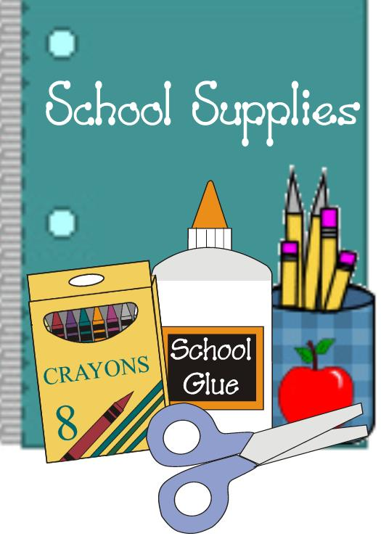
Mrs. Boniello’s Class
Supply List
2018-2019 School Year

1- Package of colored pencils
- Package of pencils
1- Box of Crayons
1- Clear (Lucite) Pencil box
3- Composition Books
2- Packages of Post-it-Notes
3- Boxes of Tissues
1- Box of large Zip Lock Bags
1- Box of small Zip Lock Bags
1- Tub of Baby Wipes
2- Tubs of Lysol wipes
2- Glue sticks

