Moonachie School District
Mathematics Curriculum:
Grade 3

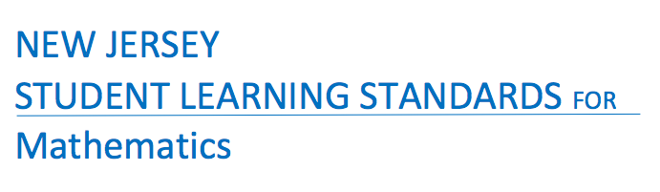

Born On & Board Approved: July 25, 2017
Re-Adopted: August 23, 2022

The following maps outline the New Jersey Student Learning Standards for grade three mathematics determined by the State Standards Initiative. Below is a list of assessment tools that are recommended for tracking student progress in these areas. In addition, resources that can be used in conjunction with instruction of these standards are provided but not limited to the list below.

Assessment:
Formative Assessment Class-Work Review
Open-Ended Problems Project-Based Assessment
Self-Assessment Timed Drills
Teacher Observation End of Year Assessment
Benchmark Assessment Math Software (ex. Study Island)
Homework Review Group & Cooperative Work
Summative Assessment TenMarks

Resources: _
Counters (variety) Protractors Tangrams
Flashcards Ten Frame Geometric Shapes
Math Word Wall Blocks Geo-Board
Connecting Cubes Calendar Textbooks
Number Line 100 Chart Attribute Blocks
Work Mats Math Songs/Poems Craft Sticks
Computer Software Calculators Wiki-Sticks
Interactive White Board Money/Coins Pattern Blocks
Flannel Board Measurement Tools Three Dimensional Shapes
Center Games Judy Clock Fraction Tiles
Concrete Objects Small Student Clocks Bar Models
Mini White Boards Time Bingo Base Ten Blocks
Manipulatives Digital Clock Math Journals
Math/Pocket Charts Analog Clock

Websites:
www.ixl.com _ www.Envision 2020.com www.xtramath.com
www.aplusmath.com www.tenmarks.com www.superteacherworksheets.com
www.brainpop.com www.commoncoresheets.com www.mrnussbaum.com
www.brainpopjr.com www.fun4thebrain.com www.learnzillion.com
www.funbrain.com www.math-play.com www.k6.thinkcentral.com
www.mathplayground.com www.smartexchange.com www. interactivesites.weebly.com/math.html
www.sheppardssoftware.com http://www.k-5mathteachingresources.com
www.songsforteaching.com

References:
http://www.state.nj.us/education/aps/cccs/math/
NJ Technology Standards: http://www.state.nj.us/education/cccs/2014/tech/8.pdf
NJ Career Ready Practices: http://www.state.nj.us/education/aps/cccs/career/

Standards for Mathematical Practice
MP. 1 - Make Sense of problems and persevere in solving them.
MP. 2 - Reason Abstractly and Quantitatively
Mp. 3 - Construct Viable Arguments and Critique the Reasoning of Others
MP. 4 - Model with Mathematics
MP. 5 - Use Appropriate Tools Strategically
MP. 6 - Attend to Precision
MP. 7 - Look for and make use of Structure
MP. 8 - Look for and Express Regularity in Repeated Reasoning

Curriculum Details
Mathematics - Grade 3
Core Materials | Envision 2020 Math, Numbers World
Interdisciplinary Connections | ELA:  NJSLSA.R1. Read closely to determine what the text says explicitly and to make logical inferences and relevant connections from it; cite specific textual evidence when writing or speaking to support conclusions drawn from the text.  NJSLSA.RI.7. Integrate and evaluate content presented in diverse media and formats, including visually and quantitatively, as well as in words.  NJSLSA.W2. Write informative/explanatory texts to examine and convey complex ideas and information clearly and accurately through the effective selection, organization, and analysis of content.  NJSLSA.L1. Demonstrate command of the conventions of standard English Grammar and usage when writing or speaking.
Career Ready Practices | CRP2. Apply appropriate academic and technical skills.  CRP4. Communicate clearly and effectively and with reason.  CRP6. Demonstrate creativity and innovation.  CRP7. Employ valid and reliable research strategies.  CRP8. Utilize critical thinking to make sense of problems and persevere in solving them.  CRP12. Work productively in teams while using cultural global competence.
Career Readiness, Life Literacies, and Key Skills | 9.1.5.FP.3: Analyze how spending choices and decision-making can result in positive or negative consequences.  9.1.5.PB.2: Describe choices consumers have with money (e.g. save, spend, donate).  9.2.5.CAP.2: Identify how you might like to earn an income.
Computer Science and Design Thinking | 8.1.5.DA.1: Collect, organize, and display data in order to highlight relationships or support a claim.  8.1.5.DA.3: Organize and present collected data visually to communicate insights gained from different views of the data.  8.1.5.DA.5: Propose cause and effect relationships, predict outcomes, or communicate ideas using data.  8.2.5.ED.2: Collaborate with peers to collect information, brainstorm to solve a problem, and evaluate all possible solutions to provide the best results with supporting sketches or models.  8.2.5.ED.3: Follow step by step directions to assemble a product or solve a problem, using appropriate tools to accomplish the task.

Math Curriculum: Grade 3
Operations and Algebraic Thinking
Math Standard 3.OA.A.1, 3.OA.A.2, 3.OA.A.3, 3.OA.A.4

Essential Question(s): How do we represent and interpret operations? How do we use multiplication and division to solve problems?
Vocabulary: Factor, product, multiplication, equation, whole number, expression, array, quotient, dividend, divisor, factor, division, equal
Content: Operations & Algebraic Thinking
SLS Anchor Standard: A. Represent and solve problems involving multiplication and division.
SLS Standards: 3.OA.A.1, 3.OA.A.2, 3.OA.A.3, 3.OA.A.4
Standards for Mathematical Practice: MP 1, MP 2, MP 4, MP 7,
Skills | Instructional Procedures |  | Explanations and Examples |  | Interdisciplinary Connections
1.Interpret products of whole numbers, e.g., interpret 5 × 7 as the total number of objects in 5 groups of 7 objects each. For example, describe and/or represent a context in which a total number of objects can be expressed as 5 × 7.  (MP 2, MP 4) | - Model multiplication expressions  - Construct multiplication expressions  - Use visuals to interpret a multiplication expression  - Solve for results unknown 5x7=n  - Solve for parts unknown 5Xn=35 |  | Students recognize multiplication as a means to determine the total number of objects when there are a specific number of groups with the same number of objects in each group. Multiplication requires students to think in terms of groups of things rather than individual things. Students learn that the multiplication symbol ‘x’ means “groups of” and problems such as 5 x 7 refer to 5 groups of 7.  To further develop this understanding, students interpret a problem situation requiring multiplication using pictures, objects, words, numbers, and equations. Then, given a multiplication expression (e.g., 5 x 6) students interpret the expression using a multiplication context. (See Table 2) They should begin to use the terms, factor and product, as they describe multiplication.  Students may use interactive whiteboards to create digital models. |  | Music:  Multiplication Rap Songs  Technology:  www.multiplication.com  Art:  Create pictures to represent a multiplication expression  Language Arts:  Storybook with multiplication concept such as The Doorbell Rang by Pat Hutchins  Writing:  Math Journals
2. Interpret whole-number quotients of whole numbers, e.g., interpret 56 ÷ 8 as the number of objects in each share when 56 objects are partitioned equally into 8 shares, or as a number of shares when 56 objects are partitioned into equal shares of 8 objects each. For example, describe and/or represent a context in which a number of shares or a number of groups can be expressed as 56 ÷ 8.  (MP 2, MP 4) | - Model division expressions  - Construct division expressions  - Use visuals to interpret a division expression  - Solve for results unknown 35 ÷ 7=__ or 35 ÷ n=5 |  | Students recognize the operation of division in two different types of situations. One situation requires determining how many groups and the other situation requires sharing (determining how many in each group). Students should be exposed to appropriate terminology (quotient, dividend, divisor, and factor).  To develop this understanding, students interpret a problem situation requiring division using pictures, objects, words, numbers, and equations. Given a division expression (e.g., 24 ÷ 6) students interpret the expression in contexts that require both interpretations of division. (See Table 2)  Students may use interactive whiteboards to create digital models. |  | Music:  Division songs  Art:  Create pictures to represent division expression  Language Arts:  Read books with division content such as: The Great Divide: A Mathematical Marathon by Dayle Ann Dodds  Writing:  Math Journals
3. Use multiplication and division within 100 to solve word problems in situations involving equal groups, arrays, and measurement quantities, e.g., by using drawings and equations with a symbol for the unknown number to represent the problem.¹  (MP 1, MP 4) | - Use a variety of representations for solving word problems ex. arrays, number lines, manipulatives, equations, equal group, repeated addition  - Solve for results in multiplication and division expressions |  | Students use a variety of representations for creating and solving one-step word problems, i.e., numbers, words, pictures, physical objects, or equations. They use multiplication and division of whole numbers up to 10 x10. Students explain their thinking, show their work by using at least one representation, and verify that their answer is reasonable.  Word problems may be represented in multiple ways:  - Equations: 3 x 4 = ?, 4 x 3 = ?, 12 ÷ 4 = ? and 12 ÷ 3 = ?  - Array:  - Equal groups  - Repeated addition: 4 + 4 + 4 or repeated subtraction  - Three equal jumps forward from 0 on the number line to 12 or three equal jumps backwards from 12 to 0  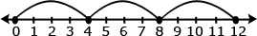  Examples of division problems:  - Determining the number of objects in each share (partitive division, where the size of the groups is unknown):  - The bag has 92 hair clips, and Laura and her three friends want to share them equally. How many hair clips will each person receive?  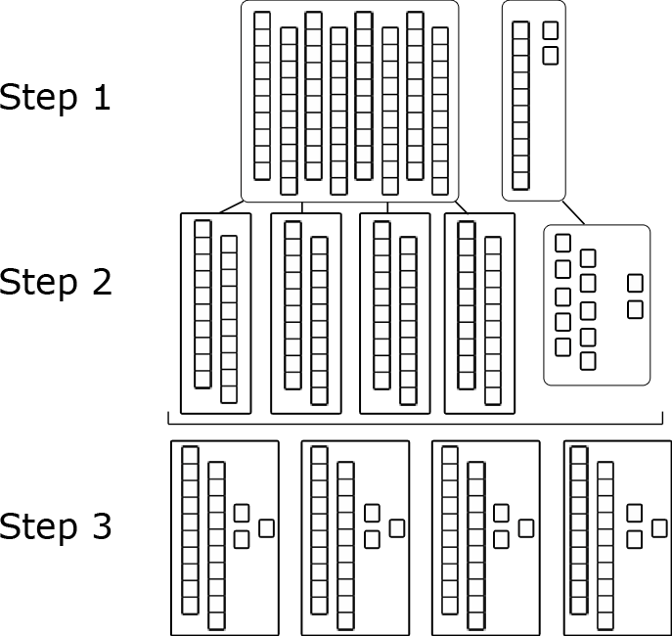  - Determining the number of shares (measurement division, where the number of groups is unknown)  Max the monkey loves bananas. Molly, his trainer, has 24 bananas. If she gives Max 4 bananas each day, how many days will the bananas last?  Starting Day 1 Day 2 Day 3 Day 4 Day 5 Day 6  24 24-4= 20 20-4= 16 16-4= 12 12-4= 8 8-4= 4 4-4= 0  Solution: The bananas will last for 6 days.  Students may use interactive whiteboards to show work and justify their thinking. |  | Art:  Create pictures to represent multiplication and division expressions in word problems  Technology:  www.brainpopjr.com  (paid website)  Kidpix- Create own problem & array  Science/ Social Studies  Create word problems based on science and social studies content  Writing:  Math Journals
4. Determine the unknown whole number in a multiplication or division equation relating three whole numbers. For example, determine the unknown number that makes the equation true in each of the equations 8 × ? = 48, 5 = _ ÷ 3, 6 × 6 = ?  (MP 2, MP 7) | - Use visuals to represent equations with unknown numbers  - Construct and solve multiplication and division expressions to show the relationship between the operations  - Use equations with a symbol for the unknown number to represent the problem  - Solve for the unknown parts, 6-2=n or 8- € = 6 |  | This standard is strongly connected to 3.AO.3 when students solve problems and determine unknowns in equations. Students should also experience creating story problems for given equations. When crafting story problems, they should carefully consider the question(s) to be asked and answered to write an appropriate equation. Students may approach the same story problem differently and write either a multiplication equation or division equation.  Students apply their understanding of the meaning of the equal sign as ”the same as” to interpret an equation with an unknown. When given 4 x ? = 40, they might think:  - 4 groups of some number is the same as 40  - 4 times some number is the same as 40  - I know that 4 groups of 10 is 40 so the unknown number is 10  - The missing factor is 10 because 4 times 10 equals 40.  Equations in the form of a x b = c and c = a x b should be used interchangeably, with the unknown in different positions.  Examples:  - Solve the equations below:  24 = ? x 6  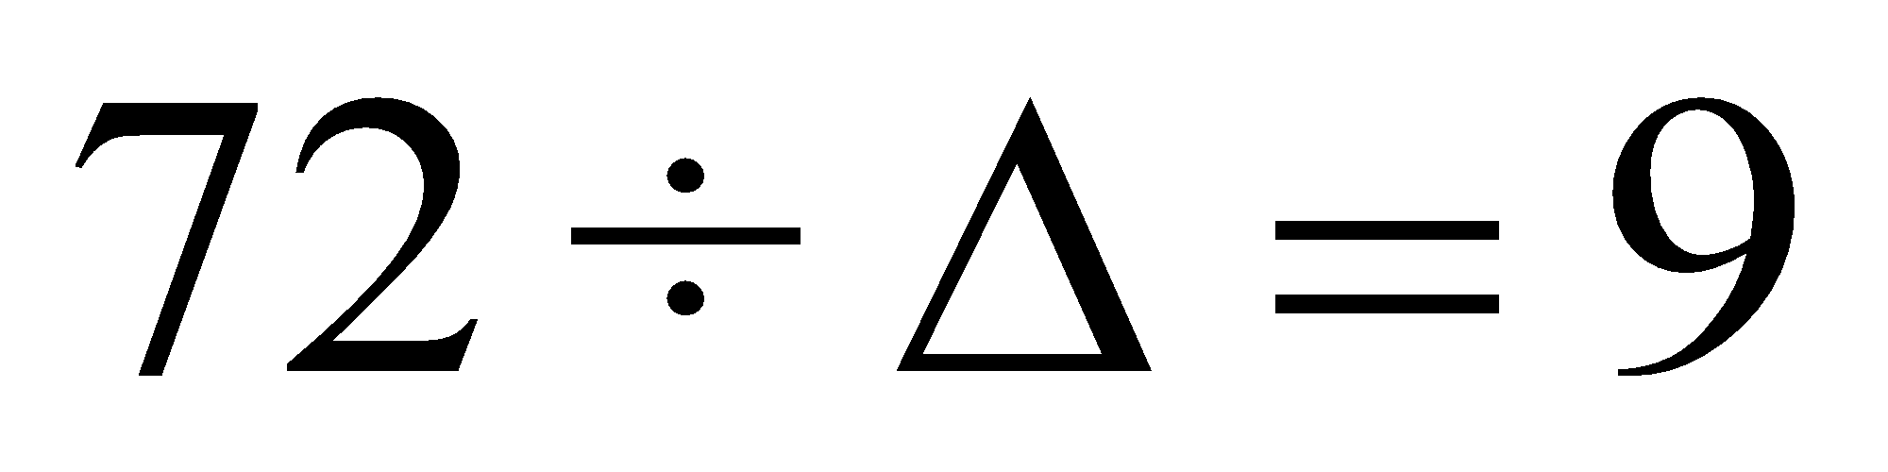  - Rachel has 3 bags. There are 4 marbles in each bag. How many marbles does Rachel have altogether? 3 x 4 = m  Students may use interactive whiteboards to create digital models to explain and justify their thinking. |  | Writing:  Math Journals, students create story problems
Differentiation/Modifications/Accommodations
Gifted and Talented |  | English Language Learners |  | Students with Disabilities |  | Students At Risk of School Failure
- Envision 2020 advanced/enrichment practice  - Create a rubric to assess the full range of knowledge needed to answer a multiplication or division word problem (ie: recalling, explaining, concluding and justifying)  - Formulate word problems with multiplication and division, including an answer key showing all work  - Students share with a partner different approaches to solve a problem and share why each strategies is reasonable  - Evaluate a peer’s argument or explanation and provide an alternative solution to the problem |  | - Using demonstration: (ie: Create three visual representations of the same multiplication or division problem)  - Using manipulatives  - Using small group interactions and peer questioning  - Using pictures and graphic organizers  - Envision 2020 ELL activities  - For more, see http://www.state.nj.us/education/modelcurriculum/ela/ellscaffolding/3u1.pdf |  | - RTI approaches: prevent misconceptions, error intervention, reteaching set, reteaching worksheets  - Extended time  - Modified assignments  - Small group, alternate location  - Modeling  - Manipulatives  - Video tutorials  - Color coding methods  - Flashcards  - Refer to each student’s IEP for more specific modifications |  | - Using demonstration: (ie: Create three visual representations of the same multiplication or division problem)  - Using manipulatives  - Using small group interactions and peer questioning  - Using pictures and graphic organizers  - Envision 2020 ELL activities  - Morning tutoring  - After school program  - Parental contact  - Tier II and Tier III Intervention

Math Curriculum: Grade 3
Operations and Algebraic Thinking
Math Standard 3.OA.B.5, 3.OA.B.6

Essential Question(s): How do we use properties of operations as strategies to multiply and divide? How are operations of multiplication and division related?
Vocabulary: Properties, commutative, associative, distributive, expression, symbol, arrays, factors, inverse operation symbols, fact families, quotient, zero property, multiplicative identity property of 1
Content: Operations & Algebraic Thinking
SLS Anchor Standard: B. Understand properties of multiplication and the relationship between multiplication and division.
SLS Standards: 3.OA.B.5, 3.OA.B.6
Standards for Mathematical Practice: MP 3, MP 5, MP 6, MP 7,
Skills | Instructional Procedures | Explanations and Examples | Interdisciplinary Connections
5. Apply properties of operations as strategies to multiply and divide.² Examples: If 6 × 4 = 24 is known, then 4 × 6 = 24 is also known. (Commutative property of multiplication.) 3 × 5 × 2 can be found by 3 × 5 = 15, then 15 × 2 = 30, or by 5 × 2 = 10, then 3 × 10 = 30. (Associative property of multiplication.) Knowing that 8 × 5 = 40 and 8 × 2 = 16, one can find 8 × 7 as 8 × (5 + 2) = (8 × 5) + (8 × 2) = 40 + 16 = 56. (Distributive property)  (MP 3, MP 5, MP 6,  MP 7) | - Use a variety of representations to demonstrate the understanding of properties ex. manipulatives, pictures, words, symbols | Students represent expressions using various objects, pictures, words and symbols in order to develop their understanding of properties. They multiply by 1 and 0 and divide by 1. They change the order of numbers to determine that the order of numbers does not make a difference in multiplication (but does make a difference in division). Given three factors, they investigate changing the order of how they multiply the numbers to determine that changing the order does not change the product. They also decompose numbers to build fluency with multiplication.  Models help build understanding of the commutative property:  Example: 3 x 6 = 6 x 3  In the following diagram it may not be obvious that 3 groups of 6 is the same as 6 groups of 3. A student may need to count to verify this.  is the same quantity as  Example: 4 x 3 = 3 x 4  An array explicitly demonstrates the concept of the commutative property.  4 rows of 3 or 4 x 3 3 rows of 4 or 3 x 4  Students are introduced to the distributive property of multiplication over addition as a strategy for using products they know to solve products they don’t know. For example, if students are asked to find the product of 7 x 8, they might decompose 7 into 5 and 2 and then multiply 5 x 8 and 2 x 8 to arrive at 40 + 16 or 56. Students should learn that they can decompose either of the factors. It is important to note that the students may record their thinking in different ways.  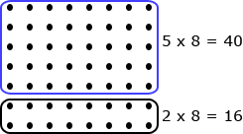  To further develop understanding of properties related to multiplication and division, students use different representations and their understanding of the relationship between multiplication and division to determine if the following types of equations are true or false.  - 0 x 7 = 7 x 0 = 0 (Zero Property of Multiplication)  - 1 x 9 = 9 x 1 = 9 (Multiplicative Identity Property of 1)  - 3 x 6 = 6 x 3 (Commutative Property)  - 8 ÷ 2 = 2 ÷ 8 (Students are only to determine that these are not equal)  - 2 x 3 x 5 = 6 x 5  - 10 x 2 < 5 x 2 x 2  - 2 x 3 x 5 = 10 x 3  - 0 x 6 > 3 x 0 x 2 | Writing:  Math Journals  Art:  Create pictorial representations
6. Understand division as an unknown-factor problem. For example, find 32 ÷ 8 by finding the number that makes 32 when multiplied by 8.  (MP 3, MP 6, MP 7) | - Model using fact families to demonstrate inverse operation  - Construct and solve multiplication and division expressions to show the relationship between the operations | Multiplication and division are inverse operations and that understanding can be used to find the unknown. Fact family triangles demonstrate the inverse operations of multiplication and division by showing the two factors and how those factors relate to the product and/or quotient.  3  5  15  X or ÷  Examples:  - 3 x 5 = 15 5 x 3 = 15  - 15 ÷ 3 = 5 15 ÷ 5 = 3  Students use their understanding of the meaning of the equal sign as “the same as” to interpret an equation with an unknown. When given 32 ÷ = 4, students may think:  - 4 groups of some number is the same as 32  - 4 times some number is the same as 32  - I know that 4 groups of 8 is 32 so the unknown number is 8  - The missing factor is 8 because 4 times 8 is 32.  Equations in the form of a ÷ b = c and c = a ÷ b need to be used interchangeably, with the unknown in different positions. | Writing:  Math Journals

Differentiation/Modifications/Accommodations
Gifted and Talented | English Language Learners | Students with Disabilities | Students At Risk of School Failure
- Envision 2020 advanced/enrichment practice  - Create a poster to represent the distributive property using images and description  - Type an explanation of how multiplication is the inverse of division.  - Create a real-world multiplication or division problems | - Using demonstration: (ie: Create three visual representations of the same multiplication or division problem)  - Using manipulatives  - Using small group interactions and peer questioning  - Using pictures and graphic organizers  - Envision 2020 ELL activities  - For more, see http://www.state.nj.us/education/modelcurriculum/ela/ellscaffolding/3u1.pdf | - RTI approaches: prevent misconceptions, error intervention, reteaching set, reteaching worksheets  - Extended time  - Modified assignments  - Small group, alternate location  - Modeling  - Manipulatives  - Video tutorials  - Color coding methods  - Flashcards  - Refer to each student’s IEP for more specific modifications | - Using demonstration: (ie: Create three visual representations of the same multiplication or division problem)  - Using manipulatives  - Using small group interactions and peer questioning  - Using pictures and graphic organizers  - Envision 2020 ELL activities  - Morning tutoring  - After school program  - Parental contact  - Tier II and Tier III Intervention

Math Curriculum: Grade 3
Operations and Algebraic Thinking
Math Standard 3.OA.C.7

Essential Question(s): How do we use mental math strategies to multiply and divide? How do we explain and apply the strategies used to multiply and divide?
Vocabulary: Properties, patterns, multiplication, division, factors
Content: Operations & Algebraic Thinking
SLS Anchor Standard: C. Multiply and Divide within 100.
SLS Standards: 3.OA.C.7
Standards for Mathematical Practice: MP 2, MP 7, MP 8
Skills | Instructional Procedures | Explanations and Examples | Interdisciplinary Connections
7. Fluently multiply and divide within 100, using strategies such as the relationship between multiplication and division (e.g., knowing that 8 × 5 = 40, one knows 40 ÷ 5 = 8) or properties of operations. By the end of Grade 3, know from memory all products of two one-digit numbers.  MP 2, MP 7, MP 8) | Model various strategies to obtain fluency of multiplication and division facts (see next column)  Explain and apply strategies used to solve mental math problems | By studying patterns and relationships in multiplication facts and relating multiplication and division, students build a foundation for fluency with multiplication and division facts. Students demonstrate fluency with multiplication facts through 10 and the related division facts. Multiplying and dividing fluently refers to knowledge of procedures, knowledge of when and how to use them appropriately, and skill in performing them flexibly, accurately, and efficiently.  Strategies students may use to attain fluency include:  - Multiplication by zeros and ones  - Doubles (2s facts), Doubling twice (4s), Doubling three times (8s)  - Tens facts (relating to place value, 5 x 10 is 5 tens or 50)  - Five facts (half of tens)  - Skip counting (counting groups of __ and knowing how many groups have been counted)  - Square numbers (ex: 3 x 3)  - Nines (10 groups less one group, e.g., 9 x 3 is 10 groups of 3 minus one group of 3)  - Decomposing into known facts (6 x 7 is 6 x 6 plus one more group of 6)  - Turn-around facts (Commutative Property)  - Fact families (Ex: 6 x 4 = 24; 24 ÷ 6 = 4; 24 ÷ 4 = 6; 4 x 6 = 24)  - Missing factors  General Note: Students should have exposure to multiplication and division problems presented in both vertical and horizontal forms. | Language Arts:  Create a book of different mental math strategies

Differentiation/Modifications/Accommodations
Gifted and Talented | English Language Learners | Students with Disabilities | Students At Risk of School Failure
- Envision 2020 advanced/enrichment practice  - Formulate questions to a board game that requires students to fluently multiply and divide within 100  - Play “Teach me how to”: a pair of students alternate giving directions to their partner for solving a multiplication/division problem. The silent student must record what their partner is telling them to do | - Using demonstration: (ie: Create three visual representations of the same multiplication or division problem)  - Using manipulatives  - Using small group interactions and peer questioning  - Using pictures and graphic organizers  - Envision 2020 ELL activities  - For more, see http://www.state.nj.us/education/modelcurriculum/ela/ellscaffolding/3u1.pdf | - RTI approaches: prevent misconceptions, error intervention, reteaching set, reteaching worksheets  - Extended time  - Modified assignments  - Small group, alternate location  - Modeling  - Manipulatives  - Video tutorials  - Color coding methods  - Flashcards  - Refer to each student’s IEP for more specific modifications | - Using demonstration: (ie: Create three visual representations of the same multiplication or division problem)  - Using manipulatives  - Using small group interactions and peer questioning  - Using pictures and graphic organizers  - Envision 2020 ELL activities  - Morning tutoring  - After school program  - Parental contact  - Tier II and Tier III Intervention

Math Curriculum: Grade 3
Operations and Algebraic Thinking
Math Standard 3.OA.D.8, 3.OA.D.9

Essential Question(s): How do we use problem solving strategies to solve two step word problems? How do we use properties of operations to identify numerical patterns?
Vocabulary: Reasonableness, estimation, rounding, numerical patterns, sum, multiple, addend
Content: Operations & Algebraic Thinking
SLS Anchor Standards: D. Solve problems involving the four operations, and identify and explain patterns in arithmetic.
SLS Standards: 3.OA.D.8, 3.OA.D.9
Standards for Mathematical Practice: MP 1, MP 2, MP 3, MP 4, MP 5, MP 6, MP 7, MP 8
Skills | Instructional Procedures | Explanations and Examples | Interdisciplinary Connections
8. Solve two-step word problems using the four operations. Represent these problems using equations with a letter standing for the unknown quantity. Assess the reasonableness of answers using mental computation and estimation strategies including rounding.³  (MP 1, MP 2, MP 3,  MP 4, MP 5, MP 6) | - ∙ Model and use various problem solving strategies  *guess check  *draw pic  *create a table  *write an expression  *find a pattern  *work backwards  *make a list  *use logical reasoning  *use mental computation and estimation  *bar modeling  ∙ Strategies to check reasonableness of answers | Students should be exposed to multiple problem-solving strategies (using any combination of words, numbers, diagrams, physical objects or symbols) and be able to choose which ones to use.  Examples:  - Jerry earned 231 points at school last week. This week he earned 79 points. If he uses 60 points to earn free time on a computer, how many points will he have left?  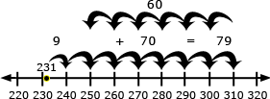  A student may use the number line above to describe his/her thinking, “231 + 9 = 240 so now I need to add 70 more. 240, 250 (10 more), 260 (20 more), 270, 280, 290, 300, 310 (70 more). Now I need to count back 60. 310, 300 (back 10), 290 (back 20), 280, 270, 260, 250 (back 60).”  A student writes the equation, 231 + 79 – 60 = m and uses rounding (230 + 80 – 60) to estimate.  A student writes the equation, 231 + 79 – 60 = m and calculates 79-60 = 19 and then calculates 231 + 19 = m.  - The soccer club is going on a trip to the water park. The cost of attending the trip is $63. Included in that price is $13 for lunch and the cost of 2 wristbands, one for the morning and one for the afternoon. Write an equation representing the cost of the field trip and determine the price of one wristband.  w  w  13  63  The above diagram helps the student write the equation, w + w + 13 = 63. Using the diagram, a student might think, “I know that the two wristbands cost $50 ($63-$13) so one wristband costs $25.” To check for reasonableness, a student might use front end estimation and say 60-10 = 50 and 50 ÷ 2 = 25.  When students solve word problems, they use various estimation skills which include identifying when estimation is appropriate, determining the level of accuracy needed, selecting the appropriate method of estimation, and verifying solutions or determining the reasonableness of solutions.  Estimation strategies include, but are not limited to:  - using benchmark numbers that are easy to compute  - front-end estimation with adjusting (using the highest place value and estimating from the front end making adjustments to the estimate by taking into account the remaining amounts)  rounding and adjusting (students round down or round up and then adjust their estimate depending on how much the rounding changed the original values) | Writing:  Math Journals  Language Arts:  Create a problem solving strategy book  Life Skills:  Example: how much tip do we leave for the waiter/waitress?
9. Identify arithmetic patterns (including patterns in the addition table or multiplication table), and explain them using properties of operations. For example, observe that 4 times a number is always even, and explain why 4 times a number can be decomposed into two equal addends.  (MP 3, MP 6, MP 7,  MP 8) | - Search, identify, and explain numerical patterns in addition, subtraction and multiplication  - Use mathematical tables and charts to identify and explain patterns. | Students need ample opportunities to observe and identify important numerical patterns related to operations. They should build on their previous experiences with properties related to addition and subtraction. Students investigate addition and multiplication tables in search of patterns and explain why these patterns make sense mathematically. For example:  - Any sum of two even numbers is even.  - Any sum of two odd numbers is even.  - Any sum of an even number and an odd number is odd.  - The multiples of 4, 6, 8, and 10 are all even because they can all be decomposed into two equal groups.  - The doubles (2 addends the same) in an addition table fall on a diagonal while the doubles (multiples of 2) in a multiplication table fall on horizontal and vertical lines.  - The multiples of any number fall on a horizontal and a vertical line due to the commutative property.  - All the multiples of 5 end in a 0 or 5 while all the multiples of 10 end with 0. Every other multiple of 5 is a multiple of 10.  Students also investigate a hundreds chart in search of addition and subtraction patterns. They record and organize all the different possible sums of a number and explain why the pattern makes sense.  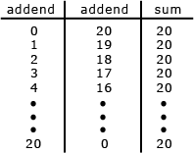 | Writing:  Math Journals

Differentiation/Modifications/Accommodations
Gifted and Talented | English Language Learners | Students with Disabilities | Students At Risk of School Failure
- Envision 2020 advanced/enrichment practice  - Create problems to be played in a class jeopardy game (requiring problems to range in difficulty)  - Design a graphic organizer for peers to use in order to solve two-step problems  - Provide students with answers and require them to create a two-step problem that would result in the given answer  - Have students create and solve three-step word problems | - Using demonstration: (ie: Create three visual representations of the same multiplication or division problem)  - Using manipulatives  - Using small group interactions and peer questioning  - Using pictures and graphic organizers  - Envision 2020 ELL activities  - For more, see http://www.state.nj.us/education/modelcurriculum/ela/ellscaffolding/3u1.pdf | - RTI approaches: prevent misconceptions, error intervention, reteaching set, reteaching worksheets  - Extended time  - Modified assignments  - Small group, alternate location  - Modeling  - Manipulatives  - Video tutorials  - Color coding methods  - Flashcards  - Refer to each student’s IEP for more specific modifications | - Using demonstration: (ie: Create three visual representations of the same multiplication or division problem)  - Using manipulatives  - Using small group interactions and peer questioning  - Using pictures and graphic organizers  - Envision 2020 ELL activities  - Morning tutoring  - After school program  - Parental contact  - Tier II and Tier III Intervention

Math Curriculum: Grade 3
Number and Operations in Base Ten
Math Standard 3.NBT.A.1, 3.NBT.A.2, 3.NBT.A.3

Essential Question(s): How do we use place value to represent numbers? How do we use properties of operations to add, subtract and multiply? How do you explain the strategies used to add, subtract and multiply?
Vocabulary: Word form, standard form, expanded form, digit, place value chart, sum, difference, product, number line, rounding, estimate, reasonable
Content: Number and Operations in Base Ten
SLS Anchor Standards: A. Use place value understanding and properties of operations to perform multi-digit arithmetic
SLS: 3.NBT.A.1, 3.NBT.A.2, 3.NBT.A.3
Standards for Mathematical Practice: MP 2
Skills | Instructional Procedures | Explanations and Examples | Interdisciplinary Connections
1. Use place value understanding to round whole numbers to the nearest 10 or 100.  (MP 2) | - Use number lines to estimate the value of a number to the nearest 10 or 100 | Students learn when and why to round numbers. They identify possible answers and halfway points. Then they narrow where the given number falls between the possible answers and halfway points. They also understand that by convention if a number is exactly at the halfway point of the two possible answers, the number is rounded up.  Example: Round 178 to the nearest 10.  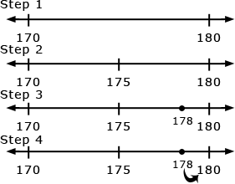  Step 1: The answer is either 170 or 180.  Step 2: The halfway point is 175.  Step 3: 178 is between 175 and 180.  Step 4: Therefore, the rounded number is 180. | Social Studies and Science:  Relate number line to time line  Science:  Measurements as temperature and rainfall are rounded
2. Fluently add and subtract within 1000 using strategies and algorithms based on place value, properties of operations, and/or the relationship between addition and subtraction.  (MP 2) | - Round numbers to estimate sums and differences  - Solve multiple digit addition and subtraction problems using strategies and algorithms | Problems should include both vertical and horizontal forms, including opportunities for students to apply the commutative and associative properties. Adding and subtracting fluently refers to knowledge of procedures, knowledge of when and how to use them appropriately, and skill in performing them flexibly, accurately, and efficiently. Students explain their thinking and show their work by using strategies and algorithms, and verify that their answer is reasonable. An interactive whiteboard or document camera may be used to show and share student thinking.  Example:  - Mary read 573 pages during her summer reading challenge. She was only required to read 399 pages. How many extra pages did Mary read beyond the challenge requirements?  Students may use several approaches to solve the problem including the traditional algorithm. Examples of other methods students may use are listed below:  - 399 + 1 = 400, 400 + 100 = 500, 500 + 73 = 573, therefore 1+ 100 + 73 = 174 pages (Adding up strategy)  - 400 + 100 is 500; 500 + 73 is 573; 100 + 73 is 173 plus 1 (for 399, to 400) is 174 (Compensating strategy)  - Take away 73 from 573 to get to 500, take away 100 to get to 400, and take away 1 to get to 399. Then 73 +100 + 1 = 174 (Subtracting to count down strategy)  - 399 + 1 is 400, 500 (that’s 100 more). 510, 520, 530, 540, 550, 560, 570, (that’s 70 more), 571, 572, 573 (that’s 3 more) so the total is  1 + 100 + 70 + 3 = 174 (Adding by tens or hundreds strategy) | Language Arts:  Journal entry explaining how to regroup in addition and subtraction problems.  Discuss with students the origin of the word subtraction. Explain that the word has a Latin origin and means “to draw from, beneath or withdraw”. Point out the prefix “sub” means “under, below” such as; subgroup, submarine, submerge.
3. Multiply one-digit whole numbers by multiples of 10 in the range 10–90 (e.g., 9 × 80, 5 × 60) using strategies based on place value and properties of operations.  (MP 2) | - Identify a pattern for multiplying one digit numbers by multiples of ten.  - Show how to use the associative property to multiply by multiples of ten. | Students use base ten blocks, diagrams, or hundreds charts to multiply one-digit numbers by multiples of 10 from 10-90. They apply their understanding of multiplication and the meaning of the multiples of 10. For example, 30 is 3 tens and 70 is 7 tens. They can interpret 2 x 40 as 2 groups of 4 tens or 8 groups of ten. They understand that 5 x 60 is 5 groups of 6 tens or 30 tens and know that 30 tens is 300. After developing this understanding they begin to recognize the patterns in multiplying by multiples of 10.  Students may use manipulatives, drawings, document camera, or interactive whiteboard to demonstrate their understanding. | Art:  Create a quilt which is 10x10 in which you can only use 5 colors to form a pattern.  Language Arts:  Read aloud Bunches and Bunches of Bunnies by Louise Matthews

Differentiation/Modifications/Accommodations
Gifted and Talented | English Language Learners | Students with Disabilities | Students At Risk of School Failure
- Envision 2020 advanced/enrichment practice  - Create task cards for classroom math centers  - Create an “I have, Who Has” place value game  - Monitor and correct peer while playing “Stomp it” (One version of Stomp it: blue tape on floor, student puts a numbered index card in each box of tape, partner must stomp on each number stating what place value it’s in. The “lead” student is responsible for creating the number and explaining why or why not the answer was correct)  - Play “Search for the Secret Number” (Student will give clues that will result in the partner figuring out the number. For example: the number in the thousands place is greater than 5 but less than 10 and when added to the ones column their total together is 13.) | - Using demonstration: (ie: Create three visual representations of the same multiplication or division problem)  - Using manipulatives  - Using small group interactions and peer questioning  - Using pictures and graphic organizers  - Scavenger hunt  - Place value mat or chart  - Envision 2020 ELL activities  - For more, see http://www.state.nj.us/education/modelcurriculum/ela/ellscaffolding/3u1.pdf | - RTI approaches: prevent misconceptions, error intervention, reteaching set, reteaching worksheets  - Extended time  - Modified assignments  - Small group, alternate location  - Modeling  - Manipulatives  - Video tutorials  - Scavenger hunt  - Place value mat or chart  - Color coding methods  - Flashcards  - Refer to each student’s IEP for more specific modifications | - Using demonstration: (ie: Create three visual representations of the same multiplication or division problem)  - Using manipulatives  - Using small group interactions and peer questioning  - Using pictures and graphic organizers  - Scavenger hunt  - Place value mat or chart  - Envision 2020 ELL activities  - Morning tutoring  - After school program  - Parental contact  - Tier II and Tier III Intervention

Math Curriculum: Grade 3
Number and Operations - Fractions
Math Standard 3.NF.A.1, 3.NF.A.2, 3.NF.A.3

Essential Question(s): How can fractions be used to describe parts of a whole or parts of a set?
Vocabulary: whole, equal parts, numerator, denominator, equivalent fractions, fraction, number line, unit fraction, like fraction, unlike fractions, greater than, less than, equal to
Content: Number and Operations - Fractions
SLS Anchor Standards: B. Developing understanding of fractions as numbers.
SLS Standards: 3.NF.A.1, 3.NF.A.2, 3.NF.A.3
Standards for Mathematical Practice: MP 2, MP 3, MP 4, MP 5, MP 6, MP 7
Skills | Instructional Procedures | Explanations and Examples | Interdisciplinary Connections
1. Understand a fraction 1/b as the quantity formed by 1 part when a whole is partitioned into b equal parts; understand a fraction a/b as the quantity formed by a parts of size 1/b.  (MP 2, MP 5, MP 6, MP 7) | - Read, write, and identify equal parts within a whole.  - Identify the numerator and denominator  - Understand that the numerator of a fraction is the count of the number of equal parts. Ex. 5/6= five 1/6 parts | Some important concepts related to developing understanding of fractions include:  - Understand fractional parts must be equal-sized  Example Non-example  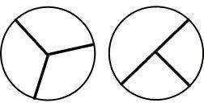  These are thirds These are NOT thirds  - The number of equal parts tell how many make a whole  - As the number of equal pieces in the whole increases, the size of the fractional pieces decreases  - The size of the fractional part is relative to the whole  - The number of children in one-half of a classroom is different than the number of children in one-half of a school. (the whole in each set is different therefore the half in each set will be different)  - When a whole is cut into equal parts, the denominator represents the number of equal parts  - The numerator of a fraction is the count of the number of equal parts  - ¾ means that there are 3 one-fourths  - Students can count one fourth, two fourths, three fourths  Students express fractions as fair sharing, parts of a whole, and parts of a set. They use various contexts (candy bars, fruit, and cakes) and a variety of models (circles, squares, rectangles, fraction bars, and number lines) to develop understanding of fractions and represent fractions. Students need many opportunities to solve word problems that require fair sharing.  To develop understanding of fair shares, students first participate in situations where the number of objects is greater than the number of children and then progress into situations where the number of objects is less than the number of children.  Examples:  - Four children share six brownies so that each child receives a fair share. How many brownies will each child receive?  - Six children share four brownies so that each child receives a fair share. What portion of each brownie will each child receive?  - What fraction of the rectangle is shaded? How might you draw the rectangle in another way but with the same fraction shaded?  Solution: or  What fraction of the set is black?  Solution:  Solution:
2. Understand a fraction as a number on the number line; represent fractions on a number line diagram.  - Represent a fraction 1/b on a number line diagram by defining the interval from 0 to 1 as the whole and partitioning it into b equal parts. Recognize that each part has size 1/b and that the endpoint of the part based at 0 locates the number 1/b on the number line.  - Represent a fraction a/b on a number line diagram by marking off a lengths 1/b from 0. Recognize that the resulting interval has size a/b and that its endpoint locates the number a/b on the number line.  (MP 5) | - Show fractions as points and distances on a number line.  - Explain that repeated addition of unit fractions forms of a whole. | Students transfer their understanding of parts of a whole to partition a number line into equal parts. There are two new concepts addressed in this standard which students should have time to develop.  - On a number line from 0 to 1, students can partition (divide) it into equal parts and recognize that each segmented part represents the same length.  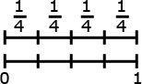  - Students label each fractional part based on how far it is from zero to the endpoint.  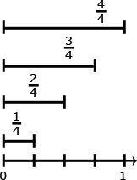  An interactive whiteboard may be used to help students develop these concepts.
3. Explain equivalence of fractions in special cases, and compare fractions by reasoning about their size.  - Understand two fractions as equivalent (equal) if they are the same size, or the same point on a number line.  - Recognize and generate simple equivalent fractions, e.g., 1/2 = 2/4, 4/6 = 2/3). Explain why the fractions are equivalent, e.g., by using a visual fraction model.  - Express whole numbers as fractions, and recognize fractions that are equivalent to whole numbers. Examples: Express 3 in the form 3 = 3/1; recognize that 6/1 = 6; locate 4/4 and 1 at the same point of a number line diagram.  - Compare two fractions with the same numerator or the same denominator by reasoning about their size. Recognize that comparisons are valid only when the two fractions refer to the same whole. Record the results of comparisons with the symbols >, =, or <, and justify the conclusions, e.g., by using a visual fraction model.  (MP 2, MP 3, MP 4, MP 5, MP 7) | - Compare fractions using models and number lines.  - Use models and numbers lines to identify equivalent fractions  - Express whole numbers as fractions  - Write fractions in simplest form  - Explain why the size of a fractional part is relative to the size of the whole | An important concept when comparing fractions is to look at the size of the parts and the number of the parts. For example, 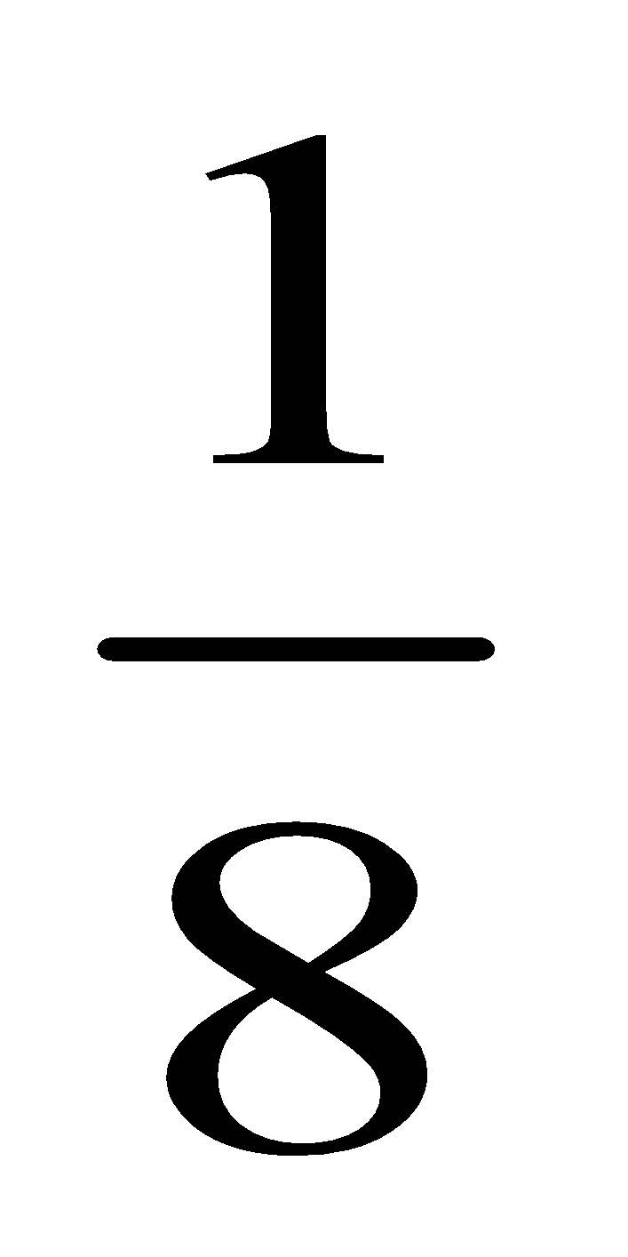 is smaller than 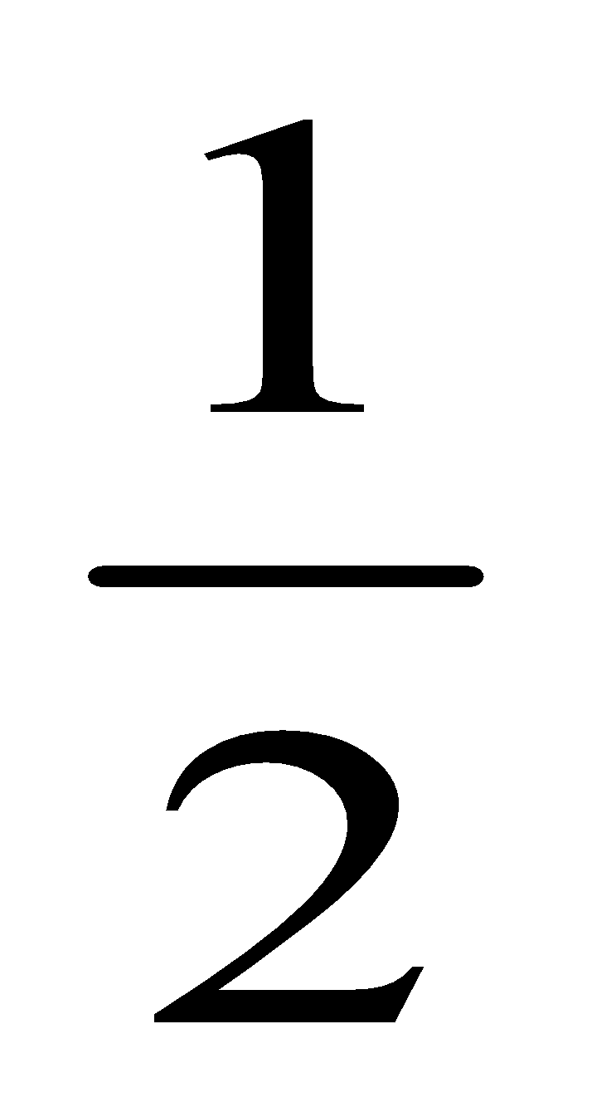because when 1 whole is cut into 8 pieces, the pieces are much smaller than when 1 whole is cut into 2 pieces.  Students recognize when examining fractions with common denominators, the wholes have been divided into the same number of equal parts. So the fraction with the larger numerator has the larger number of equal parts.  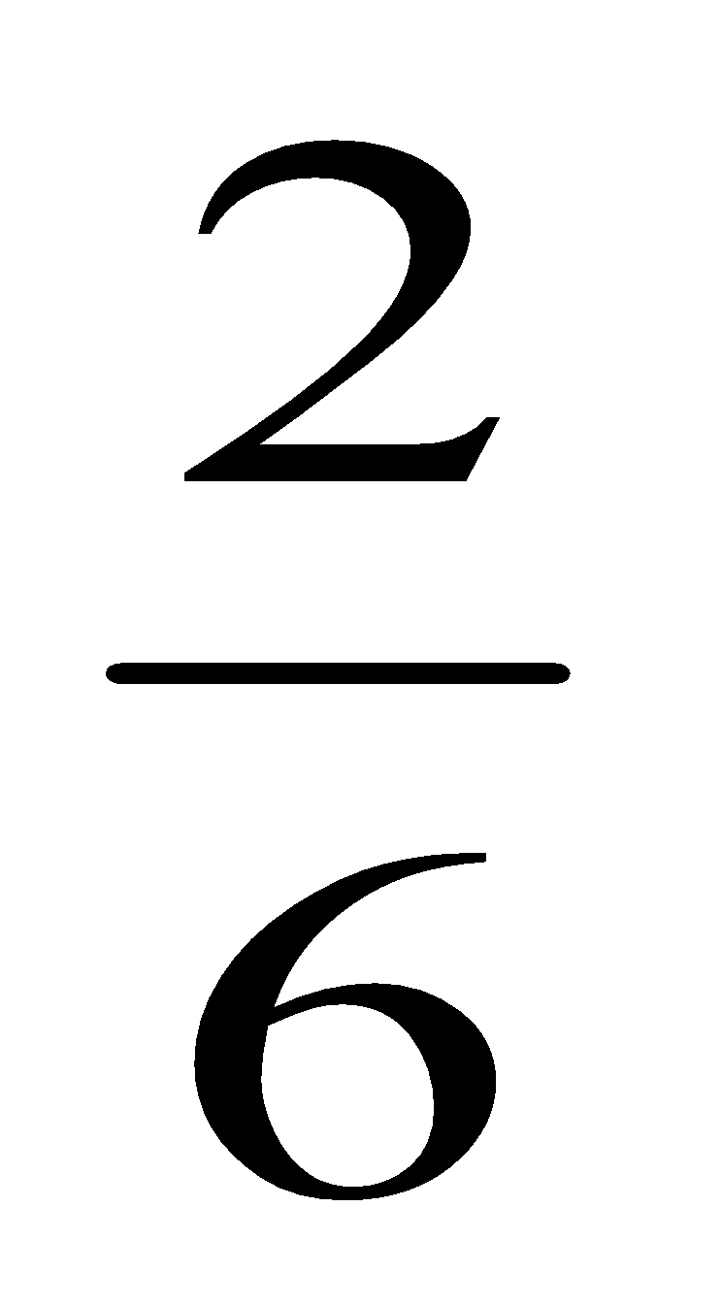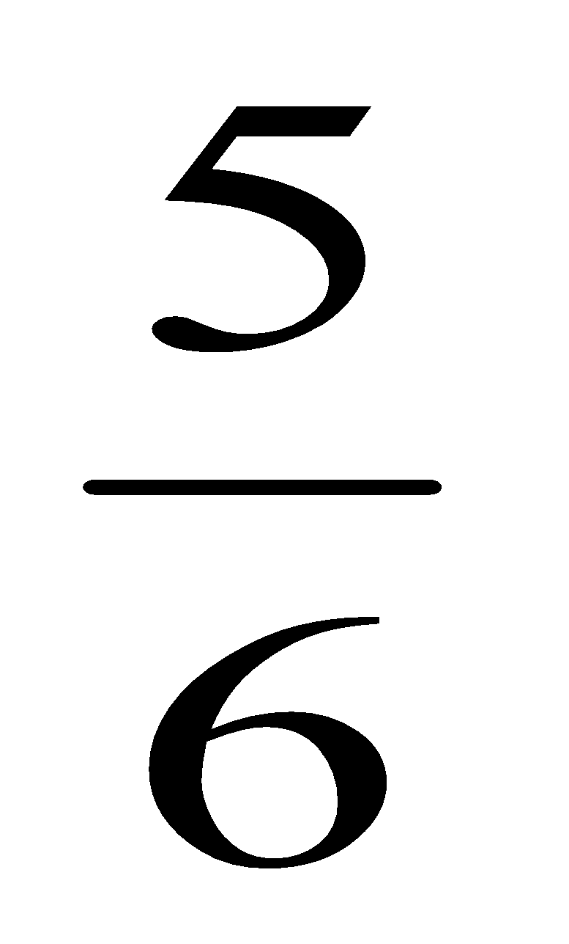  <  To compare fractions that have the same numerator but different denominators, students understand that each fraction has the same number of equal parts but the size of the parts are different. They can infer that the same number of smaller pieces is less than the same number of bigger pieces.  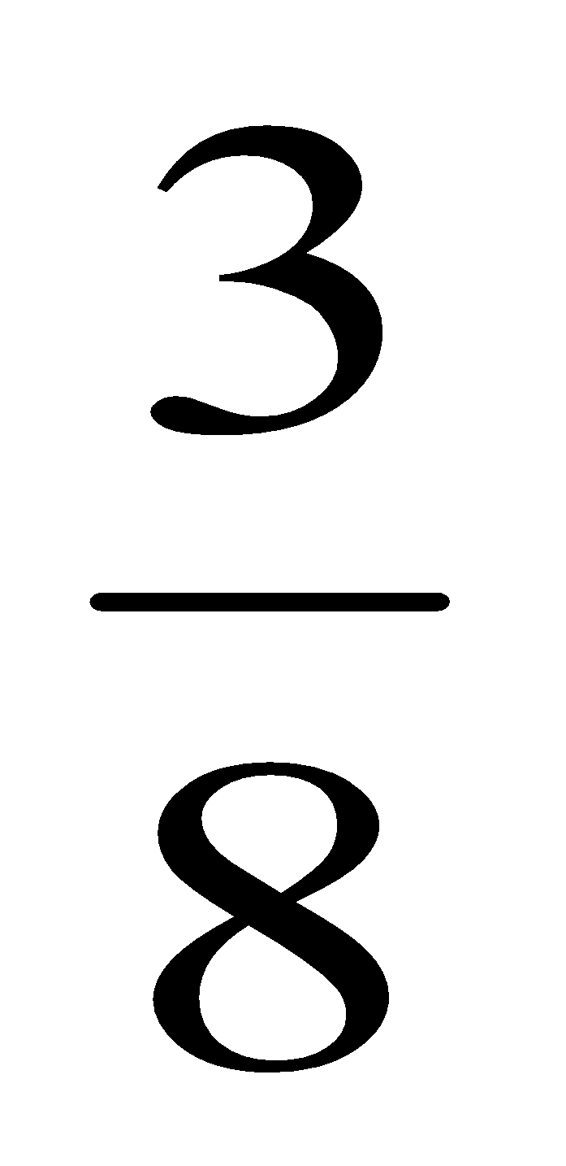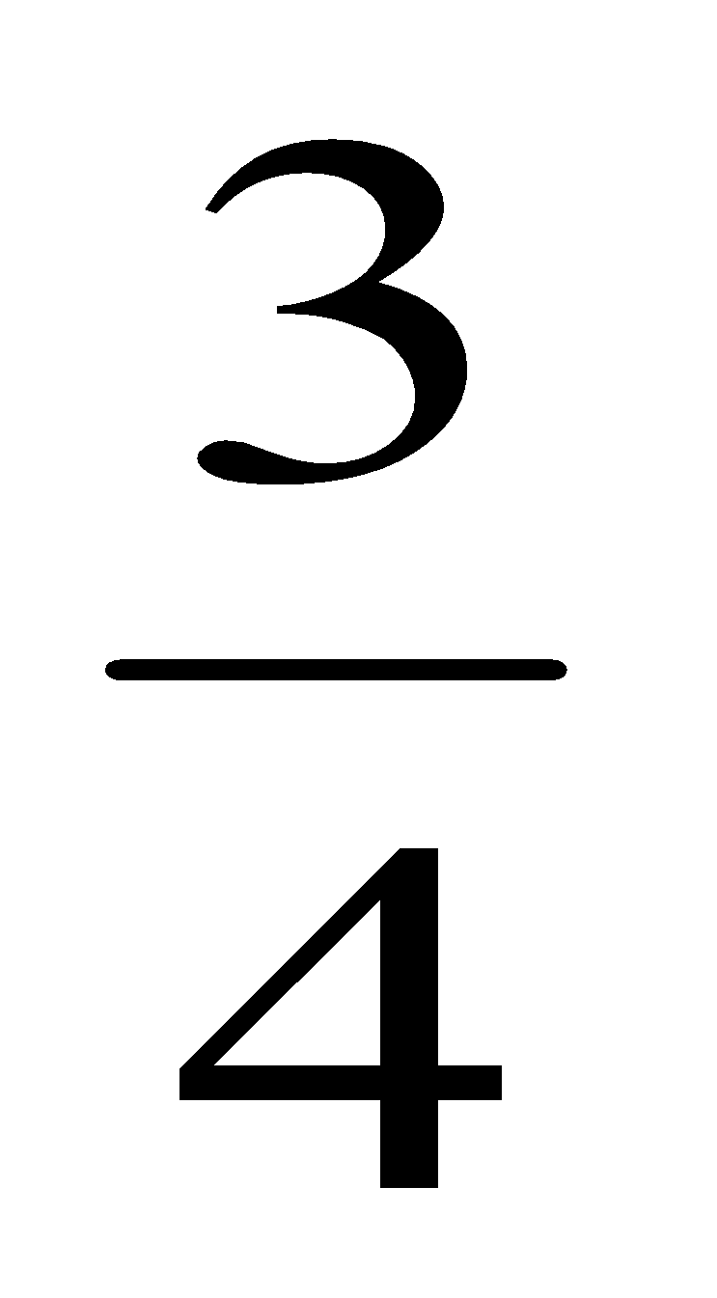  <

Differentiation/Modifications/Accommodations
Gifted and Talented | English Language Learners | Students with Disabilities | Students At Risk of School Failure
- Envision 2020 advanced/enrichment practice  - Design and present a “Classroom Garden”. Students must partition one classroom into 4 gardens using fractional models, sets and number lines to represent their design.  - After reading a mentor text about fractions (ie: The Hershey’s Milk Chocolate Fractions Book by Jerry Pallotta) students will create their own fraction book  - Create a comparison of fractions game for a math center (ie: War) | - Using demonstration: (ie: Create three visual representations of the same multiplication or division problem)  - Using manipulatives  - Using small group interactions and peer questioning  - Using pictures and graphic organizers  - Scavenger hunt  - Place value mat or chart  - Envision 2020 ELL activities  - For more, see http://www.state.nj.us/education/modelcurriculum/ela/ellscaffolding/3u1.pdf | - RTI approaches: prevent misconceptions, error intervention, reteaching set, reteaching worksheets  - Extended time  - Modified assignments  - Small group, alternate location  - Modeling  - Manipulatives  - Video tutorials  - Scavenger hunt  - Place value mat or chart  - Color coding methods  - Flashcards  - Refer to each student’s IEP for more specific modifications | - Using demonstration: (ie: Create three visual representations of the same multiplication or division problem)  - Using manipulatives  - Using small group interactions and peer questioning  - Using pictures and graphic organizers  - Scavenger hunt  - Place value mat or chart  - Envision 2020 ELL activities  - Morning tutoring  - After school program  - Parental contact  - Tier II and Tier III Intervention

Math Curriculum: Grade 3
Measurement and Data
Math Standard 3.MD.A.1, 3.MD.A.2

Essential Question(s): How can measurement be used to solve problems?
Vocabulary: minute, hour, elapsed time, volume, mass, gram, kilogram, liter
Content: Measurement and Data
A. Solve problems involving measurement and estimation of intervals of time, liquid volumes, and masses of objects.
SLS Standards: 3.MD.A.1, 3.MD.A.2
Standards for Mathematical Practice: MP 1, MP 2, MP 4, MP 5, MP 6
Skills | Instructional Procedures | Explanations and Examples | Interdisciplinary Connections
1. Tell and write time to the nearest minute and measure time intervals in minutes. Solve word problems involving addition and subtraction of time intervals in minutes, e.g., by representing the problem on a number line diagram.  (MP 1, MP 2, MP 4, MP 5) | - Tell time to the nearest minute  - Read time to the nearest minute using analog and digital clocks  - Use elapsed time  - Add and subtract time  - Use a demonstration clock with moveable hands to help students understand concept of elapsed time  - Draw a time line (number line) for sequence of events) | Students in second grade learned to tell time to the nearest five minutes. In third grade, they extend telling time and measure elapsed time both in and out of context using clocks and number lines.  Students may use an interactive whiteboard to demonstrate understanding and justify their thinking. | Social Studies:  Time line of historical events  Art:  Create a clock
2. Measure and estimate liquid volumes and masses of objects using standard units of grams (g), kilograms (kg), and liters (l).¹ Add, subtract, multiply, or divide to solve one-step word problems involving masses or volumes that are given in the same units, e.g., by using drawings (such as a beaker with a measurement scale) to represent the problem.²  (MP 1, MP 2, MP 4, MP 5, MP 6) | - Select appropriate tools and units to estimate and measure volume and mass  - Determine the volume and mass of a container  - Use reference to estimate mass  - Estimate and measure capacity in liter and milliliters | Students need multiple opportunities weighing classroom objects and filling containers to help them develop a basic understanding of the size and weight of a liter, a gram, and a kilogram. Milliliters may also be used to show amounts that are less than a liter.  Example:  Students identify 5 things that weigh about one gram. They record their findings with words and pictures. (Students can repeat this for 5 grams and 10 grams.) This activity helps develop gram benchmarks. One large paperclip weighs about one gram. A box of large paperclips (100 clips) weighs about 100 grams so 10 boxes would weigh one kilogram. | Science:  Measure body  Life and Career Skills:  Investigate careers that use metric measurements  Writing:  Math Journal

Differentiation/Modifications/Accommodations
Gifted and Talented | English Language Learners | Students with Disabilities | Students At Risk of School Failure
- Envision 2020 advanced/enrichment practice  - Research a career that uses metric units. Write a journal entry including the following; the importance of knowing the metric unit for the job and what would be involved during a day’s work  - Create recipes using both customary and metric units  - Create an itinerary for a day at Six Flags; including bathroom breaks, rollercoaster time length and waiting in line | - Using demonstration: (ie: Create three visual representations of the same multiplication or division problem)  - Using manipulatives  - Using small group interactions and peer questioning  - Using pictures and graphic organizers  - Scavenger hunt  - Place value mat or chart  - Envision 2020 ELL activities  - For more, see http://www.state.nj.us/education/modelcurriculum/ela/ellscaffolding/3u1.pdf | - RTI approaches: prevent misconceptions, error intervention, reteaching set, reteaching worksheets  - Extended time  - Modified assignments  - Small group, alternate location  - Modeling  - Manipulatives  - Video tutorials  - Scavenger hunt  - Place value mat or chart  - Color coding methods  - Flashcards  - Refer to each student’s IEP for more specific modifications | - Using demonstration: (ie: Create three visual representations of the same multiplication or division problem)  - Using manipulatives  - Using small group interactions and peer questioning  - Using pictures and graphic organizers  - Scavenger hunt  - Place value mat or chart  - Envision 2020 ELL activities  - Morning tutoring  - After school program  - Parental contact  - Tier II and Tier III Intervention

Math Curriculum: Grade 3
Measurement and Data
Math Standard 3.MD.B.3, 3.MD.B.4

Essential Question(s): How do we use data to solve problems?
Vocabulary: Bar graph, pictograph, vertical, horizontal, title, scale, category label, data, scale label, categories
Content: Measurement and Data
SLS Anchor Standard: B. Represent and Interpret Data.
SLS Standards: 3.MD.B.3, 3.MD.B.4
Standards for Mathematical Practice: MP 1, MP 2, MP 4, MP 5
Skills | Instructional Procedures | Explanations and Examples | Interdisciplinary Connections
3. Draw a scaled picture graph and a scaled bar graph to represent a data set with several categories. Solve one- and two-step “how many more” and “how many less” problems using information presented in scaled bar graphs. For example, draw a bar graph in which each square in the bar graph might represent 5 pets.  (MP 1, MP 2, MP 4) | - Interpret bar graphs and pictographs to solve real word examples  - Interpret picture and bar graphs with scales. | Students should have opportunities reading and solving problems using scaled graphs before being asked to draw one. The following graphs all use five as the scale interval, but students should experience different intervals to further develop their understanding of scale graphs and number facts.  - Pictographs: Scaled pictographs include symbols that represent multiple units. Below is an example of a pictograph with symbols that represent multiple units. Graphs should include a title, categories, category label, key, and data.  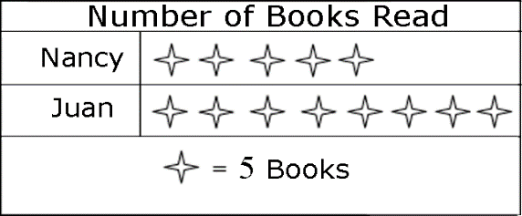  How many more books did Juan read than Nancy?  - Single Bar Graphs: Students use both horizontal and vertical bar graphs. Bar graphs include a title, scale, scale label, categories, category label, and data.  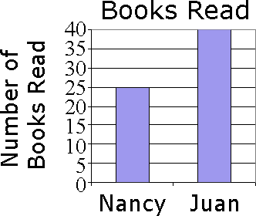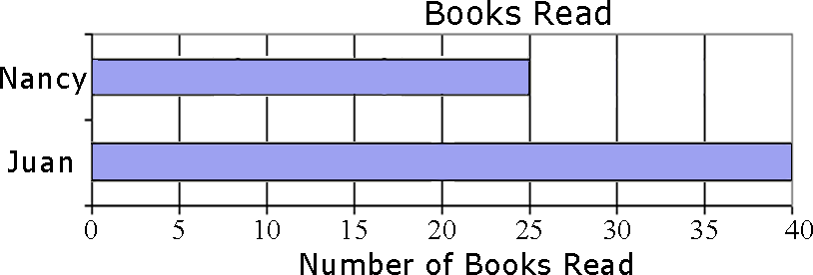 | Science:  Record data  Social Studies:  Record Data  Art:  Halloween Candy Graph
4. Generate measurement data by measuring lengths using rulers marked with halves and fourths of an inch. Show the data by making a line plot, where the horizontal scale is marked off in appropriate units— whole numbers, halves, or quarters.  (MP 2, MP 5) | - Measure length to the nearest quarter inch and half inch  - Compare data  - Chart growth from beginning to end of year  - Collect and organize data in different ways | Students in second grade measured length in whole units using both metric and U.S. customary systems. It’s important to review with students how to read and use a standard ruler including details about halves and quarter marks on the ruler. Students should connect their understanding of fractions to measuring to one-half and one-quarter inch. Third graders need many opportunities measuring the length of various objects in their environment.  Some important ideas related to measuring with a ruler are:  - The starting point of where one places a ruler to begin measuring  - Measuring is approximate. Items that students measure will not always measure exactly ¼, ½ or one whole inch. Students will need to decide on an appropriate estimate length.  - Making paper rulers and folding to find the half and quarter marks will help students develop a stronger understanding of measuring length  Students generate data by measuring and create a line plot to display their findings. An example of a line plot is shown below:  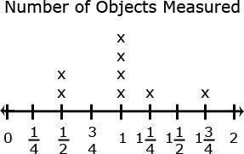 | Language Arts/ Literacy:  Abbreviations for all measurements  Physical Education:  Broad Jump

Differentiation/Modifications/Accommodations
Gifted and Talented | English Language Learners | Students with Disabilities | Students At Risk of School Failure
- Envision 2020 advanced/enrichment practice  - Design anchor charts to distinguish the importance and use of one graph from another (bar, picto, line plot)  - Research 10 monuments within the United States and record their height to the nearest quarter inch. Generate a bar graph or line plot to display their findings. | - Using demonstration: (ie: Create three visual representations of the same multiplication or division problem)  - Using manipulatives  - Using small group interactions and peer questioning  - Using pictures and graphic organizers  - Scavenger hunt  - Place value mat or chart  - Envision 2020 ELL activities  - For more, see http://www.state.nj.us/education/modelcurriculum/ela/ellscaffolding/3u1.pdf | - RTI approaches: prevent misconceptions, error intervention, reteaching set, reteaching worksheets  - Extended time  - Modified assignments  - Small group, alternate location  - Modeling  - Manipulatives  - Video tutorials  - Scavenger hunt  - Place value mat or chart  - Color coding methods  - Flashcards  - Refer to each student’s IEP for more specific modifications | - Using demonstration: (ie: Create three visual representations of the same multiplication or division problem)  - Using manipulatives  - Using small group interactions and peer questioning  - Using pictures and graphic organizers  - Scavenger hunt  - Place value mat or chart  - Envision 2020 ELL activities  - Morning tutoring  - After school program  - Parental contact  - Tier II and Tier III Intervention

Math Curriculum: Grade 3
Measurement and Data
Math Standards 3.MD.C.5, 3.MD.C.6, 3.MD.C.7

Essential Question(s): How do we measure area? How is area related to multiplication and addition?
Vocabulary: Area, plane figure, attribute, square units, product, distributive property, congruent, improvised units, square feet, square centimeter, square millimeter
Content: Measurement and Data
SLS Anchor Standard: C. Geometric measurement: understand concepts of area and relate area to multiplication and to addition.
SLS Standards: 3.MD.C.5, 3.MD.C.6, 3.MD.C.7
Standards for Mathematical Practice: MP 2, MP 3, MP 4, MP 5, MP 6, MP 7
Skills | Instructional Procedures | Explanations and Examples | Interdisciplinary Connections
5. Recognize area as an attribute of plane figures and understand concepts of area measurement.  - A square with side length 1 unit, called “a unit square,” is said to have “one square unit” of area, and can be used to measure area.  - A plane figure, which can be covered without gaps or overlaps by n unit squares is said to have an area of n square units.  (MP 2, MP 4, MP 5, MP 7) | - Find and compare the area of plane figures in different square units  - Develop foundation for understanding area  - How many rows of square units do I need to cover an index card  - Use geoboards to make a figure in square unity  - Square grid paper | Students develop understanding of using square units to measure area by:  - Using different sized square units  - Filling in an area with the same sized square units and counting the number of square units  - An interactive whiteboard would allow students to see that square units can be used to cover a plane figure.  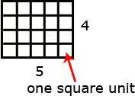 | Art:  Design a quilt
6.Measure areas by counting unit squares (square cm, square m, square in, square ft, and non-standard units).  (MP 2, MP 4, MP 5, MP 7) | - Measure area using improvised units. Example: paper clips, erasers, toothpicks, meter sticks, tissue box, floor/ ceiling tiles | Using different sized graph paper, students can explore the areas measured in square centimeters and square inches. An interactive whiteboard may also be used to display and count the unit squares (area) of a figure.
7. Relate area to the operations of multiplication and addition.  -Find the area of a rectangle with whole-number side lengths by tiling it, and show that the area is the same as would be found by multiplying the side lengths.  -Multiply side lengths to find areas of rectangles with whole-number side lengths in the context of solving real world and mathematical problems, and represent whole-number products as rectangular areas in mathematical reasoning.  -Use tiling to show in a concrete case that the area of a rectangle with whole-number side lengths a and b + c is the sum of a × b and a × c. Use area models to represent the distributive property in mathematical reasoning.  -Recognize area as additive. Find areas of rectilinear figures by decomposing them into non-overlapping rectangles and adding the areas of the non-overlapping parts, applying this technique to solve real world problems.  (MP 3, MP 4, MP 5, MP 6,  MP 7 | - Find the areas of rectangles and composite figures  - Make different plane figures with the same area  - Solve real world problems using the areas of rectangles | Students tile areas of rectangles, determine the area, record the length and width of the rectangle, investigate the patterns in the numbers, and discover that the area is the length times the width.  Example:  Joe and John made a poster that was 4’ by 3’. Mary and Amir made a poster that was 4’ by 2’. They placed their posters on the wall side-by-side so that that there was no space between them. How much area will the two posters cover?  Students use pictures, words, and numbers to explain their understanding of the distributive property in this context.  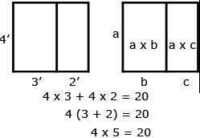  Example:  Students can decompose a rectilinear figure into different rectangles. They find the area of the figure by adding the areas of each of the rectangles together.  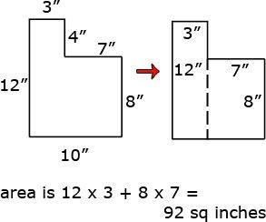 | Use post it notes  Writing:  Math Journals- Describe how to find the area of a rectangle.

Differentiation/Modifications/Accommodations
Gifted and Talented | English Language Learners | Students with Disabilities | Students At Risk of School Failure
- Envision 2020 advanced/enrichment practice  - Create a two dimensional drawing of a new Minecraft character that fits within a given area total (for example cannot exceed more than 105 sq ft)  - Design a three- dimensional city using recycled cardboard and provide the area and perimeter of each building and the entire city.  - Compose a musical piece (ie: sing-a-long, rap, jingle) to reinforce area and perimeter formulas | - Using demonstration: (ie: Create three visual representations of the same multiplication or division problem)  - Using manipulatives  - Using small group interactions and peer questioning  - Using pictures and graphic organizers  - Scavenger hunt  - Place value mat or chart  - Envision 2020 ELL activities  - For more, see http://www.state.nj.us/education/modelcurriculum/ela/ellscaffolding/3u1.pdf | - RTI approaches: prevent misconceptions, error intervention, reteaching set, reteaching worksheets  - Extended time  - Modified assignments  - Small group, alternate location  - Modeling  - Manipulatives  - Video tutorials  - Scavenger hunt  - Place value mat or chart  - Color coding methods  - Flashcards  - Refer to each student’s IEP for more specific modifications | - Using demonstration: (ie: Create three visual representations of the same multiplication or division problem)  - Using manipulatives  - Using small group interactions and peer questioning  - Using pictures and graphic organizers  - Scavenger hunt  - Place value mat or chart  - Envision 2020 ELL activities  - Morning tutoring  - After school program  - Parental contact  - Tier II and Tier III Intervention

Math Curriculum: Grade 3
Measurement and Data
Math Standards 3.MD.D.8

Essential Question(s): How do we calculate perimeter and use it to solve real world and mathematical problems? How are area and perimeter related?
Vocabulary: Perimeter, polygons, side length
Content: Measurement and Data
SLS Anchor Standard: D. Geometric measurement: recognize perimeter as an attribute of plane figures and distinguish between linear and area measures.
SLS: 3.MD.D.8
Standards for Mathematical Practice: MP 1, MP 2, MP 4, MP 5
Skills | Instructional Procedures | Explanations and Examples | Interdisciplinary Connections
8. Solve real world and mathematical problems involving perimeters of polygons, including finding the perimeter given the side lengths, finding an unknown side length, and exhibiting rectangles with the same perimeter and different areas or with the same area and different perimeters.  (MP 1, MP 2, MP 4, MP 5) | - Measure the perimeter of plane figures  - Choose the appropriate tool unit, and strategy to measure perimeter  - Compare area and perimeter of two plane figures | Students develop an understanding of the concept of perimeter by walking around the perimeter of a room, using rubber bands to represent the perimeter of a plane figure on a geoboard, or tracing around a shape on an interactive whiteboard. They find the perimeter of objects; use addition to find perimeters; and recognize the patterns that exist when finding the sum of the lengths and widths of rectangles.  Students use geoboards, tiles, and graph paper to find all the possible rectangles that have a given perimeter (e.g., find the rectangles with a perimeter of 14 cm.) They record all the possibilities using dot or graph paper, compile the possibilities into an organized list or a table, and determine whether they have all the possible rectangles.  Given a perimeter and a length or width, students use objects or pictures to find the missing length or width. They justify and communicate their solutions using words, diagrams, pictures, numbers, and an interactive whiteboard.  Students use geoboards, tiles, graph paper, or technology to find all the possible rectangles with a given area (e.g. find the rectangles that have an area of 12 square units.) They record all the possibilities using dot or graph paper, compile the possibilities into an organized list or a table, and determine whether they have all the possible rectangles. Students then investigate the perimeter of the rectangles with an area of 12.  Area Length Width Perimeter  12 sq. in. 1 in. 12 in. 26 in.  12 sq. in. 2 in. 6 in. 16 in.  12 sq. in 3 in. 4 in. 14 in.  12 sq. in 4 in. 3 in. 14 in.  12 sq. in 6 in. 2 in. 16 in.  12 sq. in 12 in. 1 in. 26 in.  The patterns in the chart allow the students to identify the factors of 12, connect the results to the commutative property, and discuss the differences in perimeter within the same area. This chart can also be used to investigate rectangles with the same perimeter. It is important to include squares in the investigation. | Writing:  Math Journal-justify and communicate their solutions using words, pictures, etc.  Science:  Find perimeter of a garden  Create a problem  Pair up with a partner to have them solve the problems  Art:  Create picture frames

Differentiation/Modifications/Accommodations
Gifted and Talented | English Language Learners | Students with Disabilities | Students At Risk of School Failure
- Envision 2020 advanced/enrichment practice  - Create a two dimensional drawing of a scene on graph paper; student must record the area and perimeter of each individual object along with the total area  - Taking turns, students will use geoboards to create a shape based on the area/perimeter clues provided by their partner | - Using demonstration: (ie: Create three visual representations of the same multiplication or division problem)  - Using manipulatives  - Using small group interactions and peer questioning  - Using pictures and graphic organizers  - Scavenger hunt  - Place value mat or chart  - Envision 2020 ELL activities  - For more, see http://www.state.nj.us/education/modelcurriculum/ela/ellscaffolding/3u1.pdf | - RTI approaches: prevent misconceptions, error intervention, reteaching set, reteaching worksheets  - Extended time  - Modified assignments  - Small group, alternate location  - Modeling  - Manipulatives  - Video tutorials  - Scavenger hunt  - Place value mat or chart  - Color coding methods  - Flashcards  - Refer to each student’s IEP for more specific modifications | - Using demonstration: (ie: Create three visual representations of the same multiplication or division problem)  - Using manipulatives  - Using small group interactions and peer questioning  - Using pictures and graphic organizers  - Scavenger hunt  - Place value mat or chart  - Envision 2020 ELL activities  - Morning tutoring  - After school program  - Parental contact  - Tier II and Tier III Intervention

Math Curriculum: Grade 3
Geometry
Math Standards 3.G.A.1, 3.G.A.2

Essential Question(s): How do we classify polygons?
Vocabulary: Rhombus, Quadrilaterals, right angle, angle
Content: Geometry
SLS Anchor Standard: A. Reason with shapes and their attributes.
SLS Standards: 3.G.A.1, 3.G.A.2
Standards for Mathematical Practice: MP 2, MP 5, MP 6, MP 7
Skills | Instructional Procedures | Explanations and Examples | Interdisciplinary Connections
1. Understand that shapes in different categories (e.g., rhombuses, rectangles, and others) may share attributes (e.g., having four sides), and that the shared attributes can define a larger category (e.g., quadrilaterals). Recognize rhombuses, rectangles, and squares as examples of quadrilaterals, and draw examples of quadrilaterals that do not belong to any of these subcategories.  (MP 5, MP 6, MP 7) | - Review the identification of rhombus, quadrilaterals  - Classify and sort polygons and quadrilaterals by attributes and properties  - Describe, analyze, compare and classify two-dimensional shapes by their sides and angles | In second grade, students identify and draw triangles, quadrilaterals, pentagons, and hexagons. Third graders build on this experience and further investigate quadrilaterals (technology may be used during this exploration). Students recognize shapes that are and are not quadrilaterals by examining the properties of the geometric figures. They conceptualize that a quadrilateral must be a closed figure with four straight sides and begin to notice characteristics of the angles and the relationship between opposite sides. Students should be encouraged to provide details and use proper vocabulary when describing the properties of quadrilaterals. They sort geometric figures (see examples below) and identify squares, rectangles, and rhombuses as quadrilaterals.  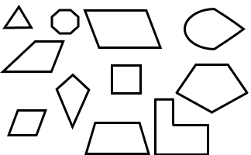 | Art:  Find magazine pictures that are and are not quadrilaterals
2. Partition shapes into parts with equal areas. Express the area of each part as a unit fraction of the whole. For example, partition a shape into 4 parts with equal area, and describe the area of each part as 1/4 of the area of the shape  (MP 2, MP 5, MP 6, MP7) | - Investigate composing and decomposing two dimensional shapes  - Demonstrate partitioning | Given a shape, students partition it into equal parts, recognizing that these parts all have the same area. They identify the fractional name of each part and are able to partition a shape into parts with equal areas in several different ways.  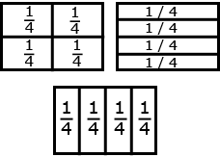

Differentiation/Modifications/Accommodations
Gifted and Talented | English Language Learners | Students with Disabilities | Students At Risk of School Failure
- Envision 2020 advanced/enrichment practice  - Formulate riddle clues for partner to identify the geometric shape  - Design pneumonic device for each polygon name and represent it in visual form (triangle through dodecagon)  - Create real life word problems using unit fractions (ie: ordering pizza for a class party) | - Using demonstration: (ie: Create three visual representations of the same multiplication or division problem)  - Using manipulatives  - Using small group interactions and peer questioning  - Using pictures and graphic organizers  - Scavenger hunt  - Place value mat or chart  - Envision 2020 ELL activities  - For more, see http://www.state.nj.us/education/modelcurriculum/ela/ellscaffolding/3u1.pdf | - RTI approaches: prevent misconceptions, error intervention, reteaching set, reteaching worksheets  - Extended time  - Modified assignments  - Small group, alternate location  - Modeling  - Manipulatives  - Video tutorials  - Scavenger hunt  - Place value mat or chart  - Color coding methods  - Flashcards  - Refer to each student’s IEP for more specific modifications | - Using demonstration: (ie: Create three visual representations of the same multiplication or division problem)  - Using manipulatives  - Using small group interactions and peer questioning  - Using pictures and graphic organizers  - Scavenger hunt  - Place value mat or chart  - Envision 2020 ELL activities  - Morning tutoring  - After school program  - Parental contact  - Tier II and Tier III Intervention

