Mathematics Curriculum:
Grade Eight

Born On & Board Approved: July 25, 2017
Re-Adopted: August 23, 2022

The following maps outline the Student Learning Standards for grade eight mathematics determined by the State Standards Initiative. Below is a list of assessment tools that are recommended for tracking student progress in these areas. In addition, resources that can be used in conjunction with instruction of these standards are provided but not limited to the list below.

Assessment:
Formative Assessment Class-Work Review
Open-Ended Problems Project-Based Assessment
Self-Assessment Teacher Observation
End of Year Assessment Group & Cooperative Work
Benchmark Assessment Math Software (ex. Study Island)
Homework Review
Summative Assessment

Resources: _
Math Journals Center Games Tangrams
Bar Models Ten Frame Geometric Shapes
Math Word Wall Protractors Geo-Board
Connecting Cubes Mini White Boards Textbooks
Number Line Manipulatives Rulers
Grid Paper Math Songs/Poems Three Dimensional Shapes
Computer Software Calculators Wiki-Sticks
Interactive White Board Fraction Tiles Pattern Blocks
Compass Measurement Tools

Websites:
http://www.aplusmath.com www.wolframalpha.com www.interactmath.com
http://www.studyisland.com www.kutasoftware.com www.number2.com
http://www.funbrain.com www.illuminations.nctm.org www.khanacademy.org
http://www.songsforteaching.com www.ixl.com www.betterlesson.com
www.purplemath.com www.tenmarks.com www.buzzmath.com

References: http://www.state.nj.us/education/aps/cccs/math/
NJ Technology Standards: http://www.state.nj.us/education/cccs/2014/tech/8.pdf
NJ Career Ready Practices: http://www.state.nj.us/education/aps/cccs/career/

Standards for Mathematical Practice
MP. 1 - Make Sense of problems and persevere in solving them.
MP. 2 - Reason Abstractly and Quantitatively
Mp. 3 - Construct Viable Arguments and Critique the Reasoning of Others
MP. 4 - Model with Mathematics
MP. 5 - Use Appropriate Tools Strategically
MP. 6 - Attend to Precision
MP. 7 - Look for and make use of Structure
MP. 8 - Look for and Express Regularity in Repeated Reasoning

Curriculum Details
Mathematics - Eighth Grade
Core Materials | Holt-McDougal, Numbers World
Interdisciplinary Connections | ELA:  NJSLSA.R1. Read closely to determine what the text says explicitly and to make logical inferences and relevant connections from it; cite specific textual evidence when writing or speaking to support conclusions drawn from the text.  NJSLSA.W2. Write informative/explanatory texts to examine and convey complex ideas and information clearly and accurately through the effective selection, organization, and analysis of content.  W.8.1 Write arguments to support claims with clear reasons and relevant evidence.  W.8.10 Write routinely over extended time frames (time for research, reflection, metacognition/self correction, and revision) and shorter time frames (a single sitting or a day or two) for a range of discipline-specific tasks, purposes, and audiences  NJSLSAS.L1 Demonstrate command of the conventions of standard English grammar and usage when writing or speaking  Social Studies  6.3.8.EconET.1: Using quantitative data, evaluate the opportunity cost of a proposed economic action, and take a position and support it (e.g. healthcare, education, transportation).  6.3.8.EconET.2: Assess the impact of government incentives and disincentives on the economy (e.g. patents, protection of private property, taxes)
Career Ready Practices | CRP2. Apply appropriate academic and technical skills.  CRP4. Communicate clearly and effectively and with reason.  CRP6. Demonstrate creativity and innovation.  CRP7. Employ valid and reliable research strategies.  CRP8. Utilize critical thinking to make sense of problems and persevere in solving them.  CRP12. Work productively in teams while using cultural global competence.
Career Readiness, Life LIteracies, and Key Skills | 9.1.8.CDM.1: Compare and contrast the use of credit cards and debit cards for specific purchases and the advantages and disadvantages of using each.  9.1.8.CP.1: Compare the prices for the same goods and services.  9.1.8.FI.4: Analyze the interest rates and fees associated with financial products.  9.1.8.PB.3: Explain how to create a budget that aligns with financial goals.  9.1.8.PB.7: Brainstorm techniques that will help decrease expenses including comparison shopping, negotiating, and day-to-day expense management.  9.2.8.CAP.3: Explain how career choices, educational choices, skills, economic conditions, and personal behavior affect income.  9.2.8.CAP.14: Evaluate sources of income and alternative resources to accurately compare employment options.  9.4.8.GCA.1: Model how to navigate cultural differences with sensitivity and respect.  9.4.8.GCA.2: Demonstrate openness to diverse ideas and perspectives through active discussions to achieve a group goal.  9.4.8.TL.1: Construct a spreadsheet in order to analyze multiple data sets, identify relationships, and facilitate data-based decision-making.  9.4.8.TL.3: Select appropriate tools to organize and present information digitally.
Computer Science and Design Thinking | 8.1.8.DA.1: Organize and transform data collected using computational tools to make it usable for a specific purpose.  8.1.8.DA.2: Explain the difference between how a computer stores data as bits and how the data is displayed.  8.1.8.DA.3: Identify the appropriate tool to access data based on its file format.  8.1.8.DA.4: Transform data to remove errors and improve the accuracy of the data for analysis.  8.2.8.ED.3: Develop a proposal for a solution to a real-world problem that includes a model (e.g. physical prototype, graphical/technical sketch).  8.1.8.AP.2: Create clearly named variables that represent different data types and perform operations on their values.

Math Curriculum
Grade Eight

Content: The Number System
Essential Question(s):
How are real numbers classified?
Why does one need to distinguish between rational and irrational numbers?
How does one locate irrational numbers on a number line?
Standards: 8.NS.A.1
A. Know that there are numbers that are not rational, and approximate them by rational numbers.
Standards for Mathematical Practice: MP 2
Vocabulary: rational approximations, irrational, decimal expansion
Grade Specific Standards | Skills |  | Instructional Procedures | Explanations and Examples
1. Know that numbers that are not rational are called irrational. Understand informally that every number has a decimal expansion; for rational numbers show that the decimal expansion repeats eventually, and convert a decimal expansion which repeats eventually into a rational number.  (MP2) | - Show that the decimal expansion of a ration number terminates or repeats eventually.  - Convert a decimal expansion, which repeats eventually into a rational number.  - Expand number system (and number line) to include rational numbers  - Understand irrational numbers and their decimal approximation |  | - Assess prior knowledge of rational numbers and decimal expansion  - Have students provide examples of each type of real number | Students can use graphic organizers to show the relationship between the subsets of the real number system.  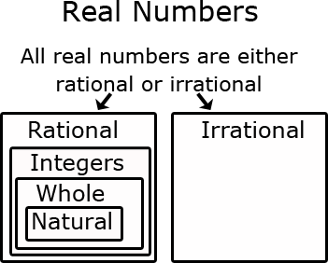
2. Use rational approximations of irrational numbers to compare the size of irrational numbers, locate them approximately on a number line diagram, and estimate the value of expressions (e.g., π²). For example, by truncating the decimal expansion of √2, show that √2 is between 1 and 2, then between 1.4 and 1.5, and explain how to continue on to get better approximations. | - Find rational approximations of irrational numbers  - Locate approximation of irrational numbers on a number line.  - Estimate the value of expressions of irrational numbers.  - Use rational numbers to approximate irrational numbers (using manipulatives and number lines |  | - Place randomly selected irrational numbers on a number line | Students can approximate square roots by iterative processes.  Examples:  - Approximate the value of 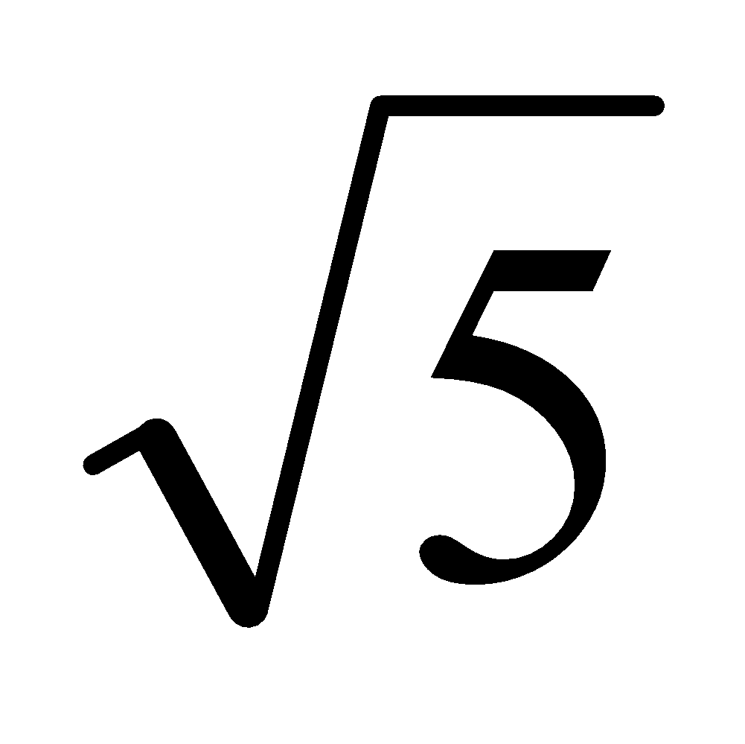to the nearest hundredth.  Solution: Students start with a rough estimate based upon perfect squares. falls between 2 and 3 because 5 falls between 2² = 4 and 3² = 9. The value will be closer to 2 than to 3. Students continue the iterative process with the tenths place value. falls between 2.2 and 2.3 because 5 falls between 2.2² = 4.84 and 2.3² = 5.29. The value is closer to 2.2. Further iteration would show that the value of is between 2.23 and 2.24 since 2.23² is 4.9729 and 2.24² is 5.0176.  - Compare √2 and √3 by estimating their values, plotting them on a number line, and making comparative statements.  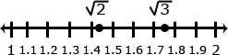  Solution: Statements for the comparison could include:  √2 is approximately 0.3 less than √3  √2 is between the whole numbers 1 and 2  √3 is between 1.7 and 1.8
Differentiation/Accommodations/Modifications
Gifted and Talented |  | English Language Learners |  | Students with Disabilities | Students at Risk of School Failure
- Teacher gives students real life situations and students create an outcome  - Rational and irrational webquest.  In your exploration of the Real Number System, you have several assignments to complete:  - Use the internet to define real number system vocabulary words  - Use the internet to research the real number system  - Use your definitions, research, and the photo gallery to write a journal entry  - Make an original cartoon or comic strip that demonstrates the difference between rational and irrational numbers  - Take the real number system quiz |  | - Video clips  - Choose excerpt(s) from book to focus on vocabulary development, comprehension  - Translate vocabulary into native language  - Read aloud  - Word Wall  - Build background knowledge  - Picture Associations  - Partner Work  - For more, see http://www.state.nj.us/education/modelcurriculum/ela/ellscaffolding/3u1.pdf |  | - Extended time  - Modified assignments  - Small group, alternate location  - Modeling  - Read aloud problems  - Calculator  - Build background knowledge  - Oral/visual reminders  - Peer assistance  - Picture associations with vocabulary  - Build background knowledge of the number system  - Refer to each student’s IEP for more specific modifications | - RTI strategies including: teacher modeling, gradual release, think-Pair-Share, Think Aloud, Interactive notes  - Tier II and Tier III intervention  - More frequent STAR assessments  - Morning tutoring  - After school program  - Parental contact

Math Curriculum
Grade Eight

Content: Expressions and Equations
Essential Question(s):
How are expressions simplified and equations solved when working with radicals and integer exponents?
What are the laws of exponents? How can the law of exponents be used to simplify expressions?
How can you solve equations with exponents?
Why is scientific notation used?
How can you compare numbers written in scientific notation?
How can you preform operations with numbers written in scientific notation?
Standards: 8.EE.A
A. Expressions and Equations work with radicals and integer exponents.
Standards for Mathematical Practice: MP 1, MP2, MP 4, MP 5, Mp 6, MP 7, MP8
Vocabulary: square root, cube, base, exponent, perfect squares, perfect cubes, irrational, scientific notation, prefix system (tera, giga)
Grade Specific Standards | Skills | Instructional Procedures | Explanations and Examples
1. Know and apply the properties of integer exponents to generate equivalent numerical expressions. For example, 3² × 3^{–5} = 3^{–3} = 1/3³ = 1/27.  (MP 1, MP2, MP4, MP5, MP6, MP7, MP8) | - Develop understanding of exponent properties conceptually  - Apply understanding of exponent properties with integer and variable bases, including:  - product of powers  - quotient of powers  - power of a power  - zero exponents  - negative exponents | - Review the definition of a negative exponent and simplification of exponents  - Understand and use exponential notations  - Identify the base and exponent of an expression  - Expand and evaluate an expression | Solve problems using exponential notations  Examples:  - 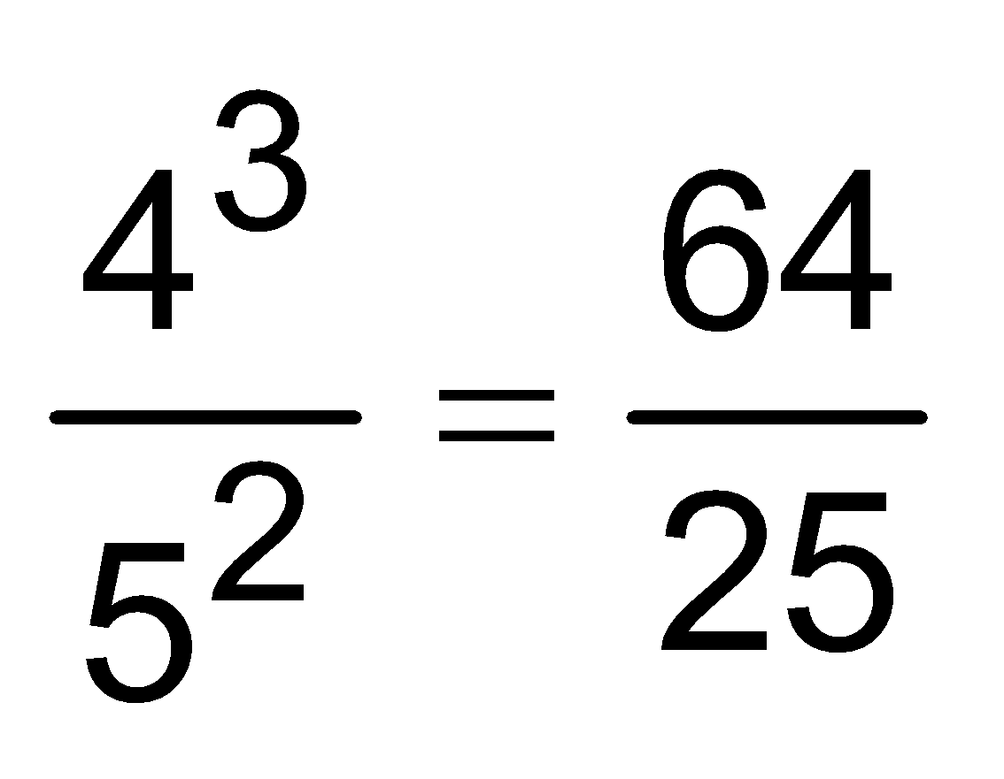  - 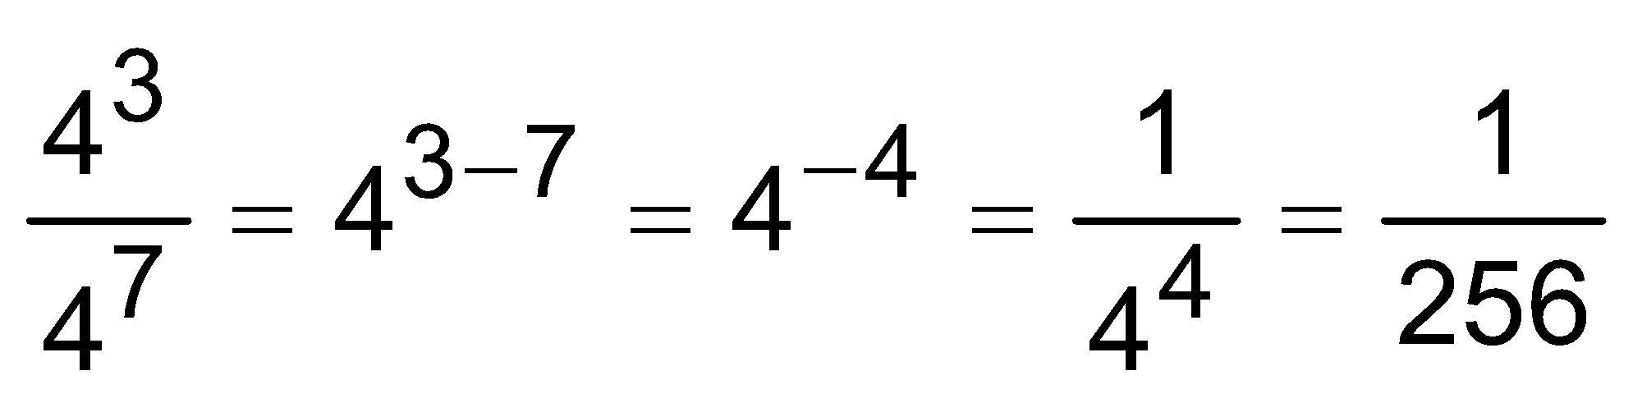  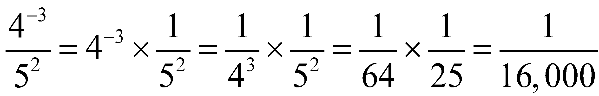
2. Use square root and cube root symbols to represent solutions to equations of the form x² = p and x³ = p, where p is a positive rational number. Evaluate square roots of small perfect squares and cube roots of small perfect cubes. Know that √2 is irrational.  - (MP 2, MP4, MP5, MP6, MP7,MP8) | - Evaluate square roots and cube roots of perfect squares/cubes  - Approximate square roots of non-perfect squares  - Solve simple equations of the form x2=p and x3=p and represent solutions as whole numbers, square roots, or cube roots | - Review perfect square and perfect cube roots  - Solve equations involving squares and cubes of variables  Solve real world problems | Examples:  - 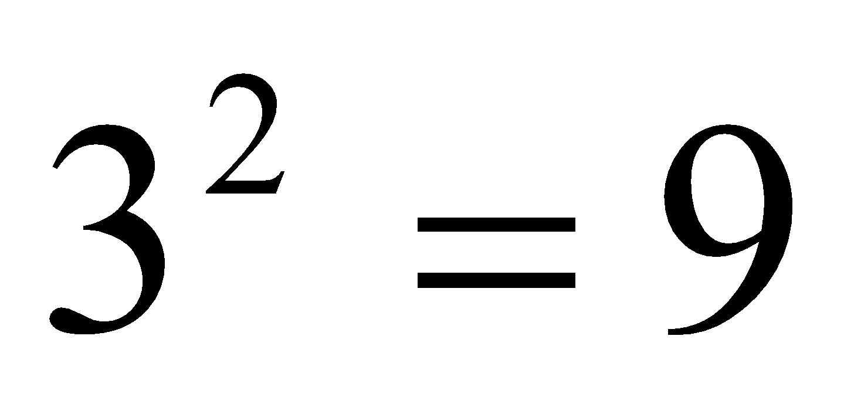 and 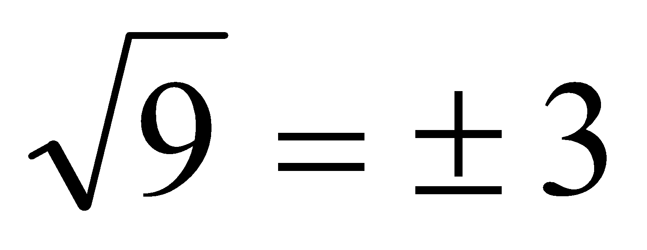  - 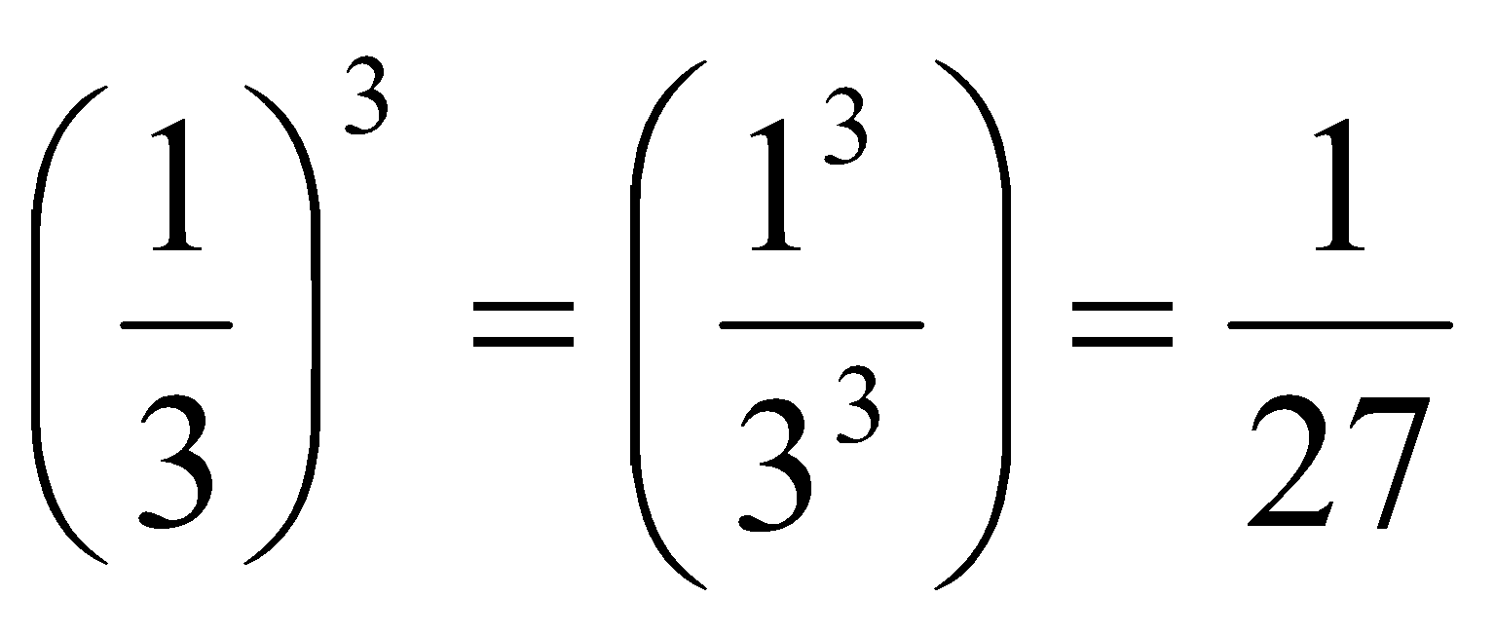 and 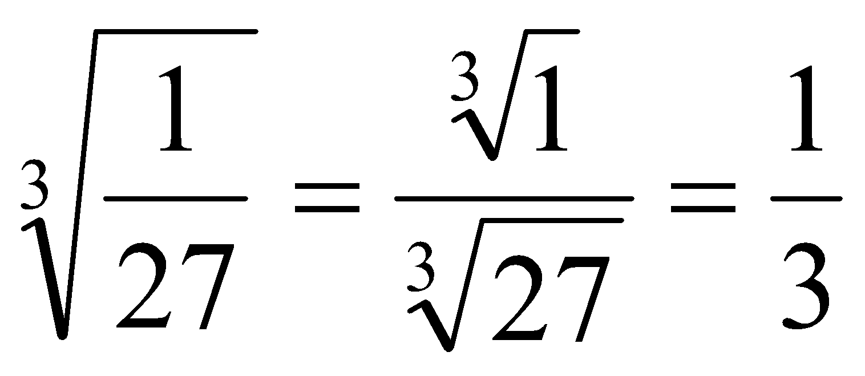  - Solve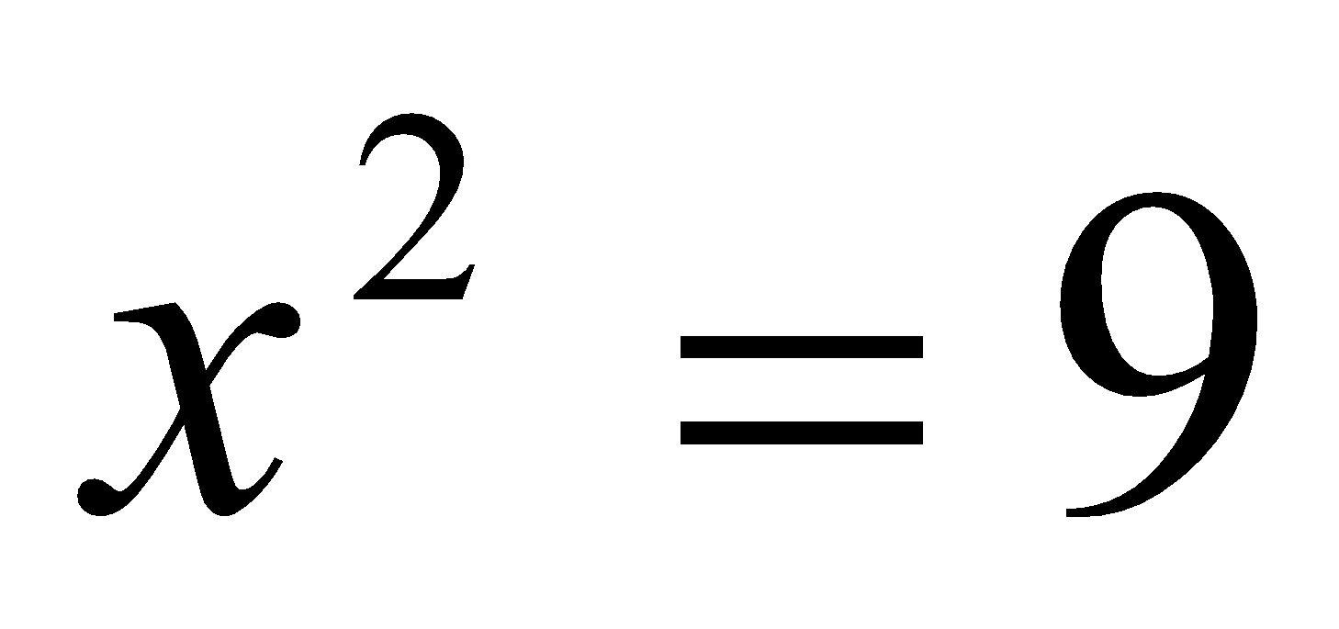  Solution:  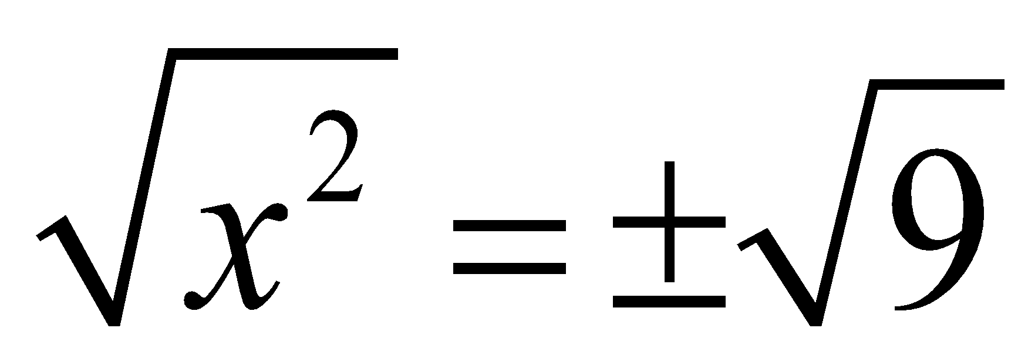  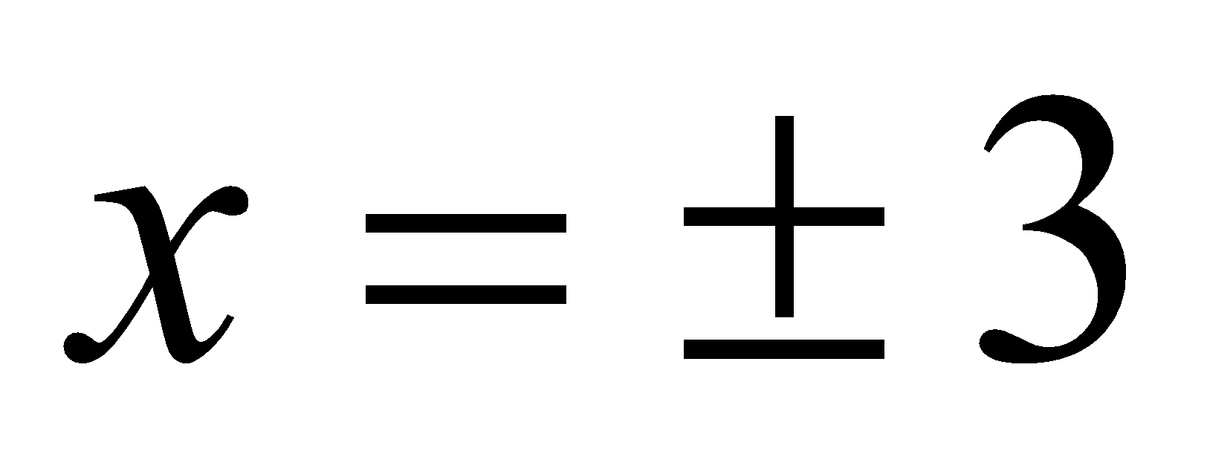  - Solve 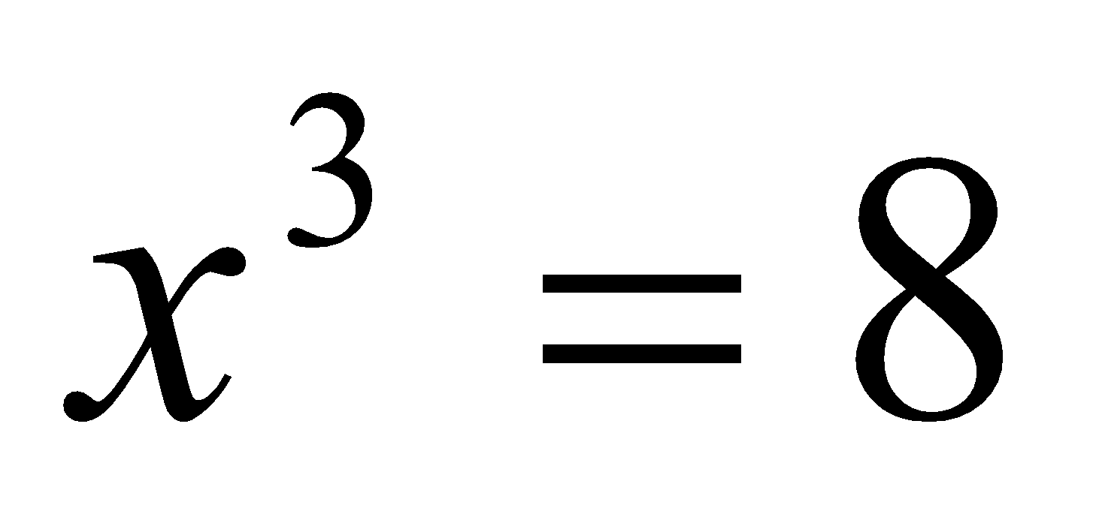  Solution:  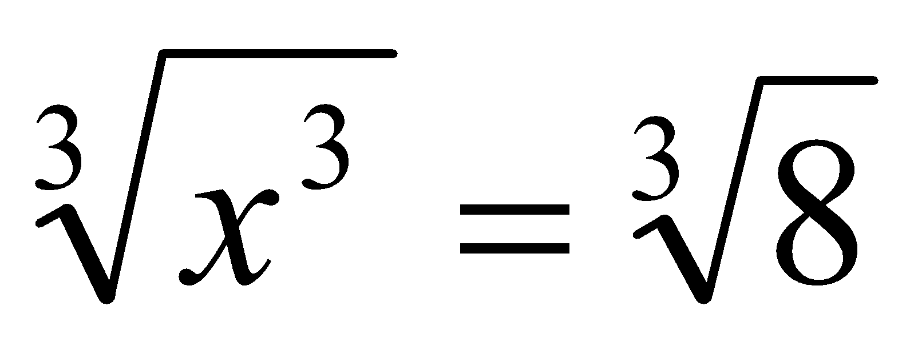  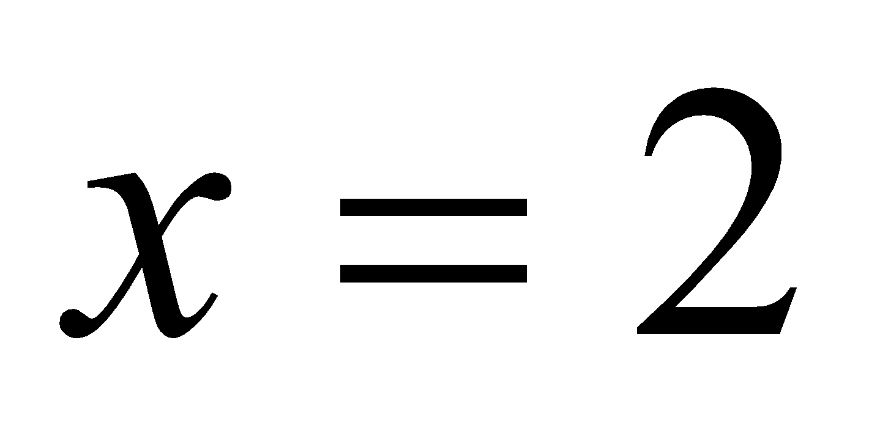
3. Use numbers expressed in the form of a single digit times a whole-number power of 10 to estimate very large or very small quantities, and to express how many times as much one is than the other. For example, estimate the population of the United States as 3 times 10⁸ and the population of the world as 7 times 10⁹, and determine that the world population is more than 20 times larger.  (MP2, MP4, MP5, MP6, MP7, MP8) | - Use scientific notation to express very large and very small quantities from real-world contexts  - Convert between standard form and scientific notation | - Assess prior knowledge of scientific notation  - Write numbers in scientific notation  - Write numbers in standard form from scientific notation  Compare numbers in scientific notation | Any number can be written in scientific notation by expressing it in two parts: a coefficient A where 1≤ A < 10, and a power of 10 where the exponent n is an integer.  Power of 10  A x 10^{n} exponent  coefficient base  ex. Write 23,000 in scientific notation  2.3 x 10⁴
4. Perform operations with numbers expressed in scientific notation, including problems where both decimal and scientific notation are used. Use scientific notation and choose units of appropriate size for measurements of very large or very small quantities (e.g., use millimeters per year for seafloor spreading). Interpret scientific notation that has been generated by technology  (MP2, MP4, MP5, MP6, MP7, MP8) | - Add, subtract, and multiply numbers expressed in scientific notation  - Understand how technology represents numbers in scientific notation and convert to correct scientific notation  - Apply understanding of scientific notation to solve real-world problems | - Add and subtract numbers in scientific notation with the same power of 10  - Add and subtract numbers in scientific notation with different powers of 10  - Review the familiar metric units of lengths  Introduce the prefix system | To add or subtract numbers in scientific notation, the powers of 10 must be the same.  Rewrite numbers so the numbers have the same power of 10 as a factor. Then factor out the common factor: 10⁶  You can check that you have factored the terms correctly by multiplying again. You get 15 ∙ 10⁶ -7 ∙ 10⁶ when you multiply (15 – 7) ∙ 10⁶ = 8 ∙ 10⁶  Students can convert decimal forms to scientific notation and apply rules of exponents to simplify expressions. In working with calculators or spreadsheets, it is important that students recognize scientific notation. Students should recognize that the output of 2.45E+23 is 2.45 x 10²³ and 3.5E-4 is 3.5 x 10⁻⁴. Students enter scientific notation using E or EE (scientific notation), * (multiplication), and ^ (exponent) symbols.  Prefix System:  Prefix Symbol 10^{n} Standard Form Term  Tera T 10¹² 1,000,000,000,000 Trillion  Giga G 10⁹ 1,000,000,000 Billion  Mega M 10⁶ 1,000,000 Million  kilo k 10³ 1,000 Thousand  - - 10⁰ 1 One  milli m 10⁻³ 0.001 Thousandth  micro μ 10⁻⁶ 0.000001 Millionth  nano n 10⁻⁹ 0.000000001 Billionth  pico p 10⁻¹² 0.000000000001 Trillionth
Differentiation/Accommodations/Modifications
Gifted and Talented | English Language Learners | Students with Disabilities | Students at Risk of School Failure
- Teacher gives students real life situations and students create an outcome  - Google Earth: Find the distances between locations on Earth.  - Read and article about rooftop gardens and create a square garden design. Students will sketch the designs and include specifications of the area for each plant. | - Video clips  - Choose excerpt(s) from book to focus on vocabulary development, comprehension  - Translate vocabulary into native language  - Read aloud  - Word Wall  - Build background knowledge  - Picture Associations  - Partner Work  - For more, see http://www.state.nj.us/education/modelcurriculum/ela/ellscaffolding/3u1.pdf | - Extended time  - Modified assignments  - Small group, alternate location  - Modeling  - Read aloud problems  - Calculator  - Build background knowledge  - Oral/visual reminders  - Peer assistance  - Picture associations with vocabulary  - Build background knowledge of the expression and equations  - Refer to each student’s IEP for more specific modifications | - RTI strategies including: teacher modeling, gradual release, think-Pair-Share, Think Aloud, Interactive notes  - Tier II and Tier III intervention  - More frequent STAR assessments  - Morning tutoring  - After school program  - Parental contact

Math Curriculum
Grade Eight

Content: Expressions and Equations
Essential Question(s): How is slope used to describe the relationship between lines and linear equations?
21st Century Theme: Financial, Economic, Business, and Entrepreneurial Literacy
21st Century Skills: Critical Thinking and Problem Solving
Standards: 8.EE.B
B. Understand the connections between proportional relationships, lines and linear equations.
Standards for Mathematical Practice: MP2, MP4, MP5, MP6, MP7, MP8
Vocabulary: horizontal, vertical, parallel lines, slope, x-intercept, y-intercept, linear relationship, unit rate, similar triangles, coordinate plane
Grade Specific Standards | Skills | Instructional Procedures | Explanations and Examples
5. Graph proportional relationships, interpreting the unit rate as the slope of the graph. Compare two different proportional relationships represented in different ways. For example, compare a distance-time graph to a distance-time equation to determine which of two moving objects has greater speed.  (MP2, MP4, MP5, MP6, MP7, MP8) | - Build on understanding of constant of proportionality (7.RP.A.2) to develop understanding of slope  - Graph and compare different proportional relationships when given scenario, equation, and/or table of values, and relate to similar triangles (review from Grade 7)  - Identify direct variation situations from other linear situations and write the equation y=mx to represent the function (review from Grade 7)  - Make connection that for any linear function the rate of change is constant  - Identify functions of the form y=mx+b as linear functions and graph the functions | - Represent a relationship between two variables using a linear equation  - Express a linear relationship between 2 variables  - Represent a linear relationship using a table of values  - Write a table of values for linear equations with 2 variables.  - Define the slope of a line  - Relate unit rate to slope  - Use slopes to compare unit rates  - Understand graphing linear equations  - Graph a linear equation by using 2 or more points  - Graph a linear equation by using slope and y intercept  - Graph a linear equation by using slope and a point | Students are expected to graph and interpret the results.  Example:  - Compare the scenarios to determine which represents a greater speed. Include a description of each scenario including the unit rates in your explanation.  Scenario 1: Scenario 2:  A direct proportion relationship is a relationship between two variable quantities x and y, where y is a constant multiple k of x. You can use an equation in the form y=kx, where k is a constant value, to represent a direct proportion relationship. When there is a constant variation between two quantities, there is a linear relationship between these two quantities.
6. Use similar triangles to explain why the slope m is the same between any two distinct points on a non-vertical line in the coordinate plane; derive the equation y = mx for a line through the origin and the equation y = mx + b for a line intercepting the vertical axis at b.  (MP2, MP4, MP5, MP6, MP7, MP8) | - Find the slope of a line given different representations of that line (graph, table of values, equation)  - Apply understanding of translations in the coordinate plane to apply a vertical translation of y=mx to generate the linear function y=mx+b | - Find slopes of horizontal and vertical lines  - Find the slope of a line passing through 2 given points  - Explore the relationship between the lines y=mx and y= mx + b  - Use the slope-intercept form to identify slopes and y-intercepts  Identify and write equations for parallel lines | Example:  - Explain why is similar to, and deduce that 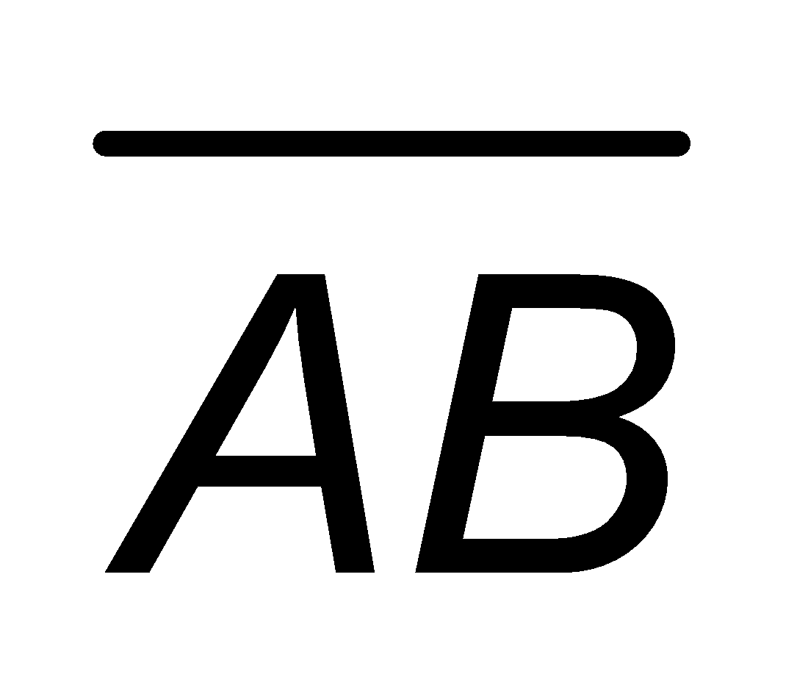has the same slope as DE. Express each line as an equation.  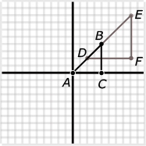

Differentiation/Accommodations/Modifications
Gifted and Talented | English Language Learners | Students with Disabilities | Students at Risk of School Failure
- Teacher gives students real life situations and students create an outcome  - This lesson involves students using the emulation of a spring scale stretched by a weight to record and graph the direct proportional relationship between the weight and the stretch.  - Students compute unit rates, find linear equations using unit rates and examine ordered pairs to confirm that linear equations represent proportional relationships.  - Illustrative mathematics: Slopes Between Points on a Line | - Video clips  - Choose excerpt(s) from book to focus on vocabulary development, comprehension  - Translate vocabulary into native language  - Read aloud  - Word Wall  - Build background knowledge  - Picture Associations  - Partner Work  - For more, see http://www.state.nj.us/education/modelcurriculum/ela/ellscaffolding/3u1.pdf | - Extended time  - Modified assignments  - Small group, alternate location  - Modeling  - Read aloud problems  - Calculator  - Build background knowledge  - Oral/visual reminders  - Peer assistance  - Picture associations with vocabulary  - Build background knowledge of the expression and equations  - Refer to each student’s IEP for more specific modifications | - RTI strategies including: teacher modeling, gradual release, think-Pair-Share, Think Aloud, Interactive notes  - Tier II and Tier III intervention  - More frequent STAR assessments  - Morning tutoring  - After school program  - Parental contact

Math Curriculum
Grade Eight

Content: Expressions and Equations
Essential Question(s):
How can solving equations relate to real world scenarios?
What situations will produce equations with no solutions? What situations will produce equations with infinite solutions?
How can you solve system of linear equations numerically, graphically, or algebraically (using substitution or elimination)? When is each strategy most effective to use?
What does the solution to the system of equations mean in the context of the problem?
Standards: 8.EE.C
C. Analyze and solve linear equations and pairs of simultaneous linear equations.
Standards for Mathematical Practice: MP1, MP2, MP5, MP6, MP7
Vocabulary: linear, like terms, rational numbers, systems of equations, simultaneous linear equations, slope, inconsistent equation (no solution), function
Grade Specific Standards | Skills | Instructional Procedures | Explanations and Examples
7. Solve linear equations in one variable.  7a Give examples of linear equations in one variable with one solution, infinitely many solutions, or no solutions. Show which of these possibilities is the case by successively transforming the given equation into simpler forms, until an equivalent equation of the form x = a, a = a, or a = b results (where a and b are different numbers).  7b Solve linear equations with rational number coefficients, including equations whose solutions require expanding expressions using the distributive property and collecting like terms.  (MP5, MP6) | - Apply understanding of linear functions to solve real-world problems with linear equations  - Write and solve equations from real-world scenarios  - Solve linear equations in one variable, including equations with one solution, infinitely many solutions, or no solutions  - Solve linear equations with rational number coefficients, including equations whose solutions require expanding expressions using the distributive property and combining like terms | - Review combining like terms  - Review distributive property  - Combine like terms  - Review steps for isolating variables  - Solve equations | As students transform linear equations in one variable into simpler forms, they discover the equations can have one solution, infinitely many solutions, or no solutions.  When the equation has one solution, the variable has one value that makes the equation true as in 12-4y=16. The only value for y that makes this equation true is -1.  When the equation has infinitely many solutions, the equation is true for all real numbers as in 7x + 14 = 7 (x+2). Since the expressions are equivalent, the value for the two sides of the equation will be the same regardless which real number is used for the substitution.  When an equation has no solutions it is also called an inconsistent equation. This is the case when the two expressions are not equivalent as in 5x - 2 = 5(x+1). When simplifying this equation, whichever real number is used for the substitution, the equation is not true and therefore has no solution.  Examples:  - Solve for x:  - 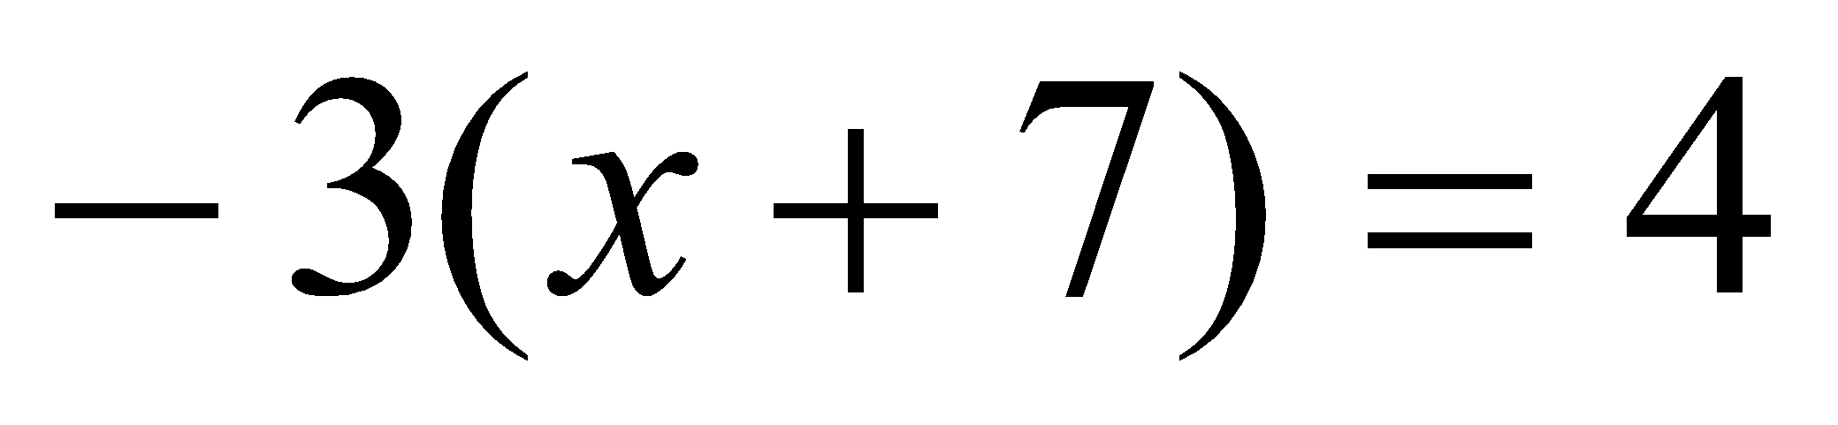  - 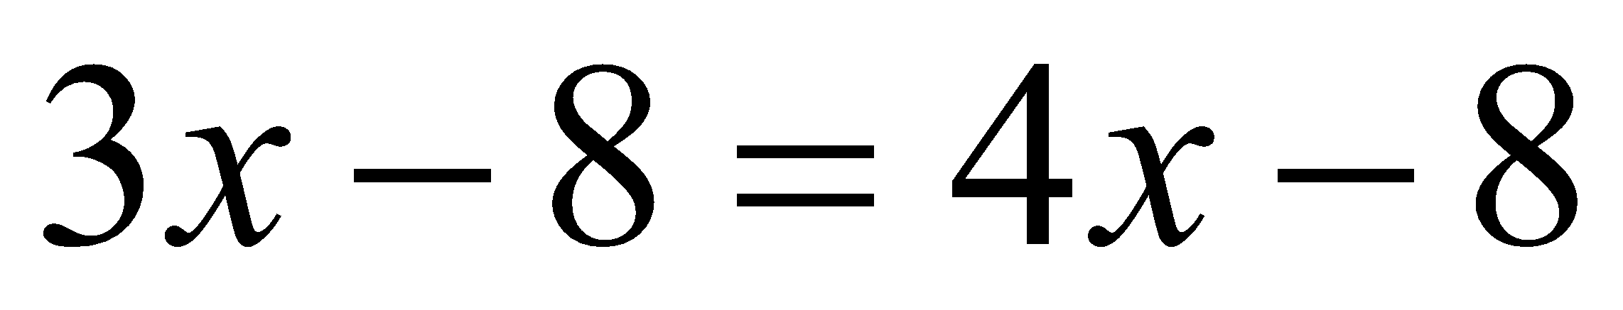  - 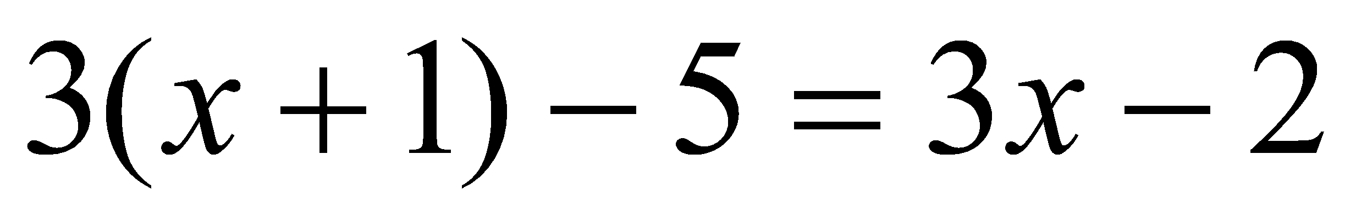  - Solve for the variable:  - 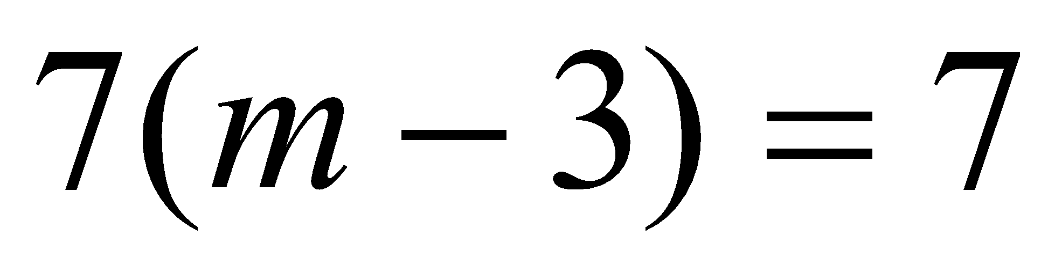  - 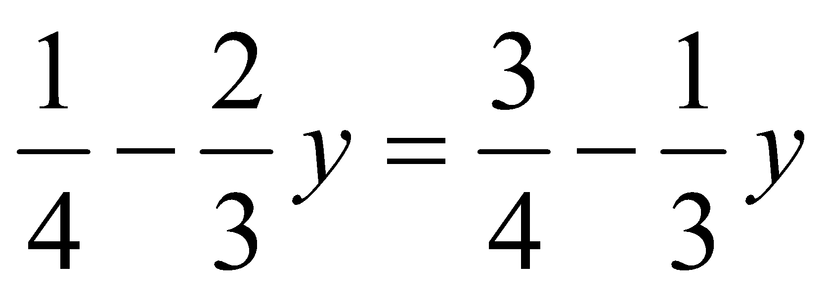
8. Analyze and solve pairs of simultaneous linear equations.  8a Understand that solutions to a system of two linear equations in two variables correspond to points of intersection of their graphs, because points of intersection satisfy both equations simultaneously.  8b Solve systems of two linear equations in two variables algebraically, and estimate solutions by graphing the equations. Solve simple cases by inspection. For example, 3x + 2y = 5 and 3x + 2y = 6 have no solution because 3x + 2y cannot simultaneously be 5 and 6.  8c Solve real-world and mathematical problems leading to two linear equations in two variables. For example, given coordinates for two pairs of points, determine whether the line through the first pair of points intersects the line through the second pair.  (MP1, MP2, MP6, MP7) | - Problem-solve to explore multiple unknowns in real-world contexts (i.e. task introduction like the baseball shop). Compare strategies to introduce concept of system of equation  - Write a system of equations to model real-world scenarios  - Compare two scenarios using different representations to determine when each scenario is the best option  - Solve systems by graphing and identify the solution as the point of intersection. Describe the solution in the context of the problem  - Understand why algebraic strategies for solving systems work. solve systems of two linear equations in two variables algebraically (using substitution or linear combination), and estimate solutions by graphing. Solve simple cases by inspection  - Relate the solution to a system to the context of the real-world problem | - Review graphing linear equations  - Review y=mx + b  - Determine the point of intersection of two lines from a graph and substitute these coordinates into both equations  - Graph and analyze two equations with the same slope  - Use the elimination method to solve systems of two equations | Systems of linear equations can also have one solution, infinitely many solutions or no solutions. Students will discover these cases as they graph systems of linear equations and solve them algebraically.  A system of linear equations whose graphs meet at one point (intersecting lines) has only one solution, the ordered pair representing the point of intersection. A system of linear equations whose graphs do not meet (parallel lines) has no solutions and the slopes of these lines are the same. A system of linear equations whose graphs are coincident (the same line) has infinitely many solutions, the set of ordered pairs representing all the points on the line.  By making connections between algebraic and graphical solutions and the context of the system of linear equations, students are able to make sense of their solutions. Students need opportunities to work with equations and context that include whole number and/or decimals/fractions.  Examples:  - Find x and y using elimination and then using substitution.  3x + 4y = 7  -2x + 8y = 10  - Plant A and Plant B are on different watering schedules. This affects their rate of growth. Compare the growth of the two plants to determine when their heights will be the same.  Let W = number of weeks  Let H = height of the plant after W weeks  Plant A Plant B  W H W H  0 4 (0,4) 0 2 (0,2)  1 6 (1,6) 1 6 (1,6)  2 8 (2,8) 2 10 (2,10)  3 10 (3,10) 3 14 (3,14)  - Given each set of coordinates, graph their corresponding lines.  Solution:  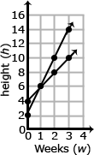  - Write an equation that represent the growth rate of Plant A and Plant B.  Solution:  Plant A H = 2W + 4  Plant B H = 4W + 2  - At which week will the plants have the same height?  Solution:  After one week, the height of Plant A and Plant B are both 6 inches.
Differentiation/Accommodations/Modifications
Gifted and Talented | English Language Learners | Students with Disabilities | Students at Risk of School Failure
- Teacher gives students real life situations and students create an outcome  - Linear equations webquest.  - Create a media presentation of comparing the deals of real life situations. | - Video clips  - Choose excerpt(s) from book to focus on vocabulary development, comprehension  - Translate vocabulary into native language  - Read aloud  - Word Wall  - Build background knowledge  - Picture Associations  - Partner Work  - For more, see http://www.state.nj.us/education/modelcurriculum/ela/ellscaffolding/3u1.pdf | - Extended time  - Modified assignments  - Small group, alternate location  - Modeling  - Read aloud problems  - Calculator  - Build background knowledge  - Oral/visual reminders  - Peer assistance  - Picture associations with vocabulary  - Build background knowledge of the expression and equations  - Refer to each student’s IEP for more specific modifications | - RTI strategies including: teacher modeling, gradual release, think-Pair-Share, Think Aloud, Interactive notes  - Tier II and Tier III intervention  - More frequent STAR assessments  - Morning tutoring  - After school program  - Parental contact

Math Curriculum
Grade Eight

Content: Functions
Essential Question(s):
How do we recognize a function? How do we compare two linear functions?
What is a function? Describe what it means to have a functional relationship?
What is the relationship between the input and output of a function?
How can you represent a function (linear or nonlinear) using real-world contexts, algebraic equations, tables of values, graphical representations, and/or diagrams?
In what ways can different types of functions be used to model various situations that occur in the real world?
What are the advantages of representing the relationship between quantities symbolically, numerically, and graphically?
Standards: 8. F
A. Define, evaluate, and compare functions.
Standards for Mathematical Practice: MP2, MP3, MP5, MP8
Vocabulary: Input/output, domain, range, ordered pair, rate of change , function, linear function, nonlinear function
Grade Specific Standards | Skills |  | Instructional Procedures |  | Explanations and Examples
1. Understand that a function is a rule that assigns to each input exactly one output. The graph of a function is the set of ordered pairs consisting of an input and the corresponding output.  (MP2, MP5) | - Define a function  - Explore multiple representations of functions (tables of values, graphs, equations, scenarios, visual representation of a pattern)  - Understand how each representation relates to the definition of a function  - Find inputs and outputs of functions |  | - Using the function, complete a T-chart |  | For example, the rule that takes x as input and gives x²+5x+4 as output is a function. Using y to stand for the output we can represent this function with the equation y = x²+5x+4, and the graph of the equation is the graph of the function. Students are not yet expected to use function notation such as f(x) = x²+5x+4.
2. Compare properties (e.g., rate change, intercepts, domain and range) of two functions each represented in a different way (algebraically, graphically, numerically in tables, or by verbal descriptions). For example, given a linear function represented by a table of values and a linear function represented by an algebraic expression, determine which function has the greater rate of change.  (MP5, MP8) | - Describe and compare properties of two functions represented in different ways |  | - Identify slope y=mx + b  - Identify slope in a graph  - Identify slope in a T-chart |  | Examples:  - Compare the two linear functions listed below and determine which equation represents a greater rate of change.  Function 1:  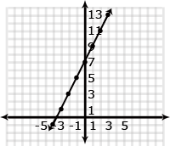  - Compare the two linear functions listed below and determine which has a negative slope.  Function 1: Gift Card  Samantha starts with $20 on a gift card for the book store. She spends $3.50 per week to buy a magazine. Let y be the amount remaining as a function of the number of weeks, x.  x y  0 20  1 16.50  2 13.00  3 9.50  4 6.00  Function 2: Calculators  The school bookstore rents graphing calculators for $5 per month. It also collects a non-refundable fee of $10.00 for the school year. Write the rule for the total cost (c) of renting a calculator as a function of the number of months (m).  Solution:  Function 1 is an example of a function whose graph has negative slope. Samantha starts with $20 and spends money each week. The amount of money left on the gift card decreases each week. The graph has a negative slope of -3.5, which is the amount the gift card balance decreases with Samantha’s weekly magazine purchase.  Function 2 is an example of a function whose graph has positive slope. Students pay a yearly nonrefundable fee for renting the calculator and pay $5 for each month they rent the calculator. This function has a positive slope of 5 which is the amount of the monthly rental fee. An equation for Function 2 could be c = 5m + 10.
3. Interpret the equation y = mx + b as defining a linear function, whose graph is a straight line; give examples of functions that are not linear. For example, the function A = s² giving the area of a square as a function of its side length is not linear because its graph contains the points (1,1), (2,4) and (3,9), which are not on a straight line.  (MP2, MP3, MP5) | - Identify functions of the form y=mx+b as linear functions and graph the functions |  | ∙ Graph various equations  to determine if they are  linear or nonlinear  - Compare the equations and determine what makes an equation nonlinear |  | Example:  - Determine which of the functions listed below are linear and which are not linear and explain your reasoning.  - y = -2x² + 3 non linear  - y = 2x linear  - A = πr² non linear  - y = 0.25 + 0.5(x – 2) linear
Differentiation/Accommodations/Modifications
Gifted and Talented |  | English Language Learners |  | Students with Disabilities |  | Students at Risk of School Failure
- Teacher gives students real life situations and students create an outcome  - Create a media presentation of comparing salary for commission based jobs.  - Research potential careers to create a savings plan. |  | - Video clips  - Choose excerpt(s) from book to focus on vocabulary development, comprehension  - Translate vocabulary into native language  - Read aloud  - Word Wall  - Build background knowledge  - Picture Associations  - Partner Work  - For more, see http://www.state.nj.us/education/modelcurriculum/ela/ellscaffolding/3u1.pdf |  | - Extended time  - Modified assignments  - Small group, alternate location  - Modeling  - Read aloud problems  - Calculator  - Build background knowledge  - Oral/visual reminders  - Peer assistance  - Picture associations with vocabulary  - Build background knowledge of functions  - each student’s IEP for more specific modifications |  | - RTI strategies including: teacher modeling, gradual release, think-Pair-Share, Think Aloud, Interactive notes  - Tier II and Tier III intervention  - More frequent STAR assessments  - Morning tutoring  - After school program  - Parental contact

Math Curriculum
Grade Eight

Content: Functions
Essential Question(s):
How can you use functions to predict real life situations?
How do you determine which linear function has a greater rate of change using the graph? Using the equation? Using a table of values?
How can proportional relationships be used to represent authentic situations in life and solve actual problems?
In what way(s) do proportional relationships relate to functions and functional relationships?
What information does the slope provide about the graph, the situation, the table of values, and the equation?
What does it mean for a context to have a slope of 0? What does it mean for a context to have an undefined slope?
How can you determine if a linear function represents a proportional relationship? How is this confirmed using an equation, a table of values, and/or a graph?

Standards: 8. F
B. Use functions to model relationships between quantities
Standards for Mathematical Practice: MP1, MP2, MP4, MP 5, MP6, MP7
Vocabulary: rate of change, initial value, negative slope, positive slope, zero slope
Grade Specific Standards | Skills | Instructional Procedures | Explanations and Examples
4. Construct a function to model a linear relationship between two quantities. Determine the rate of change and initial value of the function from a description of a relationship or from two (x, y) values, including reading these from a table or from a graph. Interpret the rate of change and initial value of a linear function in terms of the situation it models, and in terms of its graph or a table of values.  (MP 2, MP6, MP7) | - Construct linear functions to model real-world and mathematical problems, including the following cases:  - given a scenario  - given a slope and y-intercept  - given a slope and a point  - given two (or more) points  - Describe the slope and initial value in the context of the real-world situation  - Identify the rate of change (slope) and initial value from various context and multiple representations  - Describe key features of a linear graph, including when the graph is increasing or decreasing, steepness of graph, and intercepts | - Construct a function from given information, table or graph  - Analyze the results to determine the rate of change and initial value | Examples:  - The table below shows the cost of renting a car. The company charges $45 a day for the car as well as charging a one-time $25 fee for the car’s navigation system (GPS).Write an expression for the cost in dollars, c, as a function of the number of days, d.  Students might write the equation c = 45d + 25 using the verbal description or by first making a table.  Days (d) Cost (c) in dollars  1 70  2 115  3 160  4 205  Students should recognize that the rate of change is 45 (the cost of renting the car) and that initial cost (the first day charge) also includes paying for the navigation system. Discuss one time fees vs. recurrent fees.  - When scuba divers come back to the surface of the water, they need to be careful not to ascend too quickly. Divers should not come to the surface more quickly than a rate of 0.75 ft per second. If the divers start at a depth of 100 feet, the equation d = 0.75t – 100 shows the relationship between the time of the ascent in seconds (t) and the distance from the surface in feet (d).  - Will they be at the surface in 5 minutes? How long will it take the divers to surface from their dive?  Make a table of values showing several times and the corresponding distance of the divers from the surface. Explain what your table shows. How do the values in the table relate to your equation?
5. Describe qualitatively the functional relationship between two quantities by analyzing a graph (e.g., where the function is increasing or decreasing, linear or nonlinear). Sketch a graph that exhibits the qualitative features of a function that has been described verbally.  (MP 1, MP2, MP4, MP5) | - Sketch graphs of simple nonlinear function for a given scenario or representation  - Describe key features of a nonlinear graph, including when the graph is increasing or decreasing, any maximum/minimum points, etc. | - Review zero slope, positive slope, and negative slope  - Describe how slope/rate of change looks graphically  - Describe the situation | Example:  - The graph below shows a student’s trip to school. This student walks to his friend’s house and, together, they ride a bus to school. The bus stops once before arriving at school.  Describe how each part A-E of the graph relates to the story.  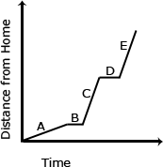
Differentiation/Accommodations/Modifications
Gifted and Talented | English Language Learners | Students with Disabilities | Students at Risk of School Failure
- Teacher gives students real life situations and students create an outcome  - Fun and Sun Rent a Car: This website provides students with the opportunity to analyze four different payment options for renting a car. Students are asked to determine the equations and represent each with a graph.  - Crossing the River: Students develop a model for the minimum number of trips to get a group across a river. | - Video clips  - Choose excerpt(s) from book to focus on vocabulary development, comprehension  - Translate vocabulary into native language  - Read aloud  - Word Wall  - Build background knowledge  - Picture Associations  - Partner Work  - For more, see http://www.state.nj.us/education/modelcurriculum/ela/ellscaffolding/3u1.pdf | - Extended time  - Modified assignments  - Small group, alternate location  - Modeling  - Read aloud problems  - Calculator  - Build background knowledge  - Oral/visual reminders  - Peer assistance  - Picture associations with vocabulary  - Build background knowledge of functions  - Refer to each student’s IEP for more specific modifications | - RTI strategies including: teacher modeling, gradual release, think-Pair-Share, Think Aloud, Interactive notes  - Tier II and Tier III intervention  - More frequent STAR assessments  - Morning tutoring  - After school program  - Parental contact

Math Curriculum
Grade Eight

Content: Geometry
Essential Question(s):
How do translations, reflections, rotations and dilations relate to congruence and similarity?
What is the relationship between the lengths of sides of a right triangle?
What are the different ways a segment (or figure) may be transformed?
What types of transformations are rigid transformations, i.e. preserve size and angle measures of the original figure?
What transformations produce figures that are similar to the original figure?
What relationships exist between angles formed by parallel lines that are cut by a transversal?
What conclusions can be made about interior and exterior angles of a triangle?

Content: Geometry
Standards: 8.G.A
A. Understand congruence and similarity using physical models, transparencies, or geometry software.
Standards for Mathematical Practice: MP2, MP3, MP5, MP7, MP8
Vocabulary: translation, rotation, reflection, dilation, image, congruence, similar figures, similarity, alternate exterior angles, alternate interior angles, vertical angles, corresponding angles, supplementary angles, angle sum, exterior angles of a triangle.
Grade Specific Standards | Skills | Instructional Procedures | Explanations and Examples
1 Verify experimentally the properties of rotations, reflections, and translations:  1a Lines are transformed to lines, and line segments to line segments of the same length.  1b Angles are transformed to angles of the same measure.  1c Parallel lines are transformedto parallel lines  (MP 3, MP5, MP8) | - Experiment with properties of reflection, translation, rotation, and dilation using patty paper, miras, protractors, and/or dynamic geometry software  - Identify similarities and differences between the different transformations, including  - preservation of angle measures  - orientation in the plane  - lengths of sides | - Understand the concept of a translation  - Translate a point  - Translate a line segment  - Translate a polygon  - Find the coordinates of points after translations  - Understand the concept of a reflection  - Identify the line of reflection  - Reflect a point  - Draw images after reflections  - Reflect a line segment  - Reflect a figure in the x-axis  - Reflect a figure in the y-axis  - Find the coordinates of a point after reflection  - Understand the concept of rotation  - Rotate a line segment  - Draw images after rotations  - Find coordinates of points after rotations | Students need multiple opportunities to explore the transformation of figures so that they can recognize that points stay the same distance apart and lines stay at the same angle after they have been rotated, reflected, and/or translated.  Students are not expected to work formally with properties of dilations until high school.
2. Understand that a two-dimensional figure is congruent to another if the second can be obtained from the first by a sequence of rotations, reflections, and translations; given two congruent figures, describe a sequence that exhibits the congruence between them.  (MP2, MP7) | - Understand that congruence is a special case of similarity in which there is a 1:1 ratio of side lengths  - Understand congruent figures can be obtained through a sequence of reflections, rotations, and/or translations | - Understand the concept of congruence  - Identify congruent figures  - Name congruent figures  - Find interior measures in congruent figures  - Identify congruent triangles  - Rotate congruent figures using geometric transformation  - Draw a sequence of transformations | Examples:  - Is Figure A congruent to Figure A’? Explain how you know.  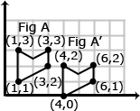  - Describe the sequence of transformations that results in the transformation of Figure A to Figure A’.  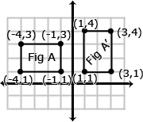
3. Describe the effect of dilations, translations, rotations, and reflections on two-dimensional figures using coordinates.  (MP 2, MP 3, MP5) | - Apply transformations to the coordinate plane  - Dilate figures from the origin and from a point on the figure  - Describe the effects of transformations of two-dimensional figures in the coordinate plane | - Relate congruent figures using geometric transformations  - Describe a sequence of transformations  - Relate congruent figures using a sequence of transformations | A dilation is a transformation that moves each point along a ray emanating from a fixed center, and multiplies distances from the center by a common scale factor. In dilated figures, the dilated figure is similar to its pre-image.  Translation: A translation is a transformation of an object that moves the object so that every point of the object moves in the same direction as well as the same distance. In a translation, the translated object is congruent to its pre-image. has been translated 7 units to the right and 3 units up. To get from A (1,5) to A’ (8,8), move A 7 units to the right (from x = 1 to x = 8) and 3 units up (from y = 5 to y = 8). Points B + C also move in the same direction (7 units to the right and 3 units up).  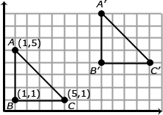  Reflection: A reflection is a transformation that flips an object across a line of reflection (in a coordinate grid the line of reflection may be the x or y axis). In a rotation, the rotated object is congruent to its pre-image.  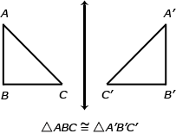  When an object is reflected across the y axis, the reflected x coordinate is the opposite of the pre-image x coordinate.  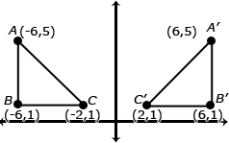  Rotation: A rotated figure is a figure that has been turned about a fixed point. This is called the center of rotation. A figure can be rotated up to 360˚. Rotated figures are congruent to their pre-image figures.  Consider when is rotated 180˚ clockwise about the origin. The coordinates of are D(2,5), E(2,1), and F(8,1). When rotated 180˚, has new coordinates D’(-2,-5), E’(-2,-1) and F’(-8,-1). Each coordinate is the opposite of its pre-image.  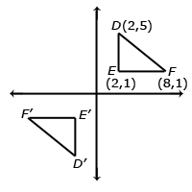
4. Understand that a two-dimensional figure is similar to another if the second can be obtained from the first by a sequence of rotations, reflections, translations, and dilations; given two similar two-dimensional figures, describe a sequence that exhibits the similarity between them.  (MP2, MP7) | - Revisit understanding of similarity from proportionality (Grade 7)  - Use angle-angle criterion for similar figures  - Understand similar figures can be obtained through a sequences of transformations | - Relate similar figures using geometric transformations  - Relate similar figures using a series of transformations | Examples:  - Is Figure A similar to Figure A’? Explain how you know.  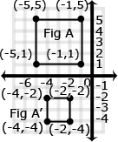  - Describe the sequence of transformations that results in the transformation of Figure A to Figure A’.  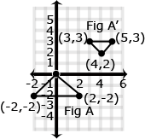
5. Use informal arguments to establish facts about the angle sum and exterior angle of triangles, about the angles created when parallel lines are cut by a transversal, and the angle-angle criterion for similarity of triangles. For example, arrange three copies of the same triangle so that the sum of the three angles appears to form a line, and give an argument in terms of transversals why this is so.  (MP2, MP3) | - Describe a sequence of transformations used to generate a transformed image | - Find the measures of the interior and exterior angles of a triangle  - Find measures of angles formed by parallel lines and a transversal  - Identify similar triangles | - Examples: Students can informally prove relationships with transversals.  Show that m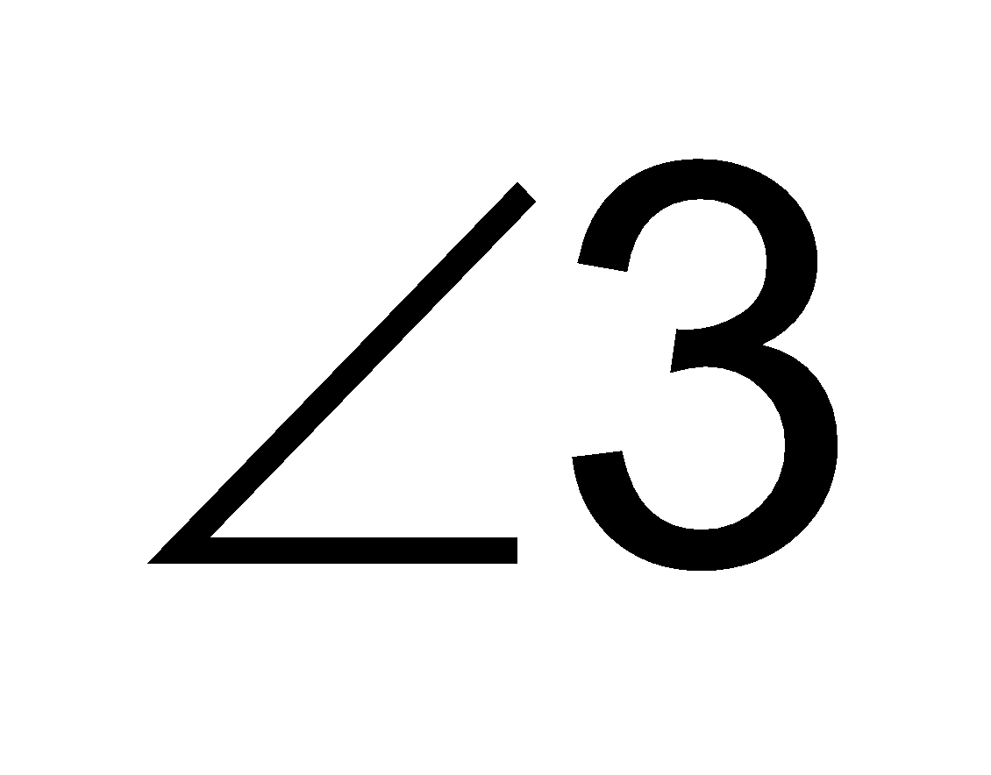 + m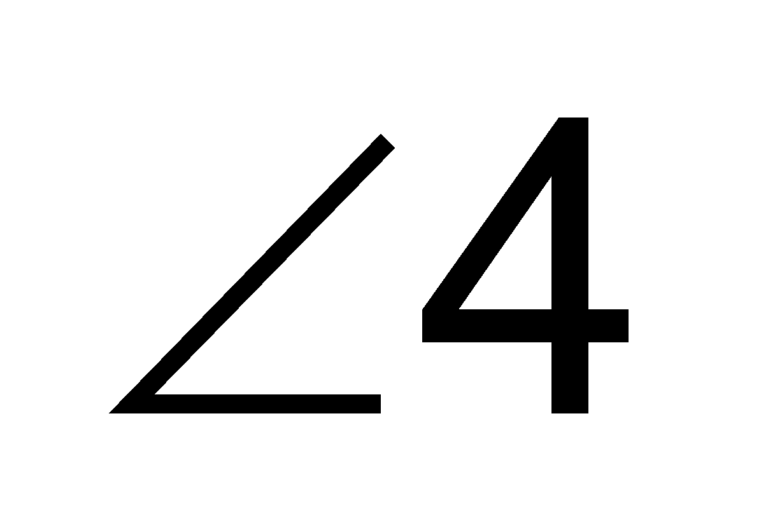 + m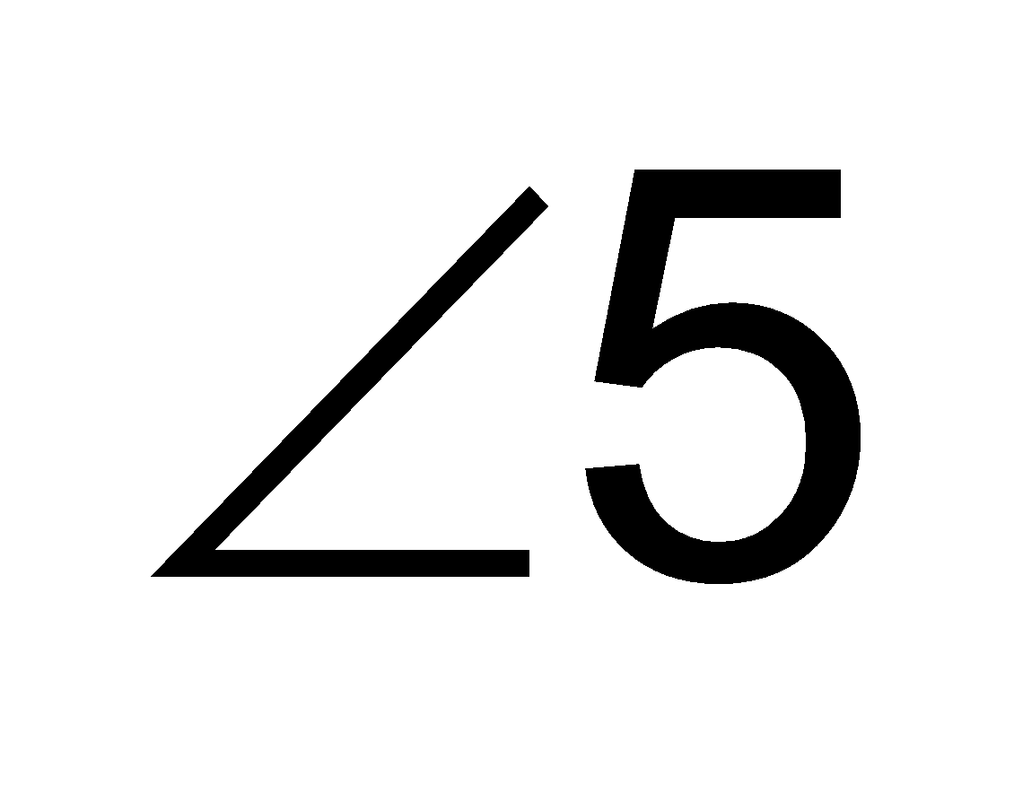 = 180˚ if l and m are parallel lines and t₁ & t₂ are transversals.  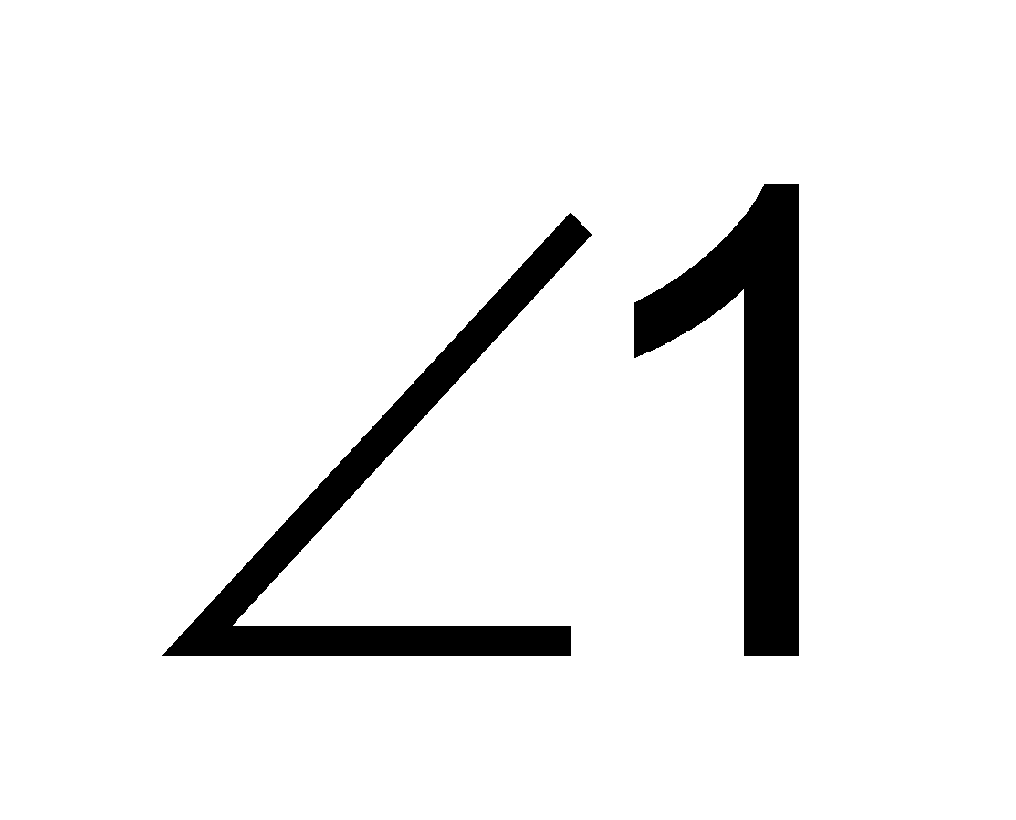 + 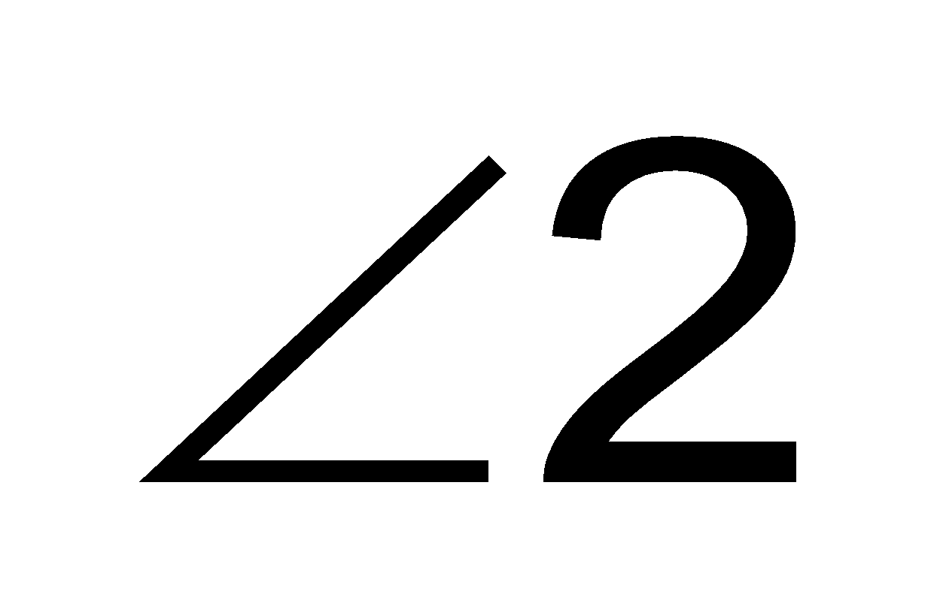 + 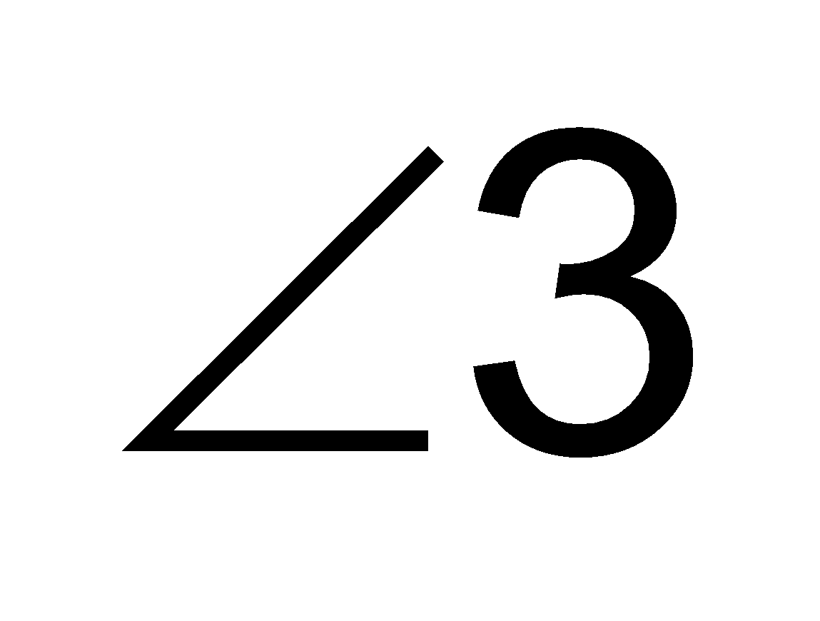 = 180˚. Angle 1 and Angle 5 are congruent because they are corresponding angles (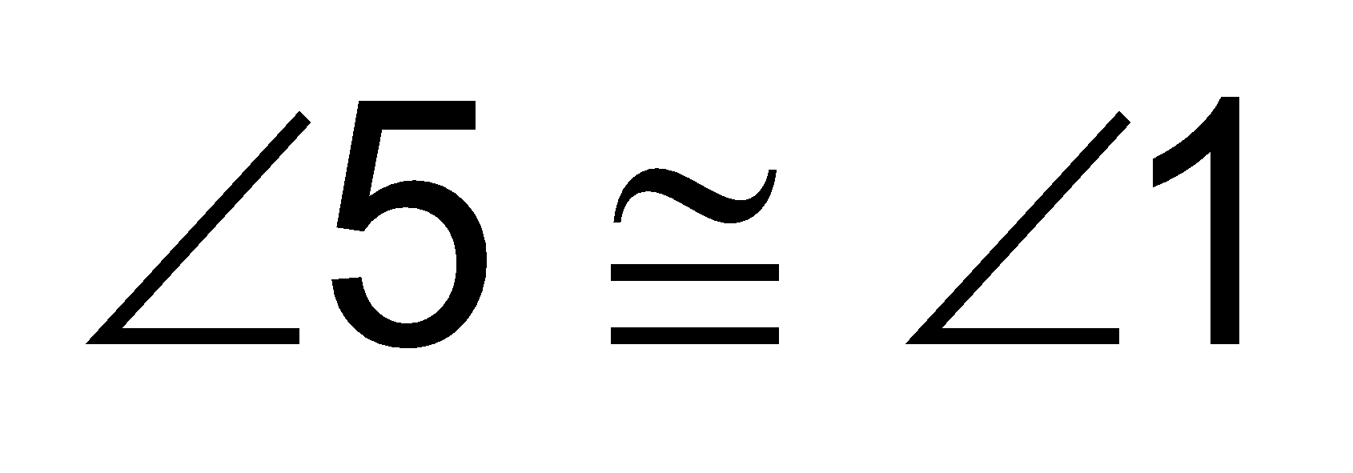). 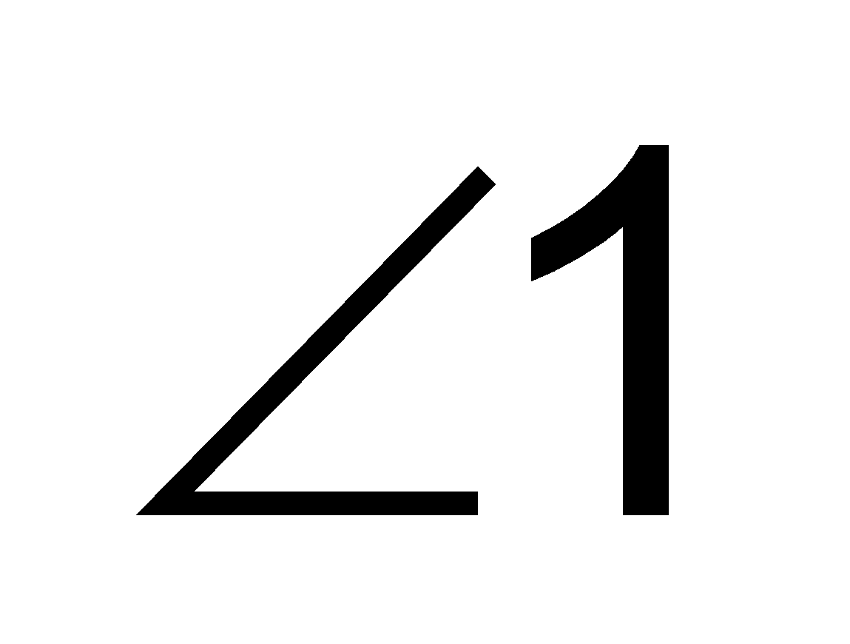 can be substituted for 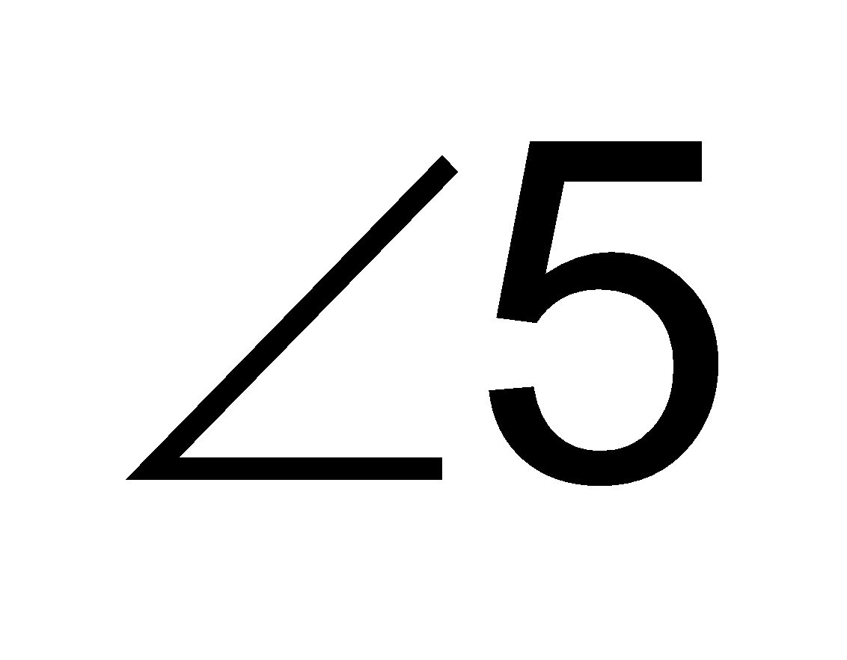.  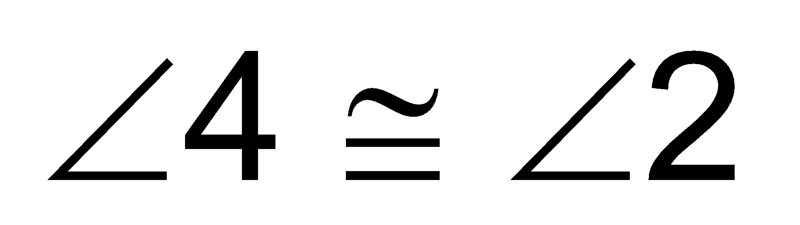 : because alternate interior angles are congruent.  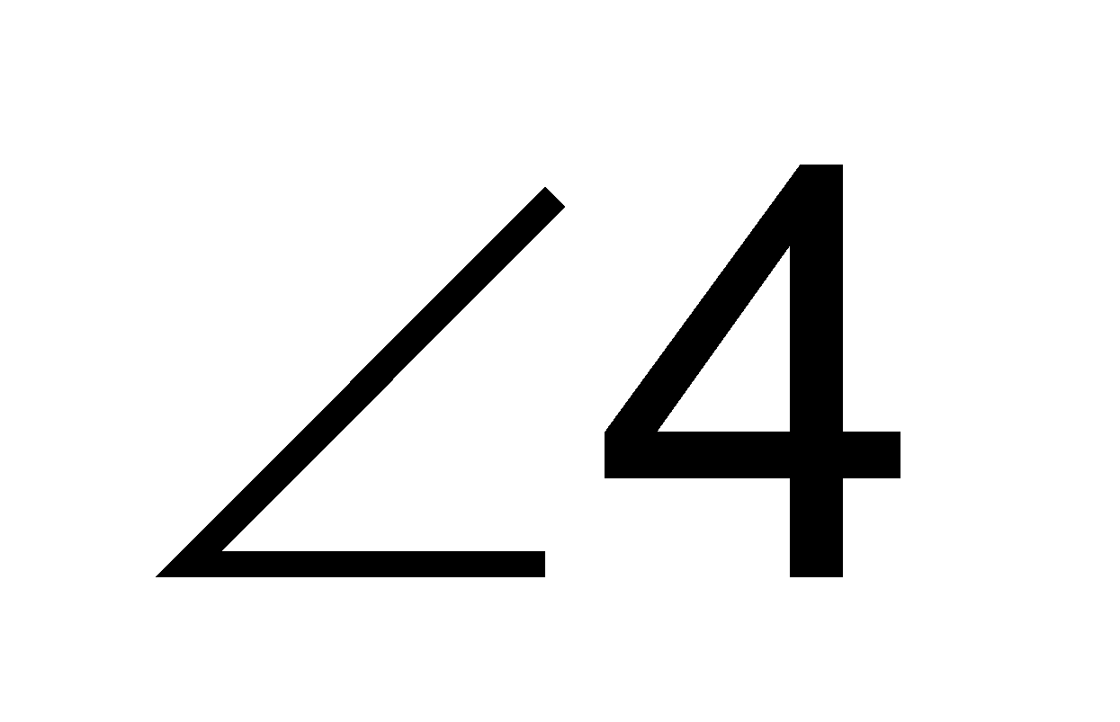can be substituted for 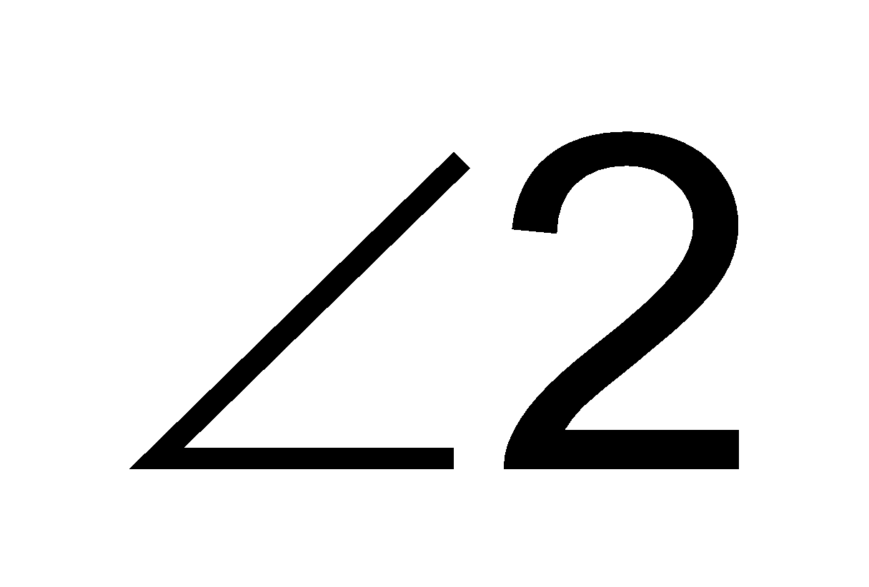  Therefore m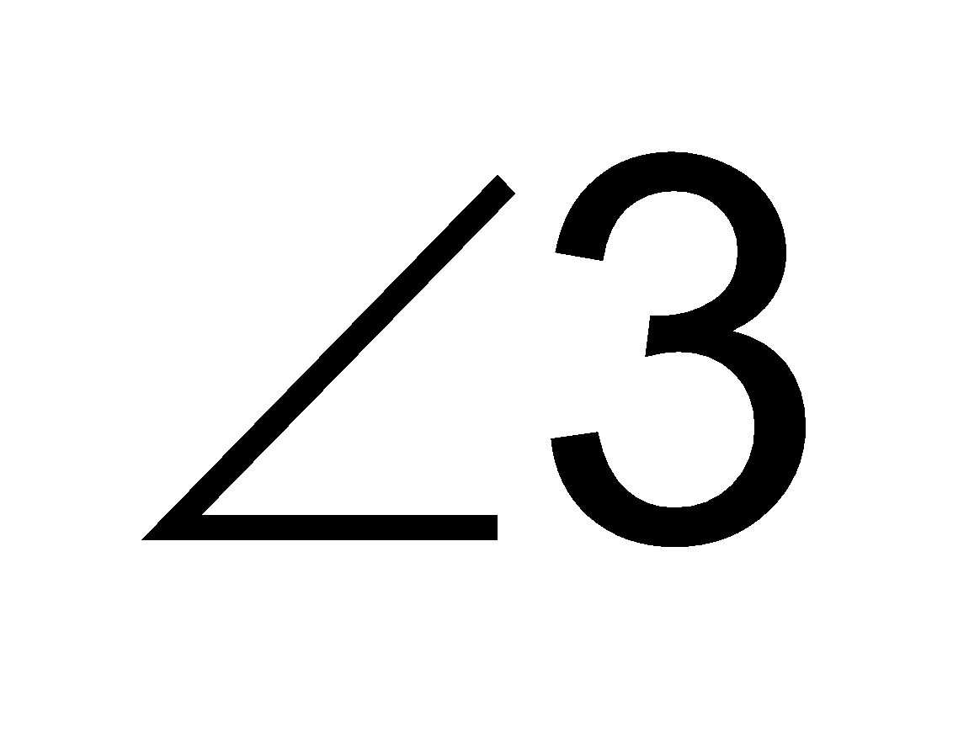 + m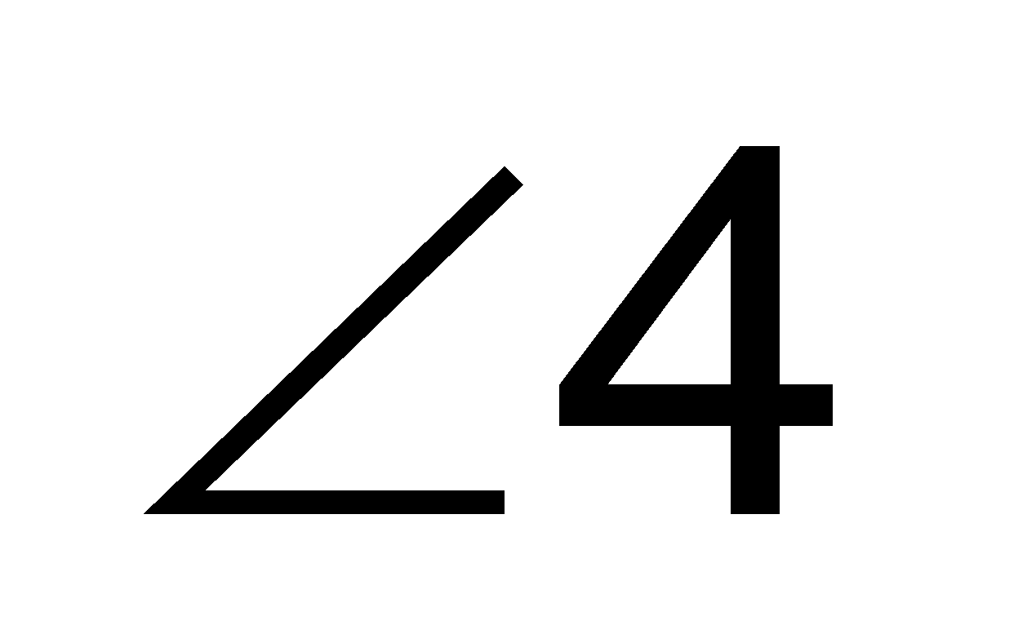 + m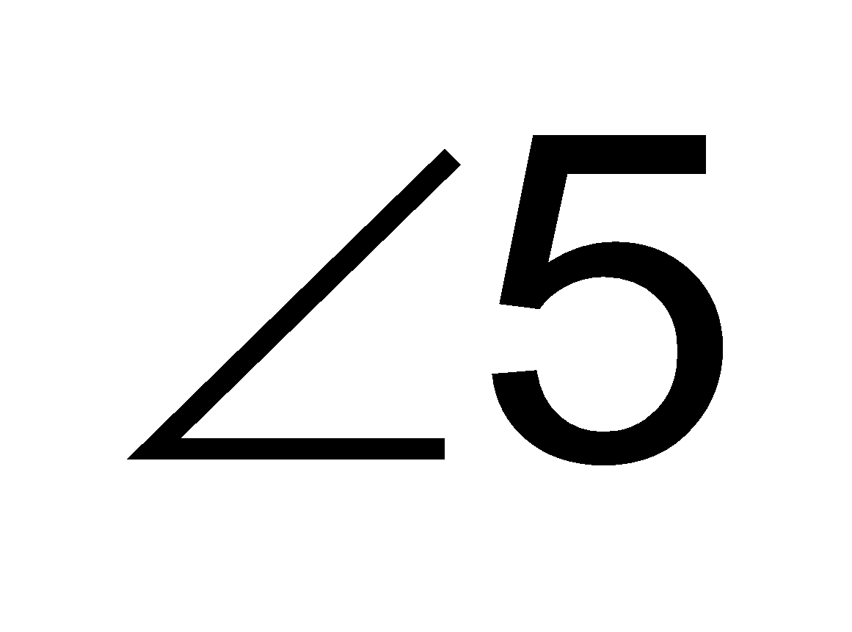 = 180˚  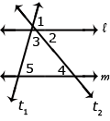  Students can informally conclude that the sum of a triangle is 180º (the angle-sum theorem) by applying their understanding of lines and alternate interior angles. In the figure below, line x is parallel to line yz:  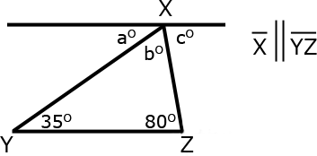  Angle a is 35º because it alternates with the angle inside the triangle that measures 35º. Angle c is 80º because it alternates with the angle inside the triangle that measures 80º. Because lines have a measure of 180º, and angles a + b + c form a straight line, then angle b must be 65 º (180 – 35 + 80 = 65). Therefore, the sum of the angles of the triangle are 35º + 65 º + 80 º

Differentiation/Accommodations/Modifications
Gifted and Talented | English Language Learners | Students with Disabilities | Students at Risk of School Failure
- Teacher gives students real life situations and students create an outcome  - Create a city blueprint using angle relationships.  - Create a graphic poster using unique clip art that undergoes ten different transformations. | - Video clips  - Choose excerpt(s) from book to focus on vocabulary development, comprehension  - Translate vocabulary into native language  - Read aloud  - Word Wall  - Build background knowledge  - Picture Associations  - Partner Work  - For more, see http://www.state.nj.us/education/modelcurriculum/ela/ellscaffolding/3u1.pdf | - Extended time  - Modified assignments  - Small group, alternate location  - Modeling  - Color coded notes  - Geoboards  - Graph paper  - Read aloud problems  - Calculator  - Build background knowledge  - Oral/visual reminders  - Peer assistance  - Picture associations with vocabulary  - Build background knowledge of functions  - Refer to each student’s IEP for more specific modifications | - RTI strategies including: teacher modeling, gradual release, think-Pair-Share, Think Aloud, Interactive notes  - Tier II and Tier III intervention  - More frequent STAR assessments  - Morning tutoring  - After school program  - Parental contact

Math Curriculum
Grade Eight

Content: Geometry
Essential Question(s):
How is the Pythagorean Theorem used in real world applications?
What is the relationship between the lengths of sides of a right triangle?
How is the Pythagorean Theorem used to find distance between two points in a coordinate plane?
Content: Geometry
Standards: 8.G.B
B. Understand and apply Pythagorean Theorem.
STandards for Mathematical Practice: MP2, MP7
Vocabulary: Pythagorean Theorem, right triangle, coordinate plane, legs, hypotenuse, distance formula, composite solid, converse, volume
Grade Specific Standards |  | Skills |  | Instructional Procedures |  | Explanations and Examples
6. Explain a proof of the Pythagorean Theorem and its converse.  (MP2) |  | - Discover the Pythagorean Theorem using physical models and/or technology  - Prove the Pythagorean theorem and its converse |  | - Discover the Pythagorean Theorem and its converse through hands-on activities |  | Students should verify, using a model, that the sum of the squares of the legs is equal to the square of the hypotenuse in a right triangle. Students should also understand that if the sum of the squares of the 2 smaller legs of a triangle is equal to the square of the third leg, then the triangle is a right triangle.
7. Apply the Pythagorean Theorem to determine unknown side lengths in right triangles in real-world and mathematical problems in two and three dimensions.  (MP2, MP7) |  | - Determine unknown side lengths in right triangles in real-world and mathematical problems |  | - Find the length of the hypotenuse of a right triangle  - Find the length of a leg of a right triangle  - Determine whether a triangle is a right triangle  - Use the Pythagorean Theorem to find unknown side lengths of solids  - Use the Pythagorean Theorem to solve problems involving volumes of composite solids (three dimensional |  | Through authentic experiences and exploration, students should use the Pythagorean Theorem to solve problems. Problems can include working in both two and three dimensions. Students should be familiar with the common Pythagorean triplets.
8. Apply the Pythagorean Theorem to find the distance between two points in a coordinate system.  (MP2, MP7) |  | - Apply Pythagorean theorem to find distance between two points in the coordinate plane  - Derive the distance formula from the Pythagorean theorem |  | - Use the Pythagorean Theorem to find a distance on the coordinate plane. Use the distance formula to find the length of the side of a triangle. |  | Example:  - Students will create a right triangle from the two points given (as shown in the diagram below) and then use the Pythagorean Theorem to find the distance between the two given points.  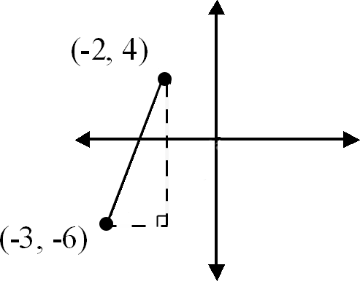
Differentiation/Accommodations/Modifications
Gifted and Talented | English Language Learners |  | Students with Disabilities |  | Students at Risk of School Failure
- Teacher gives students real life situations and students create an outcome  - Students create a model demonstrating where to find Pythagoren Theorem in real life.  - Create a theme park using grid paper to find the least amount of distance to visit each attraction. | - Video clips  - Choose excerpt(s) from book to focus on vocabulary development, comprehension  - Translate vocabulary into native language  - Read aloud  - Word Wall  - Build background knowledge  - Picture Associations  - Partner Work  - For more, see http://www.state.nj.us/education/modelcurriculum/ela/ellscaffolding/3u1.pdf |  | - Extended time  - Modified assignments  - Small group, alternate location  - Modeling  - Color coded notes  - Geoboards  - Graph paper  - Read aloud problems  - Calculator  - Build background knowledge  - Oral/visual reminders  - Peer assistance  - Picture associations with vocabulary  - Build background knowledge of geomtry  - Refer to each student’s IEP for more specific modifications |  | - RTI strategies including: teacher modeling, gradual release, think-Pair-Share, Think Aloud, Interactive notes  - Tier II and Tier III intervention  - More frequent STAR assessments  - Morning tutoring  - After school program  - Parental contact

Math Curriculum
Grade Eight

Content: Geometry
Essential Question(s):
How can formulas be used to create three-dimensional objects?
How can one use solve to solve real-world and mathematical problems?
What is the relationship, if any, between volume of cones, cylinders, and sphere?
Standards: 8.G.
C. Solve real-world and mathematical problems involving volume of cylinders, cones, and spheres.
Standards for Mathematical Practice: N/A
Vocabulary: three-dimensional, cone, cylinder, sphere, volume
Grade Specific Standards | Skills |  | Instructional Procedures |  | Explanations and Examples
9. Know the formulas for the volumes of cones, cylinders, and spheres and use them to solve real-world and mathematical problems. | - Discover the formula for the volume of a cylinder and use volume to solve real-world and mathematical problems  - Apply understanding of cylinders to discover the formula for the volume of a cone and use volume to solve real-world and mathematical problems  - Apply understanding of volumes of rectangular prisms to discover the formula for the volume of a sphere and use volume to solve real-world and mathematical problems |  | - Explain the terms of each formula to determine volume  - Use the formulas to find volume |  | Example:  - James wanted to plant pansies in his new planter. He wondered how much potting soil he should buy to fill it. Use the measurements in the diagram below to determine the planter’s volume.  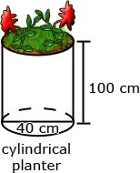
Differentiation/Accommodations/Modifications
Gifted and Talented |  | English Language Learners |  | Students with Disabilities |  | Students at Risk of School Failure
- Teacher gives students real life situations and students create an outcome  - Students will work on a “Volume” webquest.  - Students will create a presentation about three-dimensional figures.  Ex. Characteristics and volume. |  | - Video clips  - Choose excerpt(s) from book to focus on vocabulary development, comprehension  - Translate vocabulary into native language  - Read aloud  - Word Wall  - Build background knowledge  - Picture Associations  - Partner Work  - For more, see http://www.state.nj.us/education/modelcurriculum/ela/ellscaffolding/3u1.pdf |  | - Extended time  - Modified assignments  - Small group, alternate location  - Modeling  - Color coded notes  - Geoboards  - Graph paper  - Read aloud problems  - Calculator  - Build background knowledge  - Oral/visual reminders  - Peer assistance  - Picture associations with vocabulary  - Build background knowledge of volume  - Refer to each student’s IEP for more specific modifications |  | - RTI strategies including: teacher modeling, gradual release, think-Pair-Share, Think Aloud, Interactive notes  - Tier II and Tier III intervention  - More frequent STAR assessments  - Morning tutoring  - After school program  - Parental contact

Math Curriculum
Grade Eight

Content: Statistics and Probability
Essential Question(s):
What kind of patterns can be found in bivariate data?
What can data clustering reveal on a scatter plot?
What does the line of best fit represent?
When estimating a line of best fit, how should the line be positioned?
How closely does the model fit the data i.e. how close are the actual data points to the line of best fit?
How can the line of best fit be used to make predictions about the problem situation?
What does the slope and y-intercept of the line of best fit mean in the context of the situation?
What is the quadrant count ratio and how is it used?
What kind of data is displayed in a two-way table?
How can a two-way table be used to examine the relationship between two categorical variables?
Content: 8.SP.A
A. Investigate patterns of association in bivariate data.
Standards for Mathematical Practice: MP2, MP3, MP4, MP5,MP6, MP7
Vocabulary: bivariate (data that involve two variables), scatter plot, outliers, line of best fit, association (correlations), two way table, categorical data, clustering, extrapolate, interpolate, quantitative data, qualitative data
Grade Specific Standards | Skills | Instructional Procedures | Explanations and Examples
1. Construct and interpret scatter plots for bivariate measurement data to investigate patterns of association between two quantities. Describe patterns such as clustering, outliers, positive or negative association, linear association, and nonlinear association.  (MP3, MP5, MP7) | - Explore "Statistics as a Problem Solving Process"  - Briefly review understanding of univariate quantitative data from Grade 6, focusing on center from dot plots  - Introduce bivariate quantitative data from real-world contexts and discuss distribution and centers of each variable in isolation and discuss what can and cannot be seen from these representations (leading to developing a reason why scatter plots are necessary to see covariation)  - Construct scatter plots of bivariate quantitative data and describe patterns in the data (clustering, outliers, types of association)  - Use quadrant count ratio to informally describe correlation between the two quantities | - Introduce terms  - Review how to graph data and label axes  - Create scatter plots and analyze the results  - Analyze patterns in the data to determine strong, weak, or no association | Students build on their previous knowledge of scatter plots to examine relationships between variables. They analyze scatter plots to determine positive and negative associations, the degree of association, and type of association. Students examine outliers to determine if data points are valid or represent a recording or measurement error. Students can use tools such as those at the National Center for Educational Statistics to create a graph or generate data sets. (http://nces.ed.gov/nceskids/createagraph/default.aspx)  Examples:  - Data for 10 students’ Math and Science scores are provided in the chart. Describe the association between the Math and Science scores.  Student 1 2 3 4 5 6 7 8 9 10  Math 64 50 85 34 56 24 72 63 42 93  Science 68 70 83 33 60 27 74 63 40 96  - Data for 10 students’ Math scores and the distance they live from school are provided in the table below. Describe the association between the Math scores and the distance they live from school.  Student 1 2 3 4 5 6 7 8 9 10  Math score 64 50 85 34 56 24 72 63 42 93  Dist from school (miles) 0.5 1.8 1 2.3 3.4 0.2 2.5 1.6 0.8 2.5  - Data from a local fast food restaurant is provided showing the number of staff members and the average time for filling an order are provided in the table below. Describe the association between the number of staff and the average time for filling an order.  Number of staff 3 4 5 6 7 8  Average time to fill order (seconds) 180 138 120 108 96 84  - The chart below lists the life expectancy in years for people in the United States every five years from 1970 to 2005. What would you expect the life expectancy of a person in the United States to be in 2010, 2015, and 2020 based upon this data? Explain how you determined your values.  Date 1970 1975 1980 1985 1990 1995 2000 2005  Life Expectancy (in years) 70.8 72.6 73.7 74.7 75.4 75.8 76.8 77.4
2. Know that straight lines are widely used to model relationships between two quantitative variables. For scatter plots that suggest a linear association, informally fit a straight line, and informally assess the model fit (e.g., line of best fit) by judging the closeness of the data points to the line.  (MP2, MP5, MP7) | - For models that have linear association, develop understanding of how to fit a line to the data (spaghetti method and/or using technology)  - Write the equation for the line of best fit (using spaghetti method and technology)  Informally assess the closeness of the data points to the line | ∙ Draw a line of best fit  ∙ Determine if there is a strong, weak, or no association | Examples:  - The capacity of the fuel tank in a car is 13.5 gallons. The table below shows the number of miles traveled and how many gallons of gas are left in the tank. Describe the relationship between the variables. If the data is linear, determine a line of best fit. Do you think the line represents a good fit for the data set? Why or why not? What is the average fuel efficiency of the car in miles per gallon?  Miles Traveled 0 75 120 160 250 300  Gallons Used 0 2.3 4.5 5.7 9.7 10.7
3. Use the equation of a linear model to solve problems in the context of bivariate measurement data, interpreting the slope and intercept. For example, in a linear model for a biology experiment, interpret a slope of 1.5 cm/hr as meaning that an additional hour of sunlight each day is associated with an additional 1.5 cm in mature plant height.  (MP2, MP4, MP6, MP7) | - Interpret the meaning of the slope and y-intercept in the context of the problem situation  - Use the line of best fit to make predictions | - Review line of best fit  - Determine the slope and y- intercept of a given line  - Make inferences based on data using slope | See next page for example:  Examples:  - 1. Given data from students’ math scores and absences, make a scatter plot.  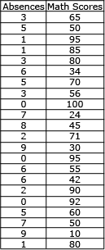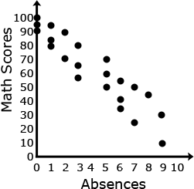  - 2. Draw a line of best fit, paying attention to the closeness of the data points on either side of the line.  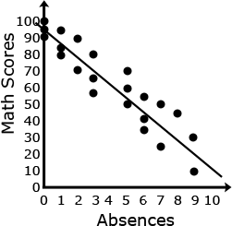  3. From the line of best fit, determine an approximate linear equation that models the given data (about y = 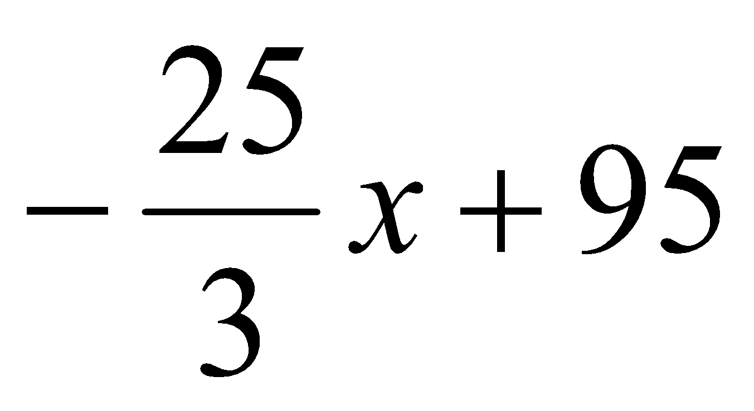)  4. Students should recognize that 95 represents the y intercept and 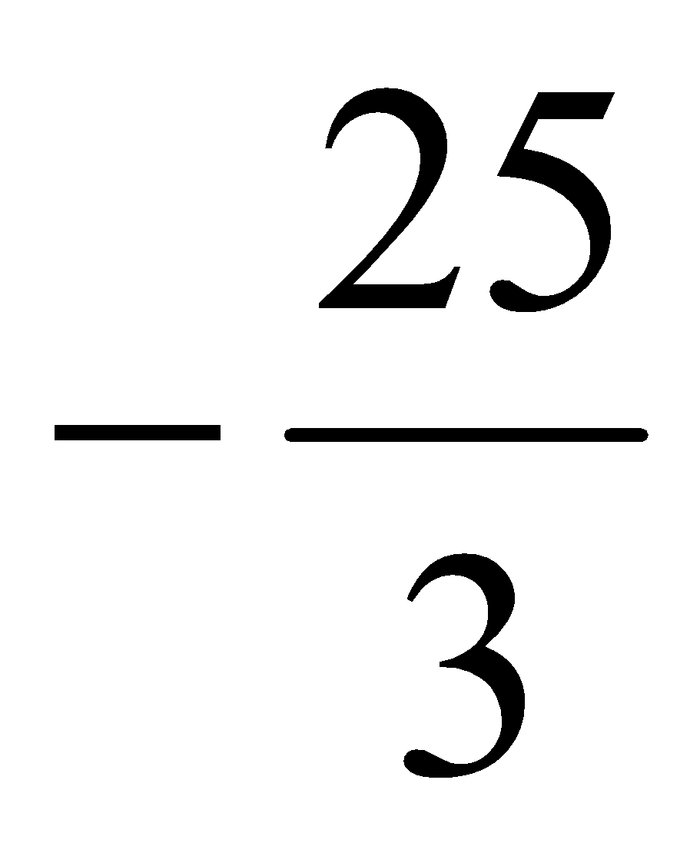represents the slope of the line.  5. Students can use this linear model to solve problems. For example, through substitution, they can use the equation to determine that a student with 4 absences should expect to receive a math score of about 62. They can then compare this value to their line.
4. Understand that patterns of association can also be seen in bivariate categorical data by displaying frequencies and relative frequencies in a two-way table. Construct and interpret a two-way table summarizing data on two categorical variables collected from the same subjects. Use relative frequencies calculated for rows or columns to describe possible association between the two variables. For example, collect data from students in your class on whether or not they have a curfew on school nights and whether or not they have assigned chores at home. Is there evidence that those who have a curfew also tend to have chores?  (MP2, MP4, MP5, MP7) | - Briefly review univariate categorical data from Grade 6, focusing on frequency tables  - Introduce scenarios that involve bivariate categorical data from real-world contexts and discuss distribution and centers of each variable in isolation and discuss what can and cannot be seen from these representations (leading to developing a reason why two-way tables are necessary to see covariation)  - Construct and interpret two-way tables  - Use relative frequencies to describe possible association between two variables  - Display conditional relative frequencies in a bar graph to compare data and verify conclusions  - Interpret results in the context of the problem situation | - Use data to create a two way chart to display frequencies  - Tally the frequencies  - Input the frequencies into the table  - Analyze the data to determine associations between the two variables | Example:  - The table illustrates the results when 100 students were asked the survey questions: Do you have a curfew? Do you have assigned chores? Is there evidence that those who have a curfew also tend to have chores?  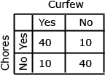  Solution: Of the students, who answered that they had a curfew, 40 had chores and 10 did not. Of the students who answered they did not have a curfew, 10 had chores and 40 did not. From this sample, there appears to be a positive correlation between having a curfew and having chores.

Differentiation/Accommodations/Modifications
Gifted and Talented | English Language Learners | Students with Disabilities | Students at Risk of School Failure
- Teacher gives students real life situations and students create an outcome  - analyze data about adult obesity rates in New Jersey since 1990 using http://stateofobesity.org/states/nj/. Examine the data and make a prediction about the obesity rate in 2020. Use mathematics to support your answer and be ready to present your work to the class.  - Line of Best Fit: Students explore lines of best fit on an interactive scatter plot. The scenario is about basketball players' salaries, but can be changed to any other major sport.  - Scatter plot project-Students have an opportunity to pick what they want to research under certain criteria. | - Video clips  - Choose excerpt(s) from book to focus on vocabulary development, comprehension  - Translate vocabulary into native language  - Read aloud  - Word Wall  - Build background knowledge  - Picture Associations  - Partner Work  - For more, see http://www.state.nj.us/education/modelcurriculum/ela/ellscaffolding/3u1.pdf | - Extended time  - Modified assignments  - Small group, alternate location  - Modeling  - Color coded notes  - Geoboards  - Graph paper  - Read aloud problems  - Calculator  - Build background knowledge  - Oral/visual reminders  - Peer assistance  - Picture associations with vocabulary  - Build background knowledge of statistic and probability.  - Refer to each student’s IEP for more specific modifications | - RTI strategies including: teacher modeling, gradual release, think-Pair-Share, Think Aloud, Interactive notes  - Tier II and Tier III intervention  - More frequent STAR assessments  - Morning tutoring  - After school program  - Parental contact

