Moonachie School District
Mathematics Curriculum:
Grade Five

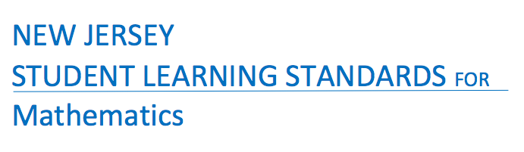

Born On & Board Approved: July 25, 2017
Re-Adopted: August 23, 2022

The following maps outline the New Jersey Student Learning Standards for grade five mathematics determined by the State Standards Initiative. Below is a list of assessment tools that are recommended for tracking student progress in these areas. In addition, resources that can be used in conjunction with instruction of these standards are provided but not limited to the list below.

Assessment:
Formative Assessment Class-Work Review
Open-Ended Problems Project-Based Assessment
Self-Assessment Timed Drills
Teacher Observation End of Year Assessment
Benchmark Assessment Math Software (ex. Study Island)
Homework Review Group & Cooperative Work
Summative Assessment

Resources: _
Counters (variety) Tangrams Protractors
Flashcards Ten Frame Geometric Shapes
Math Word Wall Blocks Geo-Board
Connecting Cubes Calendar Textbooks
Number Line 100 Chart Attribute Blocks
Work Mats Math Songs/Poems Craft Sticks
Computer Software Calculators Wiki-Sticks
Interactive White Board Money/Coins Pattern Blocks
Flannel Board Measurement Tools Three Dimensional Shapes
Center Games Rulers Fraction Tiles
Concrete Objects Bar Models Math/Pocket Charts
Mini White Boards Base Ten Blocks
Manipulatives Math Journals

Websites:
www.ixl.com _ www.Envision 2020.com www.xtramath.com
www.aplusmath.com www.tenmarks.com www.superteacherworksheets.com
www.brainpop.com www.commoncoresheets.com www.mrnussbaum.com
www.brainpopjr.com www.fun4thebrain.com www.learnzillion.com
www.funbrain.com www.math-play.com www.k6.thinkcentral.com
www.mathplayground.com www.smartexchange.com www. interactivesites.weebly.com/math.html
www.sheppardssoftware.com http://www.k-5mathteachingresources.com www.songsforteaching.com

References:
http://www.state.nj.us/education/aps/cccs/math/
NJ Technology Standards: http://www.state.nj.us/education/cccs/2014/tech/8.pdf
NJ Career Ready Practices: http://www.state.nj.us/education/aps/cccs/career/

Standards for Mathematical Practice
MP. 1 - Make Sense of problems and persevere in solving them.
MP. 2 - Reason Abstractly and Quantitatively
Mp. 3 - Construct Viable Arguments and Critique the Reasoning of Others
MP. 4 - Model with Mathematics
MP. 5 - Use Appropriate Tools Strategically
MP. 6 - Attend to Precision
MP. 7 - Look for and make use of Structure
MP. 8 - Look for and Express Regularity in Repeated Reasoning

Curriculum Details
Mathematics - Grade 5
Core Materials | Envision 2020 Math, Numbers World
Interdisciplinary Connections | ELA:  NJSLSA.R1 Read closely to determine what the text says explicitly and to make logical inferences and relevant connections from it; cite specific textual evidence when writing or speaking to support conclusions drawn from the text.  NJSLSA.W2. Write informative/explanatory texts to examine and convey complex ideas and information clearly and accurately through the effective selection, organization, and analysis of content.  NJSLSA.L1. Demonstrate command of the conventions of standard English grammar and usage when writing or speaking.
Career Ready Practices | CRP2. Apply appropriate academic and technical skills.  CRP4. Communicate clearly and effectively and with reason.  CRP6. Demonstrate creativity and innovation.  CRP7. Employ valid and reliable research strategies.  CRP8. Utilize critical thinking to make sense of problems and persevere in solving them.  CRP12. Work productively in teams while using cultural global competence.
Career Readiness, Life Literacies, and Key Skills | 9.1.5.EG.1: Explain and give examples of what is meant by the term ‘tax’.  9.1.5.EG.2: Describe how tax monies are spent  9.1.5.FP.2: Identify the elements of being a good steward of money.  9.1.5.PB.2: Describe choices consumers have with money (e.g. save, spend, donate).  9.2.5.CAP.1: Evaluate personal likes and dislikes and identify careers that might be suited to personal likes.  9.2.5.CAP.2: Identify how you might like to earn an income.  9.4.5.CT.1: Identify and gather relevant data that will aid in the problem-solving process.  9.4.5.CT.4: Apply critical thinking and problem-solving strategies to different types of problems such as personal, academic, community, and global.  9.1.5.EG.3: Explain the impact of the economic system on one’s personal financial goals.  9.1.5.EG.4: Describe how an individual’s financial decisions affect society and contribute to the overall economy.
Computer Science and Design Thinking | 8.1.5.DA.1: Collect, organize, and display data in order to highlight relationships or support a claim.  8.1.5.DA.3: Organize and present collected data visually to communicate insights gained from different views of the data.  8.1.5.DA.5: Propose cause and effect relationships, predict outcomes, or communicate ideas using data.  8.2.5.ED.2: Collaborate with peers to collect information, brainstorm to solve a problem, and evaluate all possible solutions to provide the best results with supporting sketches or models.  8.2.5.ED.3: Follow step by step directions to assemble a product or solve a problem, using appropriate tools to accomplish the task.

Math Curriculum: Grade 5
Operations & Algebraic Thinking
Math Standards 5.OA.A.1, 5.OA.A.2

Essential Question(s): How do students use computational strategies effectively?
Vocabulary: algebraic expression, parentheses, brackets, braces, numerical expression, equation, evaluate, variable
Content: Operations & Algebraic Thinking
SLS Anchor Standards: A. Write and interpret numerical expressions.
SLS Standards: 5.OA.A.1, 5.OA.A.2
Standards for Mathematical Practice: MP 1, MP 2, MP 5, MP 7, MP 8
Skills | Instructional Procedures | Explanations and Examples | Interdisciplinary Connections
1. Use parentheses, brackets, or braces in numerical expressions, and evaluate expressions with these symbols.  (MP 1, MP 5, MP 8) | - Introduce grouping symbols and how to use them  - Model evaluating expression with these symbols  - Write and solve number sentences and equations for one and tow step real- world problems  - Create situations to represent certain expressions. | This standard builds on the expectations of third grade where students are expected to start learning the conventional order. Students need experiences with multiple expressions that use grouping symbols throughout the year to develop understanding of when and how to use parentheses, brackets, and braces. First, students use these symbols with whole numbers. Then the symbols can be used as students add, subtract, multiply and divide decimals and fractions.  Examples:  - (26 + 18) $v?$ 4 Answer: 11  - {[2 x (3+5)] – 9} + [5 x (23-18)] Answer: 32  - 12 – (0.4 x 2) Answer: 11.2  - (2 + 3) x (1.5 – 0.5) Answer: 5  - 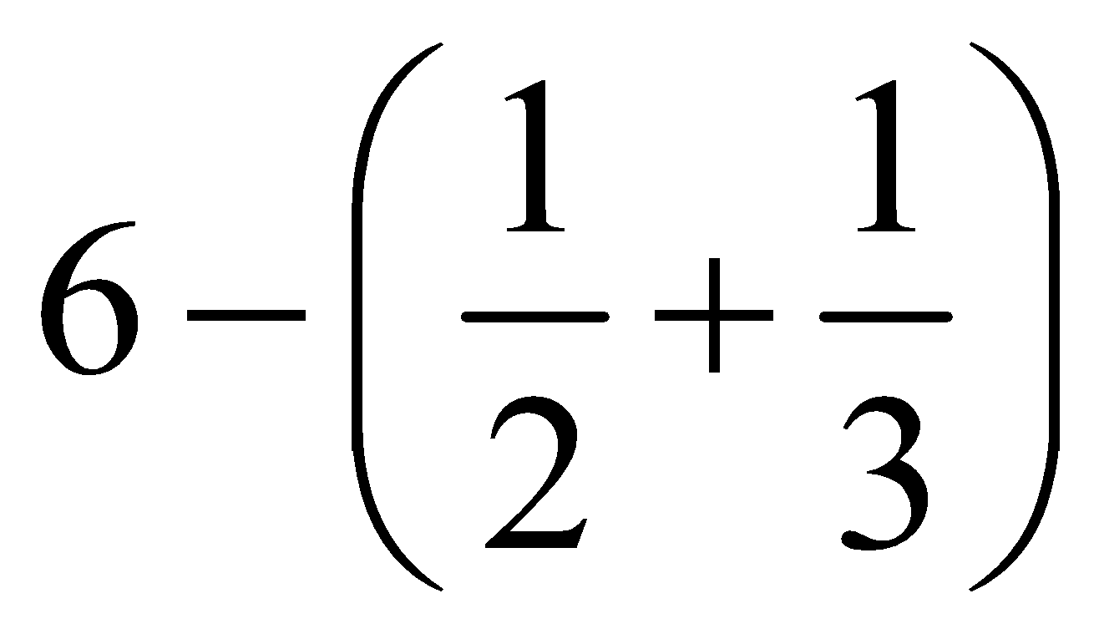 Answer: 5 1/6  - { 80 [ 2 x (3 ½ + 1 ½ ) ] }+ 100 Answer: 108  To further develop students’ understanding of grouping symbols and facility with operations, students place grouping symbols in equations to make the equations true or they compare expressions that are grouped differently.  Examples:  - 15 - 7 – 2 = 10 → 15 - (7 – 2) = 10  - 3 x 125 ÷ 25 + 7 = 22 → [3 x (125 ÷ 25)] + 7 = 22  - 24 ÷ 12 ÷ 6 ÷ 2 = 2 x 9 + 3 ÷ ½ → 24 ÷ [(12 ÷ 6) ÷ 2] = (2 x 9) + (3 ÷ ½)  - Compare 3 x 2 + 5 and 3 x (2 + 5)  Compare 15 – 6 + 7 and 15 – (6 + 7) | Language Art:  Math Journal- have students write multi-step real world problems that can be described by the given algebraic expression
2. Write simple expressions that record calculations with numbers, and interpret numerical expressions without evaluating them. For example, express the calculation “add 8 and 7, then multiply by 2” as 2 × (8 + 7). Recognize that 3 × (18932 + 921) is three times as large as 18932 + 921, without having to calculate the indicated sum or product.  (MP 1, MP 2, MP 7, MP 8) | - Write a numerical expression to show how numbers in a situation are related.  - Recognize relationships between words and algebraic expressions. | Students use their understanding of operations and grouping symbols to write expressions and interpret the meaning of a numerical expression.  Examples:  - Students write an expression for calculations given in words such as “divide 144 by 12, and then subtract 7/8.” They write (144 ÷ 12) – 7/8.  Students recognize that 0.5 x (300 ÷ 15) is ½ of (300 ÷ 15) without calculating the quotient.

Differentiation/Modifications/Accommodations
Gifted and Talented | English Language Learners | Students with Disabilities | Students At Risk of School Failure

- Envision 2020 advanced/enrichment practice  - Create multistep real life word problems with answer key  - Solve equations with missing factors, showing all work to reach final answer  - Create a tutorial video to demonstrate the process of using order of operations  - Create a pneumonic device for the class to use as a resource tool | - Use 3D magnetic objects to represent parenthesis/brackets and operations symbols  - Using manipulatives  - Using small group interactions and peer questioning  - Using pictures and graphic organizers  - Envision 2020 ELL activities  - For more, see http://www.state.nj.us/education/modelcurriculum/ela/ellscaffolding/3u1.pdf | - RTI approaches: prevent misconceptions, error intervention, reteaching set, reteaching worksheets  - Extended time  - Modified assignments  - Small group, alternate location  - Modeling  - Manipulatives  - Video tutorials  - Color coding methods  - Flashcards  - Refer to each student’s IEP for more specific modifications | - Using demonstration: (ie: Create three visual representations of the same multiplication or division problem)  - Using manipulatives  - Using small group interactions and peer questioning  - Using pictures and graphic organizers  - Envision 2020 ELL activities  - Morning tutoring  - After school program  - Parental contact  - Tier II and Tier III Intervention

Math Curriculum: Grade 5
Operations & Algebraic Thinking
Math Standards 5.OA.A.3

 | Essential Question(s): How can graphs or visual tools represent the relationship between patterns?
 | Vocabulary: coordinate plane, graphing, ordered pairs, x-axis, y-axis, sequence, terms
 | Content: Operations & Algebraic Thinking
 | SLS Anchor Standards: B. Analysis patterns and relationships.
 | SLS Standards: 5.OA.A.3
 | Standards for Mathematical Practice: MP 2, MP 7
 | Skills | Instructional Procedures |  | Explanations and Examples |  |  | Interdisciplinary Connections
 | 3. Generate two numerical patterns using two given rules. Identify apparent relationships between corresponding terms. Form ordered pairs consisting of corresponding terms from the two patterns, and graph the ordered pairs on a coordinate plane. For example, given the rule “Add 3” and the starting number 0, and given the rule “Add 6” and the starting number 0, generate terms in the resulting sequences, and observe that the terms in one sequence are twice the corresponding terms in the other sequence. Explain informally why this is so.  (MP 2, MP 7) | - Find rules to complete number patterns  - Identify apparent relationships between corresponding terms  - Form ordered pairs consisting of corresponding terms from two patterns  - Plot points on a coordinate grid. |  | Example:  Use the rule “add 3” to write a sequence of numbers. Starting with a 0, students write 0, 3, 6, 9, 12, . . .  Use the rule “add 6” to write a sequence of numbers. Starting with 0, students write 0, 6, 12, 18, 24, . . .  After comparing these two sequences, the students notice that each term in the second sequence is twice the corresponding terms of the first sequence. One way they justify this is by describing the patterns of the terms. Their justification may include some mathematical notation (See example below). A student may explain that both sequences start with zero and to generate each term of the second sequence he/she added 6, which is twice as much as was added to produce the terms in the first sequence. Students may also use the distributive property to describe the relationship between the two numerical patterns by reasoning that 6 + 6 + 6 = 2 (3 + 3 + 3).  0, ⁺³ 3, ⁺³ 6, ⁺³ 9, ⁺³12, . . .  0, ⁺⁶ 6, ⁺⁶ 12, ⁺⁶18, ⁺⁶ 24, . . .  Continued on next page  Once students can describe that the second sequence of numbers is twice the corresponding terms of the first sequence, the terms can be written in ordered pairs and then graphed on a coordinate grid. They should recognize that each point on the graph represents two quantities in which the second quantity is twice the first quantity.  Ordered pairs  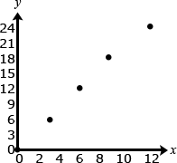  (0, 0)  (3, 6)  (6, 12)  (9, 18)  (12, 24) |  |  | Art:  Color on grid by ordered pairs
Differentiation/Modifications/Accommodations
Gifted and Talented |  |  | English Language Learners |  | Students with Disabilities | Students At Risk of School Failure

- Envision 2020 advanced/enrichment practice  - Create an image based on ordered pairs in decimal form  - Solve a list of riddles to find the ordered pairs on a coordinate plane  - Create riddles, using ordered pair cues, to have peer identify a place on the coordinate plane  - Create their own image using ordered pairs on a coordinate plane | - Manipulate large scale coordinate plane  - Coordinate Plane Twister: use body to represent a plotted point on a life size grid (ex: can use squares on classroom floor)  - Using small group interactions and peer questioning  - Interactive smartboard activity  - Envision 2020 ELL activities  - For more, see http://www.state.nj.us/education/modelcurriculum/ela/ellscaffolding/3u1.pdf | - RTI approaches: prevent misconceptions, error intervention, reteaching set, reteaching worksheets  - Extended time  - Modified assignments  - Small group, alternate location  - Modeling  - Manipulatives  - Video tutorials  - Color coding methods  - Flashcards  - Refer to each student’s IEP for more specific modifications | - Using demonstration: (ie: Create three visual representations of the same multiplication or division problem)  - Using manipulatives  - Using small group interactions and peer questioning  - Using pictures and graphic organizers  - Envision 2020 ELL activities  - Morning tutoring  - After school program  - Parental contact  - Tier II and Tier III Intervention

Math Curriculum: Grade 5
Operations & Algebraic Thinking
Math Standards 5.NBT.A.1, 5.NBT.A.2, 5.NBT.A.3, 5.NBT.A.4

 | Essential Question(s): How do you use place value to represent whole numbers and decimals?
 | Vocabulary: word form, expanded form, standard form, place value, value, whole numbers, decimals, greater than, less than, equal to, period, exponents, powers of 10, benchmark, fraction
 | Content: Numbers and Operations in Base Ten
 | SLS Anchor Standards: A. Understand the place value system.
 | SLS Standards: 5.NBT.A.1, 5.NBT.A.2, 5.NBT.A.3, 5.NBT.A.4
 | Standards for Mathematical Practice: MP 2, MP 4, MP 5, MP 6, MP 7
 | Skills | Instructional Procedures |  | Explanations and Examples |  |  | Interdisciplinary Connections
 | 1. Recognize that in a multi-digit number, a digit in one place represents 10 times as much as it represents in the place to its right and 1/10 of what it represents in the place to its left.  (MP 2, MP 6, MP 7) | - Explain and apply why the value of a digit changes when the place value changes. |  | In fourth grade, students examined the relationships of the digits in numbers for whole numbers only. This standard extends this understanding to the relationship of decimal fractions. Students use base ten blocks, pictures of base ten blocks, and interactive images of base ten blocks to manipulate and investigate the place value relationships. They use their understanding of unit fractions to compare decimal places and fractional language to describe those comparisons.  Before considering the relationship of decimal fractions, students express their understanding that in multi-digit whole numbers, a digit in one place represents 10 times what it represents in the place to its right and 1/10 of what it represents in the place to its left.  A student thinks, “I know that in the number 5555, the 5 in the tens place (5555) represents 50 and the 5 in the hundreds place (5555) represents 500. So a 5 in the hundreds place is ten times as much as a 5 in the tens place or a 5 in the tens place is 1/10 of the value of a 5 in the hundreds place.  To extend this understanding of place value to their work with decimals, students use a model of one unit; they cut it into 10 equal pieces, shade in, or describe 1/10 of that model using fractional language (“This is 1 out of 10 equal parts. So it is 1/10”. I can write this using 1/10 or 0.1”). They repeat the process by finding 1/10 of a 1/10 (e.g., dividing 1/10 into 10 equal parts to arrive at 1/100 or 0.01) and can explain their reasoning, “0.01 is 1/10 of 1/10 thus is 1/100 of the whole unit.”  In the number 55.55, each digit is 5, but the value of the digits is different because of the placement.  5 5 . 5 5  The 5 that the arrow points to is 1/10 of the 5 to the left and 10 times the 5 to the right. The 5 in the ones place is 1/10 of 50 and 10 times five tenths.  5 5 . 5 5  The 5 that the arrow points to is 1/10 of the 5 to the left and 10 times the 5 to the right. The 5 in the tenths place is 10 times five hundredths.  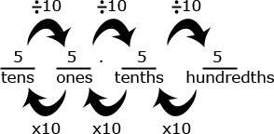 |  |  | Language Arts:  Read The History of Counting by Denise Shmandt-Besserat  Science:  Review with students the names of the planets in order of increasing distance from the sun. Have students write each measurement in word form and expanded form.
 | 2. Explain patterns in the number of zeros of the product when multiplying a number by powers of 10, and explain patterns in the placement of the decimal point when a decimal is multiplied or divided by a power of 10. Use whole-number exponents to denote powers of 10.  (MP 2, MP 6, MP 7) | - Use place value to find an algorithm that can be used to multiply or divide numbers by a power by 10 using whole number exponents to denote the power of ten. |  | Examples:  Students might write:  - 36 x 10 = 36 x 10¹ = 360  - 36 x 10 x 10 = 36 x 10² = 3600  - 36 x 10 x 10 x 10 = 36 x 10³ = 36,000  - 36 x 10 x 10 x 10 x 10 = 36 x 10⁴ = 360,000  Students might think and/or say:  - I noticed that every time, I multiplied by 10 I added a zero to the end of the number. That makes sense because each digit’s value became 10 times larger. To make a digit 10 times larger, I have to move it one place value to the left.  - When I multiplied 36 by 10, the 30 became 300. The 6 became 60 or the 36 became 360. So I had to add a zero at the end to have the 3 represent 3 one-hundreds (instead of 3 tens) and the 6 represents 6 tens (instead of 6 ones).  Students should be able to use the same type of reasoning as above to explain why the following multiplication and division problem by powers of 10 make sense.  - 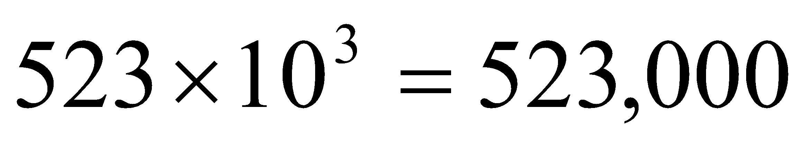 The place value of 523 is increased by 3 places.  - 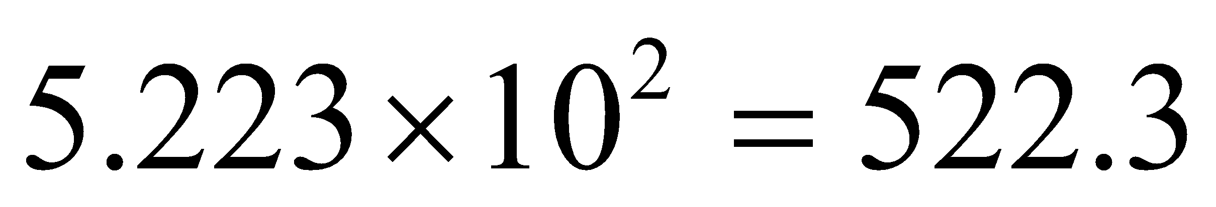 The place value of 5.223 is increased by 2 places.  - 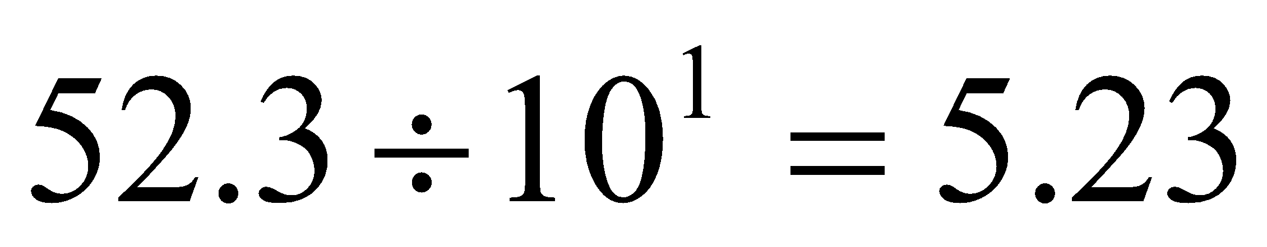 The place value of 52.3 is decreased by one place. |  |  | Language Arts:  The Great Number Rumble: A Story of math in Surprising Places by Cora Lee and Gillian O’ Rielly- The story presents a myriad of ways math affects us in our everyday life.
 | 3. Read, write, and compare decimals to thousandths.  a) Read and write decimals to thousandths using base-ten numerals, number names, and expanded form, e.g., 347.392 = 3 × 100 + 4 × 10 + 7 × 1 + 3 × (1/10) + 9 × (1/100) + 2 × (1/1000).  b) Compare two decimals to thousandths based on meanings of the digits in each place, using >, =, and < symbols to record the results of comparisons.  (MP 2, MP 4, MP 5, MP 6, MP 7) | - Read and write decimals through thousandths  - Compose and order decimals using the standard algorithm and benchmarks to determine •, •, =  - Identify relationships between functions and decimals |  | Students build on the understanding they developed in fourth grade to read, write, and compare decimals to thousandths. They connect their prior experiences with using decimal notation for fractions and addition of fractions with denominators of 10 and 100. They use concrete models and number lines to extend this understanding to decimals to the thousandths. Models may include base ten blocks, place value charts, grids, pictures, drawings, manipulatives, technology-based, etc. They read decimals using fractional language and write decimals in fractional form, as well as in expanded notation as show in the standard 3a. This investigation leads them to understanding equivalence of decimals (0.8 = 0.80 = 0.800).  Example:  Some equivalent forms of 0.72 are:  72/100 7/10 + 2/100 7 x (1/10) + 2 x (1/100) 0.70 + 0.02 70/100 + 2/100 0.720 7 x (1/10) + 2 x (1/100) + 0 x (1/1000) 720/1000  Students need to understand the size of decimal numbers and relate them to common benchmarks such as 0, 0.5 (0.50 and 0.500), and 1. Comparing tenths to tenths, hundredths to hundredths, and thousandths to thousandths is simplified if students use their understanding of fractions to compare decimals.  Example:  Comparing 0.25 and 0.17, a student might think, “25 hundredths is more than 17 hundredths”. They may also think that it is 8 hundredths more. They may write this comparison as 0.25 > 0.17 and recognize that 0.17 < 0.25 is another way to express this comparison.  Comparing 0.207 to 0.26, a student might think, “Both numbers have 2 tenths, so I need to compare the hundredths. The second number has 6 hundredths and the first number has no hundredths so the second number must be larger. Another student might think while writing fractions, “I know that 0.207 is 207 thousandths (and may write 207/1000). 0.26 is 26 hundredths (and may write 26/100) but I can also think of it as 260 thousandths (260/1000). So, 260 thousandths is more than 207 thousandths. |  |  | Science:  The speed of sound is 767.58 miles per hour. Have students research vehicles that have traveled faster than the speed of sound, such as airplane, rockets and even cars. Have students present their reports to the class. Encourage them to include visuals with their reports.
 | 4. Use place value understanding to round decimals to any place.  (MP 2, MP 6, MP 7) | - Recognize, compare, and round using the standard algorithm and benchmarks. |  | When rounding a decimal to a given place, students may identify the two possible answers, and use their understanding of place value to compare the given number to the possible answers.  Example:  Round 14.235 to the nearest tenth.  - Students recognize that the possible answer must be in tenths thus, it is either 14.2 or 14.3. They then identify that 14.235 is closer to 14.2 (14.20) than to 14.3 (14.30).  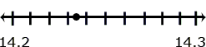
Differentiation/Modifications/Accommodations
Gifted and Talented |  |  | English Language Learners |  | Students with Disabilities | Students At Risk of School Failure

- Envision 2020 advanced/enrichment practice  - Provide clues to identify the value of a number in a specific place  - Expanded form riddles  - Create “I Have..Who Has” game for expanded form | - Using small group interactions and peer questioning  - Interactive smartboard activity  - Place value blocks  - Color coded place value chart  - Color coded bean bag place value toss  - Interactive smartboard number lines  - Do Now - Physical number line, students place themselves or a peer on the number line to correctly identify the number of the day  - Envision 2020 ELL activities  - For more, see http://www.state.nj.us/education/modelcurriculum/ela/ellscaffolding/3u1.pdf | - RTI approaches: prevent misconceptions, error intervention, reteaching set, reteaching worksheets  - Extended time  - Modified assignments  - Small group, alternate location  - Modeling  - Manipulatives  - Color coded bean bag place value toss  - Video tutorials  - Color coded place value chart  - Interactive smartboard number lines  - Do Now - Physical number line, students place themselves or a peer on the number line to correctly identify the number of the day  - Flashcards  - Place value blocks  - Refer to each student’s IEP for more specific modifications | - Using demonstration: (ie: Create three visual representations of the same multiplication or division problem)  - Using manipulatives  - Using small group interactions and peer questioning  - Using pictures and graphic organizers  - Envision 2020 ELL activities  - Morning tutoring  - After school program  - Parental contact  - Tier II and Tier III Intervention

Math Curriculum: Grade 5
Operations & Algebraic Thinking
Math Standards 5.NBT.B.5, 5.NBT.B.6, 5.NBT.B.7

Essential Question(s): How do we use the standard algorithm to multiply multi-digit whole numbers?
How do you use properties of operations and other strategies to find whole number quotients?
How do you use properties of operations and other strategies to add, subtract, multiply and divide decimals?
 | Vocabulary: algorithm, sum, difference, products, quotients
 | Content: Numbers and Operations in Base Ten
 | SLS Anchor Standard: B. Perform operations with multi-digit whole numbers and with decimals to the hundredths.
 | SLS Standards: 5.NBT.B.5, 5.NBT.B.6, 5.NBT.B.7
 | Standards for Mathematical Practice: MP 2, MP 3, MP 4, MP 5, MP 6, MP 7, MP 8
 | Skills | Instructional Procedures |  | Explanations and Examples |  |  | Interdisciplinary Connections
 | 5. Fluently multiply multi-digit whole numbers using the standard algorithm.  (MP 2, MP 3, MP 4, MP 5, MP 6, MP 7, MP 8) | - Use the standard algorithm to multiply multi-digits whole number by a two-digit number |  | In prior grades, students used various strategies to multiply. Students can continue to use these different strategies as long as they are efficient, but must also understand and be able to use the standard algorithm. In applying the standard algorithm, students recognize the importance of place value.  Example:  123 x 34. When students apply the standard algorithm, they, decompose 34 into 30 + 4. Then they multiply 123 by 4, the value of the number in the ones place, and then multiply 123 by 30, the value of the 3 in the tens place, and add the two products. |  |  | Science:  Research the approximate length of one day on each planet in “earth day” then convert to the number or earth hours.
 | 6. Find whole-number quotients of whole numbers with up to four-digit dividends and two-digit divisors, using strategies based on place value, the properties of operations, and/or the relationship between multiplication and division. Illustrate and explain the calculation by using equations, rectangular arrays, and/or area models.  (MP 2, MP 3, MP 4, MP 5, MP 7) | - Divide up to four –digit dividends by two-digit divisors with the regrouping with or without remainders using properties of operations, area models or the standard algorithm. |  | In fourth grade, students’ experiences with division were limited to dividing by one-digit divisors. This standard extends students’ prior experiences with strategies, illustrations, and explanations. When the two-digit divisor is a “familiar” number, a student might decompose the dividend using place value.  Example:  - Using expanded notation ~ 2682 ÷ 25 = (2000 + 600 + 80 + 2) ÷ 25  - Using his or her understanding of the relationship between 100 and 25, a student might think ~  - I know that 100 divided by 25 is 4 so 200 divided by 25 is 8 and 2000 divided by 25 is 80.  - 600 divided by 25 has to be 24.  - Since 3 x 25 is 75, I know that 80 divided by 25 is 3 with a reminder of 5. (Note that a student might divide into 82 and not 80)  - I can’t divide 2 by 25 so 2 plus the 5 leaves a remainder of 7.  - 80 + 24 + 3 = 107. So, the answer is 107 with a remainder of 7.  Using an equation that relates division to multiplication, 25 x n = 2682, a student might estimate the answer to be slightly larger than 100 because s/he recognizes that 25 x 100 = 2500.  Example: 968 ÷ 21  - Using base ten models, a student can represent 962 and use the models to make an array with one dimension of 21. The student continues to make the array until no more groups of 21 can be made. Remainders are not part of the array.  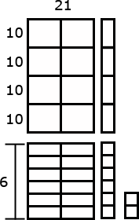  Example: 9984 ÷ 64  - An area model for division is shown below. As the student uses the area model, s/he keeps track of how much of the 9984 is left to divide.  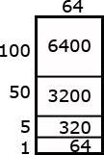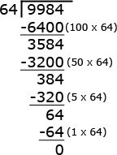 |  |  | Science:  Elephants eat 300 lbs, of food each day. Elephants spend at least 16 hours per day eating. Have students make a table showing how much food elephants each day, week, month and year. Then have them do the same for the number of hours elephants spend eating during each time period.
 | 7. Add, subtract, multiply, and divide decimals to hundredths, using concrete models or drawings and strategies based on place value, properties of operations, and/or the relationship between addition and subtraction; relate the strategy to a written method and explain the reasoning used.  (MP 2, MP 3, MP 4, MP 5, MP 7) | - Use rounding to estimate sum, differences, products and quotients.  - Add and subtract decimals to hundredths using the standard algorithm and concrete models  - Multiply and divide decimals to hundredths using the standard algorithm, partial products, and area models. |  | This standard requires students to extend the models and strategies they developed for whole numbers in grades 1-4 to decimal values. Before students are asked to give exact answers, they should estimate answers based on their understanding of operations and the value of the numbers.  Examples:  - 3.6 + 1.7  - A student might estimate the sum to be larger than 5 because 3.6 is more than 3 ½ and 1.7 is more than 1 ½.  - 5.4 – 0.8  - A student might estimate the answer to be a little more than 4.4 because a number less than 1 is being subtracted.  - 6 x 2.4  - A student might estimate an answer between 12 and 18 since 6 x 2 is 12 and 6 x 3 is 18. Another student might give an estimate of a little less than 15 because s/he figures the answer to be very close, but smaller than 6 x 2 ½ and think of 2 ½ groups of 6 as 12 (2 groups of 6) + 3 (½ of a group of 6).  Students should be able to express that when they add decimals they add tenths to tenths and hundredths to hundredths. So, when they are adding in a vertical format (numbers beneath each other), it is important that they write numbers with the same place value beneath each other. This understanding can be reinforced by connecting addition of decimals to their understanding of addition of fractions. Adding fractions with denominators of 10 and 100 is a standard in fourth grade.  Example: 4 - 0.3  - 3 tenths subtracted from 4 wholes. The wholes must be divided into tenths.  The answer is 3 and 7/10 or 3.7.  Example: An area model can be useful for illustrating products.  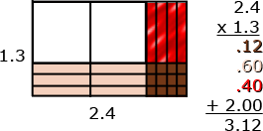  Students should be able to describe the partial products displayed by the area model. For example,  “3/10 times 4/10 is 12/100.  3/10 times 2 is 6/10 or 60/100.  1 group of 4/10 is 4/10 or 40/100.  1 group of 2 is 2.”  Example of division: finding the number in each group or share  - Students should be encouraged to apply a fair sharing model separating decimal values into equal parts such as  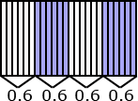  Example of division: find the number of groups  - Joe has 1.6 meters of rope. He has to cut pieces of rope that are 0.2 meters long. How many can he cut?  - To divide to find the number of groups, a student might  - draw a segment to represent 1.6 meters. In doing so, s/he would count in tenths to identify the 6 tenths, and be able identify the number of 2 tenths within the 6 tenths. The student can then extend the idea of counting by tenths to divide the one meter into tenths and determine that there are 5 more groups of 2 tenths.  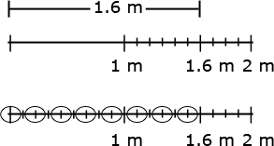  - count groups of 2 tenths without the use of models or diagrams. Knowing that 1 can be thought of as 10/10, a student might think of 1.6 as 16 tenths. Counting 2 tenths, 4 tenths, 6 tenths, . . .16 tenths, a student can count 8 groups of 2 tenths.  - Use their understanding of multiplication and think, “8 groups of 2 is 16, so 8 groups of 2/10 is 16/10 or 1 6/10.”  Technology Connections: Create models using Interactive Whiteboard software (such as SMART Notebook) |  |  | Science:  Research the maximum speed of three different animals. Find the distance they will travel in 3 hours, 4 hours, 5 hours etc. Have students estimate how long it will take them to travel x miles.
Differentiation/Modifications/Accommodations
Gifted and Talented |  |  | English Language Learners |  | Students with Disabilities | Students At Risk of School Failure

- Envision 2020 advanced/enrichment practice  - Use graph paper to create a real life object using arrays. (Students have to identify each array used within the object and record the total area)  - Event Planners: create classroom party within a given budget (ie: $200) use technology to research their items and menu options. Must provide list of items with prices (including cost per person) and prepare a presentation to be chosen for the best party.  - MrNussbaum.com Tipster game | - Using small group interactions and peer questioning  - Interactive smartboard activity  - Graph paper and highlighting tools to represent arrays  - Color coded arrays to represent decimal parts  - Place value blocks  - Number lines  - Menu Math  - Division Mat – template to help student understand where to stop the division process  - Pneumonic device bookmark/checklist  - Envision 2020 ELL activities  - For more, see http://www.state.nj.us/education/modelcurriculum/ela/ellscaffolding/3u1.pdf | - RTI approaches: prevent misconceptions, error intervention, reteaching set, reteaching worksheets  - Extended time  - Modified assignments  - Small group, alternate location  - Modeling  - Manipulatives  - Graph paper and highlighting tools to represent arrays  - Place value blocks  - Menu Math  - Number lines  - Division Mat – template to help student understand where to stop the division process  - Pneumonic device bookmark/checklist  - Refer to each student’s IEP for more specific modifications | - Using demonstration: (ie: Create three visual representations of the same multiplication or division problem)  - Using manipulatives  - Using small group interactions and peer questioning  - Using pictures and graphic organizers  - Envision 2020 ELL activities  - Morning tutoring  - After school program  - Parental contact  - Tier II and Tier III Intervention

Math Curriculum: Grade 5
Operations & Algebraic Thinking
Math Standards 5.NF.A.1, 5.NF.A.2

Essential Question(s): How do we use equivalent fractions as a strategy to add and subtract fractions?
How can your knowledge of fractions be used to solve problems?
Vocabulary: numerator, denominator, common denominator, equivalent fraction, least common denominator (lcd), least common multiple (lcm), sum, difference
Content: Number and Operations- Fractions
SLS Anchor Standards: A. Use equivalent fractions as a strategy to add and subtract fractions.
SLS Standards: 5.NF.A.1, 5.NF.A.2
Standards for Mathematical Practice: MP 1, MP 2, MP 3, MP 4, MP 5, MP 6, MP 7, MP 8
Skills | Instructional Procedures | Explanations and Examples | Interdisciplinary Connections
1. Add and subtract fractions with unlike denominators (including mixed numbers) by replacing given fractions with equivalent fractions in such a way as to produce an equivalent sum or difference of fractions with like denominators. For example, 2/3 + 5/4 = 8/12 + 15/12 = 23/12. (In general, a/b + c/d = (ad + bc)/bd.)  (MP 1, MP 2, MP 3, MP 4, MP 5, MP 6, MP 7, MP 8) | - Review fraction concepts  - Equivalent fractions (use lcm)  - Simplest form  - Mixed numbers  - Compare and order factions and mixed numbers  - Add and subtract like fractions  - Use common denominators  - Use least common denominator  - Add and subtract unlike fractions  - Add and subtract mixed numbers | Students should apply their understanding of equivalent fractions developed in fourth grade and their ability to rewrite fractions in an equivalent form to find common denominators. They should know that multiplying the denominators will always give a common denominator but may not result in the smallest denominator.  Examples:  - 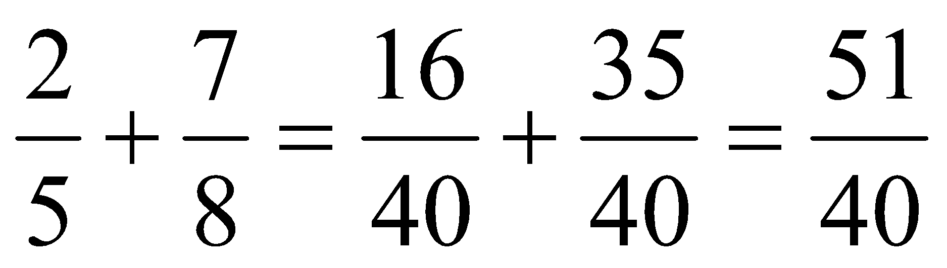  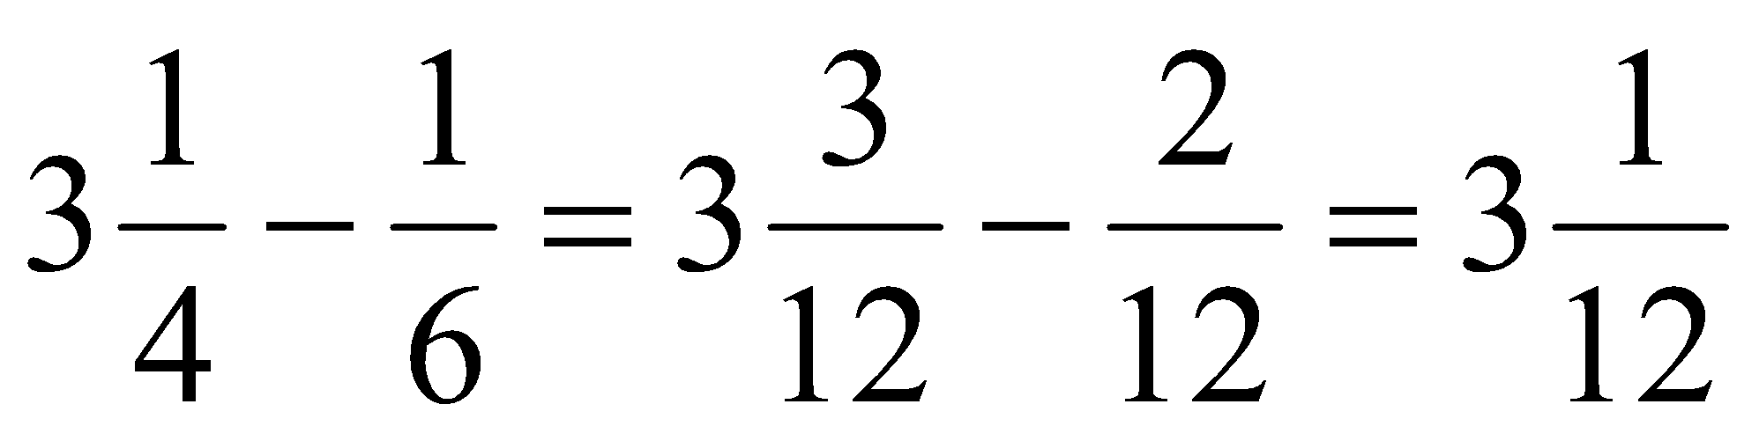 | Science:  Measuring fractions of a whole  Social Studies:  Calendar break down what fraction the month is of the year, etc.
2. Solve word problems involving addition and subtraction of fractions referring to the same whole, including cases of unlike denominators, e.g., by using visual fraction models or equations to represent the problem. Use benchmark fractions and number sense of fractions to estimate mentally and assess the reasonableness of answers. For example, recognize an incorrect result 2/5 + 1/2 = 3/7, by observing that 3/7 < 1/2.  (MP 1, MP 2, MP 3, MP 4, MP 5, MP 6, MP 7) | - Solve word problems involving addition and subtraction of fractions with like denominators  - Provide visual representations to solve word problems | Examples:  sugar and the other needed Jerry was making two different types of cookies. One recipe needed ¾ cup of sugar and the other needed $\frac{ 2}{3}$ cup of sugar. How much sugar did he need to make both recipes?  - Mental estimation:  - A student may say that Jerry needs more than 1 cup of sugar but less than 2 cups. An explanation may compare both fractions to ½ and state that both are larger than ½ so the total must be more than 1. In addition, both fractions are slightly less than 1 so the sum cannot be more than 2.  - Area model  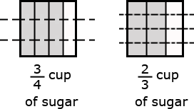  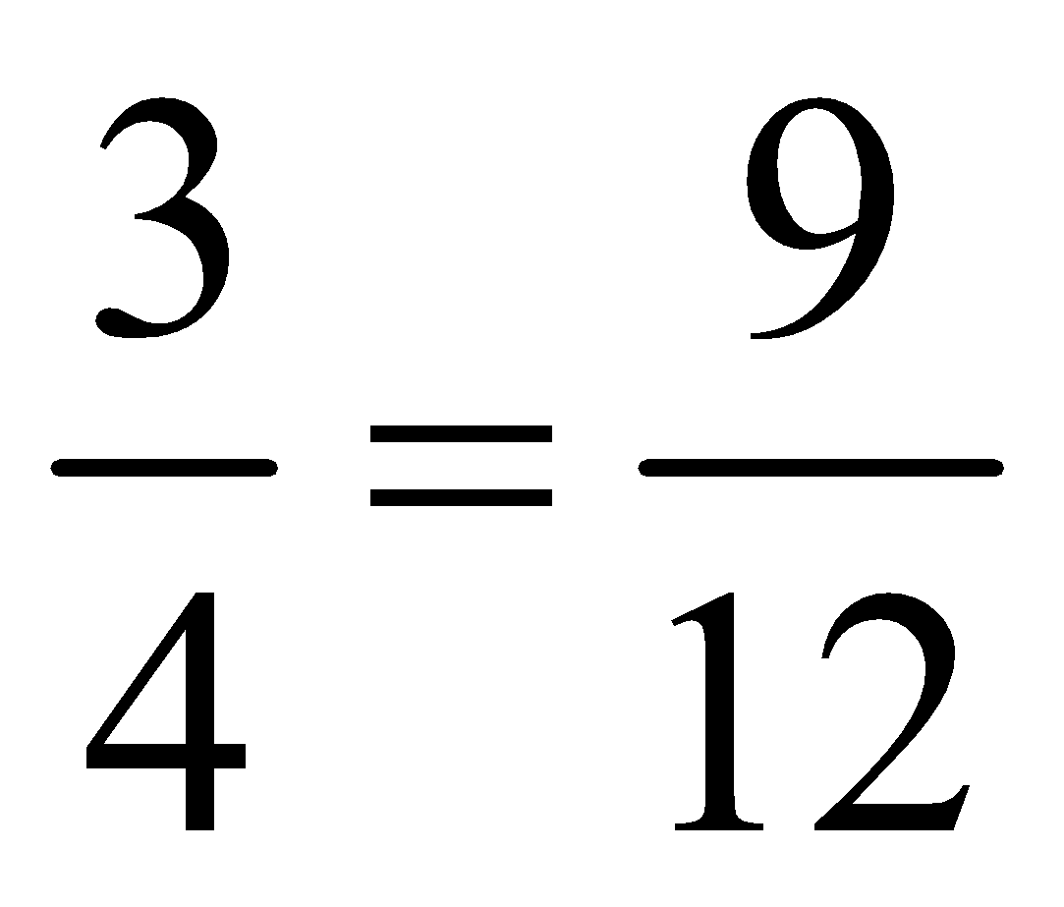 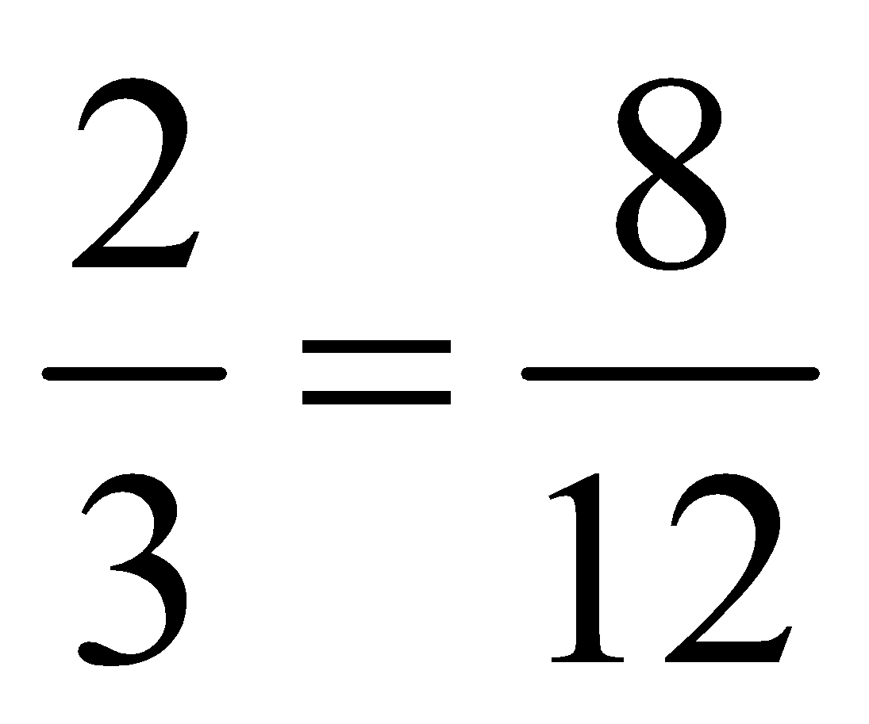 $\frac{ 2}{3}\frac{9}{12}$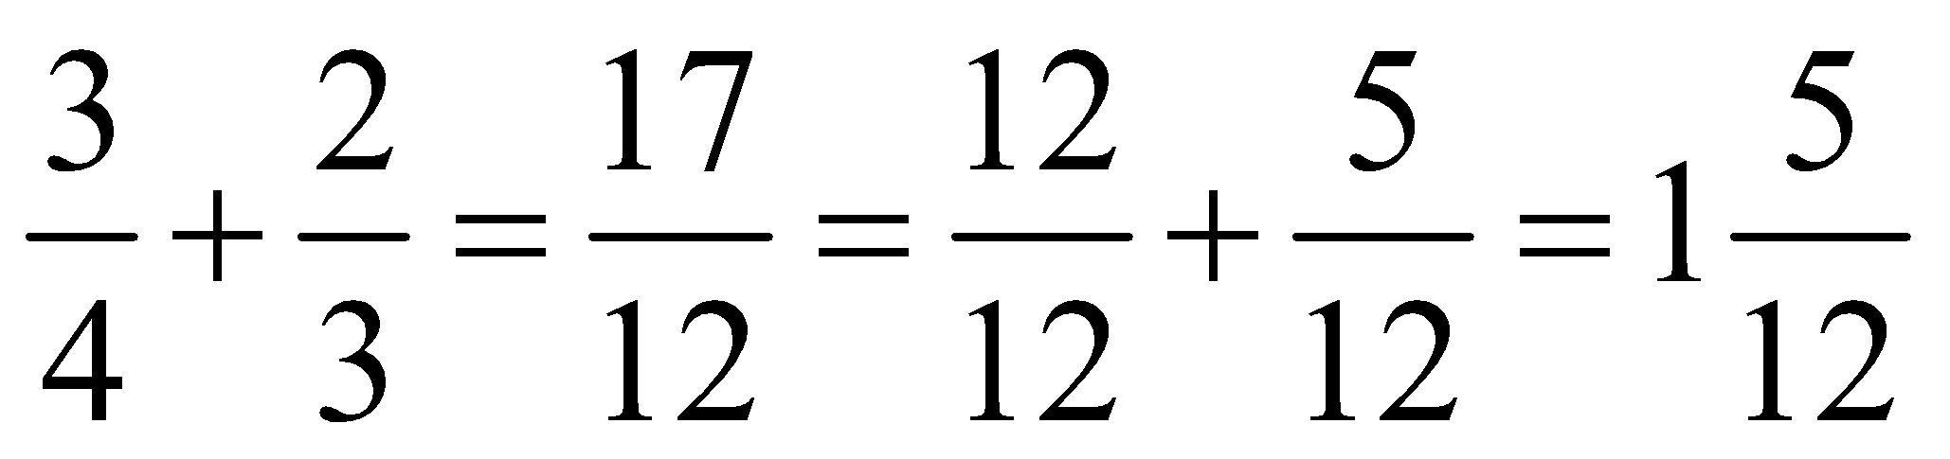  - Linear model  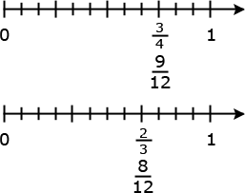  Solution:  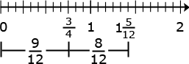  Example: Using a bar diagram  - Sonia had 2 1/3 candy bars. She promised her brother that she would give him ½ of a candy bar. How much will she have left after she gives her brother the amount she promised?  - If Mary ran 3 miles every week for 4 weeks, she would reach her goal for the month. The first day of the first week she ran 1 ¾ miles. How many miles does she still need to run the first week?  - Using addition to find the answer:1 ¾ + n = 3  - A student might add 1 ¼ to 1 ¾ to get to 3 miles. Then he or she would add 1/6 more. Thus 1 ¼ miles + 1/6 of a mile is what Mary needs to run during that week.  Example: Using an area model to subtract  - This model shows 1 ¾ subtracted from 3 1/6 leaving 1 + ¼ + 1/6 which a student can then change to 1 + 3/12 + 2/12 = 1 5/12.  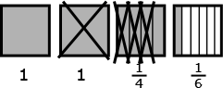  - This diagram models a way to show how 3 3 $\frac{1}{6}$ and 1 ¾ can be expressed with a denominator of 12. Once this is done a student can complete the problem, 2 14/12 – 1 9/12 = 1 5/12.  - This diagram models a way to show how 3 $\frac{1}{6}$ and 1 ¾ can be expressed with a denominator of 12. Once this is accomplished, a student can complete the problem, 2 14/12 – 1 9/12 = 1 5/12.  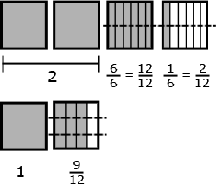  Estimation skills include identifying when estimation is appropriate, determining the level of accuracy needed, selecting the appropriate method of estimation, and verifying solutions or determining the reasonableness of situations using various estimation strategies. Estimation strategies for calculations with fractions extend from students’ work with whole number operations and can be supported through the use of physical models.  Example:  - Elli drank $\frac{3}{5}$ quart of milk and Javier drank $\frac{1}{10}$ of a quart less than Ellie. How much milk did they drink all together?  Solution:  - $\frac{3}{5}-\frac{1}{10}=\frac{6}{10}-\frac{1}{10}=\frac{5}{10 }$ This is how much milk Javier drank  - $\frac{3}{5}+\frac{5}{10}=\frac{6}{10}+\frac{5}{10}=\frac{11}{10}$ Together they drank $1\frac{1}{10}$ quarts of milk  This solution is reasonable because Ellie drank more than ½ quart and Javier drank ½ quart so together they drank slightly more than one quart. | Career and Life Skills:  Cooking

Differentiation/Modifications/Accommodations
Gifted and Talented | English Language Learners | Students with Disabilities | Students At Risk of School Failure

- Envision 2020 advanced/enrichment practice  - Pyramid Math – provide a large fraction at the top and students will have to break down the fraction addends to get to the bottom (largest sum is on top and each pair is the addend that equals the number)  - Fraction Freddy – students will receive body parts (leg, arm, head) with blank addend space and will have to construct Freddy back to together to match the labeled fraction sums on his torso . | - Using small group interactions and peer questioning  - Interactive smartboard activity  - Number lines  - Fraction Freddy – students will have to match the color coded fraction buttons (for Freddy’s coat) to match Freddy’s parts (all pieces will have both fraction addends and sums on them)  - Envision 2020 ELL activities  - For more, see http://www.state.nj.us/education/modelcurriculum/ela/ellscaffolding/3u1.pdf | - RTI approaches: prevent misconceptions, error intervention, reteaching set, reteaching worksheets  - Extended time  - Modified assignments  - Small group, alternate location  - Modeling  - Fraction Freddy – students will have to match the color coded fraction buttons (for Freddy’s coat) to match Freddy’s parts (all pieces will have both fraction addends and sums on them)  - Manipulatives  - Refer to each student’s IEP for more specific modifications | - Using demonstration: (ie: Create three visual representations of the same multiplication or division problem)  - Using manipulatives  - Using small group interactions and peer questioning  - Using pictures and graphic organizers  - Envision 2020 ELL activities  - Morning tutoring  - After school program  - Parental contact  - Tier II and Tier III Intervention

